**MINISTRY OF EDUCATION AND TRAINING**

**FPT UNIVERSITY**

Capstone Project Document

**Support System For Exchanging, Buying And Selling Personal Widgets**

|  |  |
| --- | --- |
| **Team** | |
| **Group members** | Mai Quế Tùng – SE61555  Đinh Công Đức – SE61551  Trần Gia Huy – SE61449 |
| **Supervisor** | Nguyễn Ngọc Anh |
| **Capstone Project code** | SEBS |

– Da Nang City, August, 2017 –

## Table of Contents

## List of Figures

## List of Tables

## Definitions, Acronyms and Abbreviations

|  |  |
| --- | --- |
| Terms | Explain |
| SEBS | Support system for exchanging, buying and selling personal widgets |
| UC | Use case |
| SD | Sequence Diagram |
| UI | User Interface |
| TC | Test case |
| App | Application |

1. Introduction
   1. Project information

* Project name: **Support system for exchanging, buying and selling personal widgets**
* Project code: **SEBS**
* Product type: **Web application and Mobile application**
* Start date: **May 8th, 2017**
* End date: **August 23rd, 2017**
  1. Introduction

Nowadays, human are facing with the problems of toxic waste. One of the causes is the discharging industrial waste and old widgets. The handling of waste is costly and time consuming.

In addition, something that you do not need, somebody is searching. Something that you need, somebody wants to give away. Somewhere somebody throws their fashionable clothes away and somewhere children just wish for a warm cloth. Somewhere somebody owns so many books and somewhere somebody is hungry for buying books. How do we could find someone needs things that we do not need and someone who wants to give away things that we need.

We built SEBS as a system to help connect buyers (receivers) and sellers (donors). Through our system, people can buy, sell and exchange personal widgets. Moreover, we can share the widgets with the poverty by the charity donation of old widgets. This solve the problem of discharging industrial waste and old widgets.

* 1. Current situation

Currently, the process of selling and buying product often go like this:

1. Post searching demand on Facebook or the e-commerce forums.
2. People have to wait and follow their post to know the answer from others.
3. Make a deal about price between buyer and seller.
4. Unify about shipping and payment method.

The process of doing charity:

1. Finding the suitable people through social network or charity organizations.
2. Research about the information of the organization.
3. Contact and do charity.

And the exchanging widgets process among people is:

1. Post searching demand on Facebook or the e-commerce forums.
2. People have to wait and follow their post to know the answer from others.
3. Unify about shipping method.

These processes is inefficient and requires a lot of manual work.

* 1. Problem definition

As mentioned in the last section, the above processes in the current situation are inefficient. They expose many disadvantages:

* **Difficult to buy and sell products.**  
  Buyers and sellers have to find each other manually in some group on social networks or forum without any matching system. With the traditional way of buying and selling, interpersonal trading is usually done on the C2C trading platform. By this way, users often have problems finding the products they need as well as selling them to the buyers.
* **Difficult to do charity with the old widgets**   
  Hard for receivers to find the donors for their desire widgets.
* **Difficult to exchange products.**Exchange through social networks or forum waste time. All works are done manually.
  1. Proposed solution
* By the building of intelligent matching algorithm base on the rule of supply – demand
* Our proposed solution is to build a system called “Support system for exchanging, buying and selling personal widgets”, or SESB for short. We focus on solving problems that we mentioned.
* Our system:
  + Allows users to find suitable products.
  + Allows users manage their personal information.
  + Provides Statistic Report for Administrator.
  + Help users manage their post.
  + Allows buyers/sellers rate others through their trade.
    1. Web Application Function
  + For Guest
    - Register as an User
    - Login
    - Change Language (English/Vietnamese)
    - Find nearby Products
    - Find posted Products
  + For User
    - Logout
    - Manage Profile
* Change Password
* Edit Profile
  + - Change Language (English/Vietnamese)
    - Find nearby Products
    - Find posted Products
    - Receive Notification
    - Manage Posts
* View Post List
* View Post Detail
* Edit Post
* Delete Post
* Cancel Post
* Finish Post
* Post Products
* Post Buying
* Post Selling
* Post Exchanging
* Post Charity
* Feedback Posts
* Comment Posts
* Chat with other Users
* Match Posts
  + For System Administrator
    - Manage Users
      * View User List
      * Ban User
    - Manage Feedbacks
* View Feedback List
  + - Manage Posts
* View Post List
* Examine Post
* Extend Post
  + - Manage Charity Campaigns
* Create Charity Campaign
* Edit Charity Campaign
* Delete Charity Campaign
  + - Manage Product Categories
* Create Product Category
* Edit Product Category
* Delete Product Category
  + - View Statistic Report
    1. Mobile Application Function
* Guest
  + Register as an User
  + Login
  + Change Language (English/Vietnamese)
  + Find nearby Products
  + Find posted Products
  + For User
    - Logout
    - Manage Profile
* Change Password
* Edit Profile
  + - Change Language (English/Vietnamese)
    - Find nearby Products
    - Find posted Products
    - Receive Notification
    - Manage Posts
* View Post List
* View Post Detail
* Edit Post
* Delete Post
* Cancel Post
* Finish Post
* Post Products
* Post Buying
* Post Selling
* Post Exchanging
* Post Charity
* Feedback Posts
* Comment Posts
* Chat with other Users
* Match Posts
  1. Functional requirements
     1. Web Application
  + For Guest
    - Register as an User
    - Login
    - Change Language (English/Vietnamese)
    - Find nearby Products
    - Find posted Products
  + For User
    - Logout
    - Manage Profile
* Change Password
* Edit Profile
  + - Change Language (English/Vietnamese)
    - Find nearby Products
    - Find posted Products
    - Receive Notification
    - Manage Posts
* View Post List
* View Post Detail
* Edit Post
* Delete Post
* Cancel Post
* Finish Post
* Post Products
* Post Buying
* Post Selling
* Post Exchanging
* Post Charity
* Feedback Posts
* Comment Posts
* Chat with other Users
* Match Posts
  + For System Administrator
    - Manage Users
      * View User List
      * Ban User
    - Manage Feedbacks
* View Feedback List
  + - Manage Posts
* View Post List
* Examine Post
* Extend Post
  + - Manage Charity Campaigns
* Create Charity Campaign
* Edit Charity Campaign
* Delete Charity Campaign
  + - Manage Product Categories
* Create Product Category
* Edit Product Category
* Delete Product Category
  + - View Statistic Report
    1. Mobile Application
* Guest
  + Register as an User
  + Login
  + Change Language (English/Vietnamese)
  + Find nearby Products
  + Find posted Products
  + For User
    - Logout
    - Manage Profile
* Change Password
* Edit Profile
  + - Change Language (English/Vietnamese)
    - Find nearby Products
    - Find posted Products
    - Receive Notification
    - Manage Posts
* View Post List
* View Post Detail
* Edit Post
* Delete Post
* Cancel Post
* Finish Post
* Post Products
* Post Buying
* Post Selling
* Post Exchanging
* Post Charity
* Feedback Posts
* Comment Posts
* Chat with other Users
* Match Posts
  1. Roles and responsibilities

|  |  |  |  |  |
| --- | --- | --- | --- | --- |
| **No** | **Full Name** | **Role** | **Position** | **Contact** |
| 1 | Nguyễn Ngọc Anh | Product Owner | Supervisor | anhnn@fpt.edu.vn |
| 2 | Mai Quế Tùng | Scrum Team | Leader | tungmqse61555@fpt.edu.vn |
| 3 | Đinh Công Đức | Scrum Team | Member | ducdcse61551@fpt.edu.vn |
| 4 | Trần Gia Huy | Scrum Team | Member | huytgse61449@fpt.edu.vn |

Table : Roles and responsibilities

1. Software Project Management Plan
   1. Problem definition
      1. Name of this Capstone Project

* Official name: Support system for exchanging, buying and selling personal widgets
* Vietnamese Name: Hệ thống hỗ trợ trao đổi và mua bán các vật dụng cá nhân
* Abbreviation: SEBS
  + 1. Problem abstract

Human are facing with the problems of toxic waste. One of the causes is the discharging industrial waste and old widgets. These widgets are still capable of using but it is not responding user needs. The handling is time – consuming and costly.

How do we could find someone needs things that we do not need and someone who wants to give away things that we need. Instead of buying or selling a product, we can exchange what we do not need to get what we need with others.

Somewhere somebody throws their fashionable clothes away and somewhere children just wish for a warm cloth. Somewhere somebody owns so many books and somewhere somebody is hungry for buying books. Things we do not need anymore may be things that others desire.

To help the situation, we provide a system that allows connecting buyers (receivers) and sellers (donors). Through our system, people can buy, sell and exchange personal widgets. Moreover, we can share the widget with the poverty by the charity donation of old widgets.

* + 1. Project Overview
       1. Current Situation

These are the problems encountered in this project:

* **Advantages:**
  + Identify the specific customer object.
  + Google provides many useful APIs.
  + Team members are familiar with Web technologies and E-Commerce.
  + Team lead and members have capable of good teamwork.
* **Disadvantages:**
  + The system depends on Google Maps API, if Google changes their API in the future, there will be many things need to rework.
  + The team has only three members.
  + Do not found a way to make money effectively.
  + Members do not have experience developing in mobile application.
    - 1. The proposed System

SEBS is built as web based and mobile application.

After technology research, we are going to use Google Maps API locate yourself and to find nearby products, find posted products. Guest can register an account to use the application.

In the application, we allow users to post products that they have, they need or they want to exchange. After retrieving information from the posts, we use our algorithm to match them together and user can choose the most suitable products.

Users manage their personal information and manage their posts. Each post has contact information so that users can interact with each other easily.

In addition, the application support when users want to give products to the person who need it. Charity is also very easy.

##### Boundaries of the System

The system is for Sellers (people want to sell the product they have), Buyers (people want to buy the product they need or exchange with other product).

Donors (people want to give products for charity) and Receivers (difficult people need charity products or charity organizations).

* + - 1. Future Plan

We will deploy our application on a cloud service so that we can avoid problems such as overload, maintenance issues (backup/restore) and gain many benefits like flexibility.

* + - 1. Development environment

##### 1.3.4.1 Hardware requirements

For server deployment

|  |  |  |
| --- | --- | --- |
|  | **Minimum Requirement** | **Recommended** |
| Internet Connection | Cable, Wi-Fi (4 Mbps) | Cable, Wi-Fi (20 Mbps) |
| Operating System | Window Server 2008 | Window Server 2008 |
| Computer Processor | Intel Core i3 Quad core 2.5 GHz | Intel Core i5 Quad core 3.2 GHz |
| Computer Memory | 4GB RAM | 8GB or more |

Table : Hardware Requirements

##### 1.3.4.2 Software requirements

|  |  |  |
| --- | --- | --- |
| **Software** | **Name/Version** | **Description** |
| Operating system | Window 7 64 bit | Operating system and platform for development |
| Environment | .NET Framework Core | Specification for developing web application |
| IDE | Visual Studio Community 2017 | Programming tools |
| DBMS | SQL Server Express 2014 | Database management tools |
| Source control | Source Tree | To control source code and document version |
| Web Brower | Google Chrome  Mozilla Firefox | Testing browser |

Table : Software Requirements

* 1. Project organization
     1. Software Process Model

#### 2.1.1 Overall Description

This project is developed under Scrum process. Scrum is an agile way to manage a project. Scrum relies on a self-organizing, cross-functional team. The scrum team is self-organizing in that there is no overall team leader who decides which person will do which task or how a problem will be solved. The team as a whole decides those issues. Moreover, in Scrum, a team is cross functional, meaning everyone is needed to take a feature from idea to implementation.

The project is managed by a series of sprints. Each sprint last 14 days. Each sprint is planned to complete a function or a scenario. Each day during a sprint, the team holds a daily scrum to talk about what he/she did last day and he/she will do. The daily scrum can help members discuss the problem and review working progress.

#### 2.1.2 Scrum Method – Evolutionary

The primary artifact in Scrum development is, of course, the product itself. The Scrum model expects the team to bring the product or system to a potentially shippable state at the end of each Scrum sprint.

A Product Backlog is never complete. The earliest development of it only lays out the initially known and best-understood requirements. The Product Backlog evolves as the product and the environment in which it will be used evolves. The Product Backlog is dynamic; it constantly changes to identify what the product needs to be appropriate, competitive, and useful. As long as a product exists, its Product Backlog also exists.

The Product Backlog lists all features, functions, requirements, enhancements, and fixes that constitute the changes to be made to the product in future releases. Product Backlog items have the attributes of a description, order, estimate and value.

The Sprint Backlog is the set of Product Backlog items selected for the Sprint, plus a plan for delivering the product Increment and realizing the Sprint Goal. The Sprint Backlog is a forecast by the Development Team about what functionality will be in the next Increment and the work needed to deliver that functionality into a “Done” Increment.

The Sprint Backlog makes visible all of the work that the Development Team identifies as necessary to meet the Sprint Goal.

The heart of Scrum is a Sprint, a time-box of one month or less during which a “Done”, useable, and potentially releasable product Increment is created. Sprints best have consistent durations throughout a development effort. A new Sprint starts immediately after the conclusion of the previous Sprint.

Sprints contain and consist of the Sprint Planning, Daily Scrums, the development work, the Sprint Review, and the Sprint Retrospective.

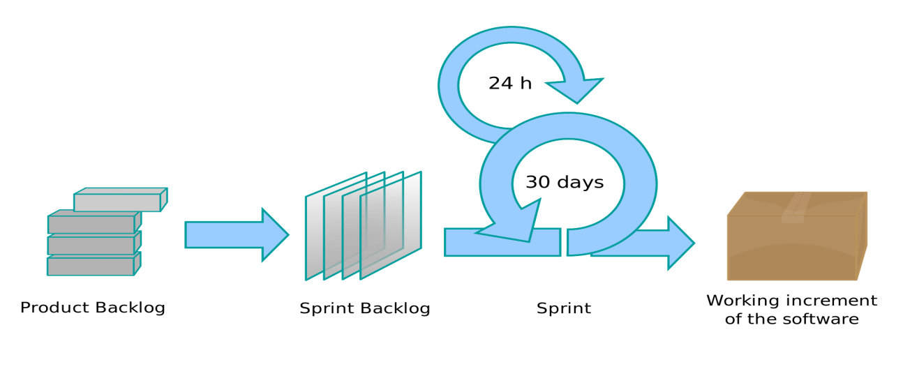

14 days

Figure : Scrum process model

#### 2.1.3 Reasons for choosing

We choose Scrum process because:

* The system can be divided into 2 independent subsystems, which are Web/Mobile Application and Report system.
* This project use new technology such as Google Maps API and Retrofit, which need research.
* The first time team approaches Mobile application.
  + 1. Roles and responsibilities

|  |  |  |  |
| --- | --- | --- | --- |
| **No.** | **Full name** | **Role in Group** | **Responsibilities** |
| 1 | Nguyễn Ngọc Anh | Product Owner – Technical Expert | Specify user requirement  Specifying the business  Control the development process  Give advices on techniques, solutions and business analysis support |
| 2 | Mai Quế Tùng | Scrum Master, BA, Dev, Tester | Managing process  Clarifying requirements  Researching solutions and techniques  Assigning task for members  Design architecture  Support team members  Reviewing the task result of members  Creating/ Editing documents and reports  Reviewing documents and reports  Designing Web UI  Coding Web application  Coding Web API  Creating test plan  Creating test case  Testing |
| 3 | Đinh Công Đức | Member, BA, Dev, Tester | Clarifying requirements  Researching solutions and techniques  Design architecture  Support team members  Creating/ Editing documents and reports  Reviewing documents and reports  Coding Mobile application  Creating test plan  Creating test case  Testing |
| 4 | Trần Gia Huy | Member, BA, Dev, Tester | Clarifying requirements  Researching solutions and techniques  Design architecture  Support team members  Creating/ Editing documents and reports  Reviewing documents and reports  Designing WebUI  Coding Mobile application  Creating test plan  Creating test case  Testing |

Table : Roles and responsibilities detail

* + 1. Tools and Techniques

|  |  |
| --- | --- |
| **Tool/ Technique** | **Name/Version** |
| Front-end | HTML, CSS, JQuery, Ajax |
| Back-end | ASP.NET, Google Maps API |
| IDE | Visual Studio Express 2017 |
| Database Management | SQL Server Express 2014 |
| Document | Microsoft Office 2013 |
| UML Diagram | StarUML |
| Source control | SourceTree |

Table : Tools and Techniques

* + 1. Scrum Documents (Sửa)

|  |  |
| --- | --- |
| **Product backlog Item** | **Added in Sprint** |
| Analyze requirement, research about technology, create report 1,2 | Sprint 1,2 |
| Truck Management | Sprint 5, 6, 7 |
| Driver Management | Sprint 5, 6, 7 |
| Deal Management | Sprint 7, 8, 9 |
| Route Management | Sprint 7, 8, 9 |
| Order Management | Sprint 7, 8, 9 |
| User Management | Sprint 10 |
| Supporting features, final report | Sprint 6, 7 |

Table : Scrum Documents

All detail information of product backlog, sprint backlog are managed by visualstudio.com

1. Software Requirement Specification
   1. User Requirement Specification

|  |  |  |
| --- | --- | --- |
| **No** | **Actor** | **Definition** |
| 1 | Guest | A person who does not have an account in the system |
| 2 | User | A person who already had an account in the system |
| 3 | System Administrator | A person who manages the SEBS system |

Table : User Requirement Specification

* + 1. Guest Requirement
  + Register as an User: Guest creates a User account using their username and password.
  + Login: Guest using their account to login.
  + Change Language: Guest can change language to either English or Vietnamese.
  + Find nearby Products: Guest can finds products around their location.
  + Find posted Products: Guest can finds products posted in the system.
    1. User Requirement
* Log out: User using their account to log out.
* Manage Profile:
* Change Password: User can change their password.
* Edit Profile: User can edit their profile such as name, address, phone …
* Change Language: User can change language to either English or Vietnamese.
* Find nearby Products: User can finds products around their location.
* Find posted Products: User can finds products posted in the system.
* Receive Notification: User can receive notification from the system.
* Manage Posts:
  + View Posts List: User sees a list of all posts in the system.
  + View Post Detail: User sees detail information of a post in the system.
  + Edit Post: User can edit information of their posts in the system.
  + Delete Post: User can delete their posts in the system.
  + Cancel Post: User changes status post to not display.
  + Finish Post: User can finish post after successful transaction.
* Post Products:
* Post Buying: User can post products what they want to buy.
* Post Selling: User can post products what they want to sell.
* Post Exchanging: User can post products what they want to exchange with product what they have.
* Post Charity: User can post products what they want to the people or charity organizations need.
* Feedback Posts: User can feedback posts with administrator of the system.
* Comment Posts: User can comment posts when they see detail this post.
* Chat with other Users: User can chat with other User on a post.
* Match Posts: User is suggested posts that matching their post.
  + 1. System Administrator Requirement
* Log out: Administrator using their account to log out.
* Manage Profile:
* Change Password: Administrator can change their password.
* Edit Profile: Administrator can edit their profile such as name, address, phone…
* Manage Users:
  + View User List: Administrator sees a list of all users in the system.
  + Ban User: Administrator permanently bans User from accessing the system.
* Manage Feedbacks:
* View Feedback List: Administrator sees a list of all feedbacks in the system.
* Manage Posts:
* View Post List: Administrator sees a list of all posts and status in the system.
* Examine Post: Administrator can change status of all posts in the system.
* Extend Post: Administrator can extend the post that has expired.
* Manage Charity Campaigns:
* Create Charity Campaign: Administrator can create new charity campaign in the system.
* Edit Charity Campaign: Administrator can edit information a charity campaign in the system.
* Delete Charity Campaign: Administrator can delete a charity campaign in the system.
* Manage Product Categories:
* Create Product Category: Administrator can create a product category in the system.
* Edit Product Category: Administrator can edit information of product category in the system.
* Delete Product Category: Administrator can delete a product category in the system.
* View Statistic Report: Administrator sees various types of report.
  1. System Requirement Specification
     1. External Interface Requirement
        1. User Interface
* The user interface use Vietnamese (default) or English (optional) language.
* The best resolution for user interface is 1366x768 pixels.
* General requirement for graphics user interface is the GUI should be simple, clear, intuitive, and reminiscent.
  + - 1. Hardware Interface
* Computer with Internet connection and Internet browser.
* Recommend system:
  + OS: Windows 7.
  + RAM: 4GB.
  + CPU: Intel core i3.
    - 1. Software Interface
* Web application: In general, works with HTML5 browser (preferably Google Chrome v56).
* Mobile application: Android API 16-25 (Jelly Bean – Nougat).
  + - 1. Communication Protocol
* Use HTTP protocol for communication between Client and Web server.
  + 1. System Overview Use Case

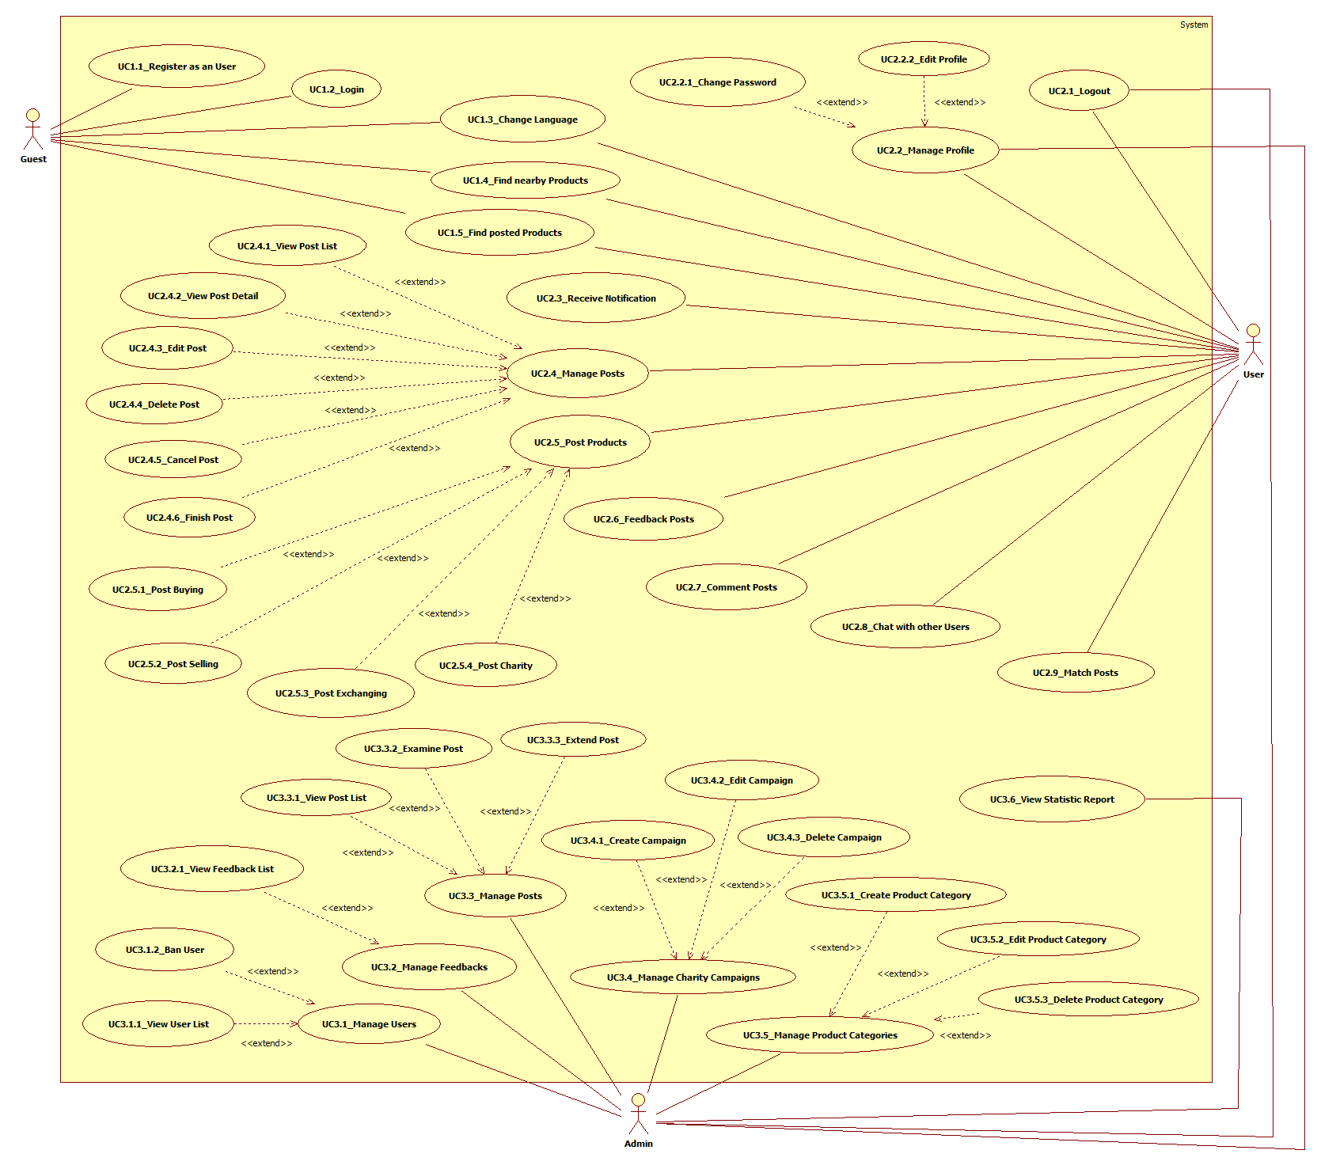

Figure : Use case overview

* + 1. List of Use Case
       1. Guest Overview Use Case

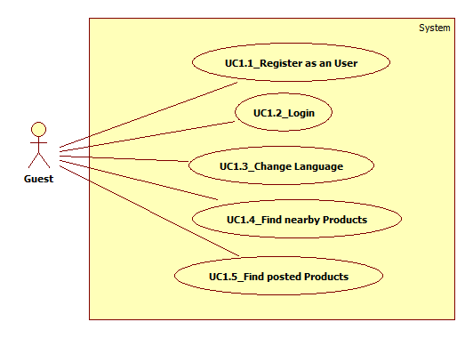

Figure : Guest Overview UC

* + - * 1. <Guest> Register as an User

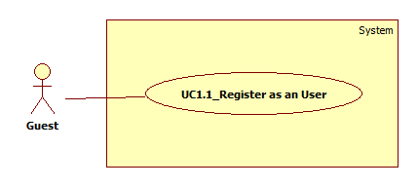

Figure : <Guest> Register as an User UC

|  |  |  |  |  |  |
| --- | --- | --- | --- | --- | --- |
| **USE CASE – UC1.1_Register as an User** | | | | | |
| **Use Case No.** | UC1.1 | **Use Case Version** | | 1.0 | |
| **Use Case Name** | Register as an User | | | | |
| **Author** | Dinh Cong Duc | | | | |
| **Date** | 05/06/2017 | | **Priority** | | Normal |
| **Actor:**   * Guest   **Summary:**   * This use case allows Guest to create an account as a User role.   **Goal:**   * Guest has a User account.   **Triggers:**   * Guest clicks “TẠO MỚI TÀI KHOẢN” hyperlink on home page.   **Preconditions:**   * N/A   **Post Conditions:**   * **Success:** A new account has been created. * **Fail:** System shows error message on screen.   **Main Success Scenario:**   |  |  |  | | --- | --- | --- | | **Step** | **Actor Action** | **System Response** | | 1 | Guest clicks “TẠO MỚI TÀI KHOẢN” hyperlink on home page. | Register screen appears with a form including:   * + Địa chỉ email: textbox   + Mật khẩu: password   + Xác nhận mật khẩu: password   + Họ và tên: textbox   + Địa chỉ: texbox   + “ĐĂNG KÝ” button | | 2 | Guest inputs all required fields and clicks “ĐĂNG KÝ” button.  [Alternative 1] | System validates all input fields.  [Exception 1]  [Exception 2]  [Exception 3]  [Exception 4]  System checks if Email exists in the database or not.  [Exception 5]  System redirect to the successful screen. |   **Alternative 1:**   |  |  |  | | --- | --- | --- | | **Step** | **Cause** | **System Response** | | 1 | Guest click “trang đăng nhập” hyberlink. | System redirects Guest to login screen. |   **Exceptions 1:**   |  |  |  | | --- | --- | --- | | **Step** | **Cause** | **System Response** | | 1 | Guest enters invalid input or empty. | System shows error message below invalid field(s) or empty: “Vui lòng điền vào trường này”. |     **Exceptions 2:**   |  |  |  | | --- | --- | --- | | **Step** | **Cause** | **System Response** | | 1 | Guests do not input password. | System shows error message: “Lỗi”. |   **Exceptions 3:**   |  |  |  | | --- | --- | --- | | **Step** | **Cause** | **System Response** | | 1 | Password and confirm password do not have uppercase, lowercase, special character and digit. | System shows error message: “Mật khẩu yêu cầu chữ hoa, thường, số và ký tự đặc biệt!”. |   **Exceptions 4:**   |  |  |  | | --- | --- | --- | | **Step** | **Cause** | **System Response** | | 1 | Password and confirm password do not match. | System shows error message: “Mật khẩu xác nhận chưa chính xác!”. |   **Exceptions 5:**   |  |  |  | | --- | --- | --- | | **Step** | **Cause** | **System Response** | | 1 | Guest inputs an email that already exists. | System shows error message: “Email đã tồn tại, vui lòng nhập email khác”. |   **Relationship:** N/A  **Business Rules:**  **-** Email must be input the correct format.  **-** Password must have uppercase, lowercase, special character and digit.  **-** “Mật khẩu” and “Xác nhận mật khẩu” must be matching.  **-** Each email must be unique in system.  **-** The symbol (*) is required. | | | | | |

Table : <Guest> Register as an User UC

* + - * 1. <Guest> Login

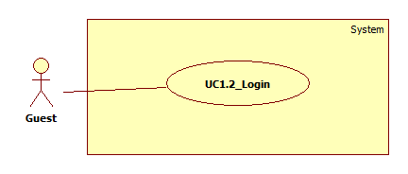

Figure : <Guest> Login UC

|  |  |  |  |  |  |
| --- | --- | --- | --- | --- | --- |
| **USE CASE – UC1.2_Login** | | | | | |
| **Use Case No.** | UC1.2 | **Use Case Version** | | 1.0 | |
| **Use Case Name** | Login | | | | |
| **Author** | Dinh Cong Duc | | | | |
| **Date** | 05/06/2017 | | **Priority** | | Normal |
| **Actor:**   * Guest   **Summary:**   * This use case allows Guest to login to system as a User role.   **Goal:**   * Guest can login to system and have role User.   **Triggers:**   * Guest clicks “ĐĂNG NHẬP” button on home page.   **Preconditions:**   * Email and password must be generated before and store in storage.   **Post Conditions:**   * **Success:** System shows login successful and guest have role User. * **Fail:** System shows error message and comes back login screen again.   **Main Success Scenario:**   |  |  |  | | --- | --- | --- | | **Step** | **Actor Action** | **System Response** | | 1 | Guest click “ĐĂNG NHẬP” button on home page. | Login screen appears with a form including:   * + Đại chỉ email: textbox   + Mật khẩu: password   + “ĐĂNG NHẬP” button   + “SIGN IN WITH FACEBOOK” hyperlink   + “TIẾP TỤC” button | | 2 | Guest inputs email and password.  [Alternative 1] |  | | 3 | Guest clicks “ĐĂNG NHẬP” button.  [Alternative 2]  [Alternative 3] | System checks validate the input in 2 field email and password.  [Exception 1]  System will check email and password and verify the authorization for account. |   **Alternative 1:**   |  |  |  | | --- | --- | --- | | **Step** | **Cause** | **System Response** | | 1 | Guest inputs wrong email or password. | System shows error message: “Email hoặc mật khẩu không hợp lệ”. |   **Alternative 2:**   |  |  |  | | --- | --- | --- | | **Step** | **Cause** | **System Response** | | 1 | Guest clicks “ĐĂNG NHẬP BẰNG FACEBOOK” hyperlink. | System redirects Guest to login by Facebook screen. |   **Alternative 3:**   |  |  |  | | --- | --- | --- | | **Step** | **Cause** | **System Response** | | 1 | Guest clicks “TIẾP TỤC” button. | System redirects Guest to register screen. |   **Exceptions 1:**   |  |  |  | | --- | --- | --- | | **Step** | **Cause** | **System Response** | | 1 | Guest enters invalid input or empty. | System does not allow Guest to login. |   **Relationship:** N/A  **Business Rules:**   * After login to system, if role is “User”, the system will display User view. * After login to system, if role is “Admin”, the system will display Admin view. * Email must be input the correct format. | | | | | |

Table : <Guest> Login UC

* + - * 1. <Guest> <User> Change Language

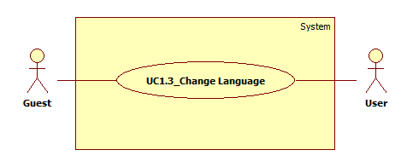

Figure : <Guest> <User> Change Language UC

|  |  |  |  |  |  |
| --- | --- | --- | --- | --- | --- |
| **USE CASE – UC1.3_Change Language** | | | | | |
| **Use Case No.** | UC1.3 | **Use Case Version** | | 1.0 | |
| **Use Case Name** | Change Language | | | | |
| **Author** | Dinh Cong Duc | | | | |
| **Date** | 05/06/2017 | | **Priority** | | Low |
| **Actor:**   * Guest, User   **Summary:**   * This use case allows Guest or User to change UI’s language from Vietnamese to English or vice versa.   **Goal:**   * Guest or User can change UI’s language from Vietnamese to English or vice versa in the system.   **Triggers:**   * Guest or User clicks England flag or Viet Nam flag.   **Preconditions:**   * N/A   **Post Conditions:**   * **Success:** UI’s language changed. * **Fail:** N/A   **Main Success Scenario:**   |  |  |  | | --- | --- | --- | | **Step** | **Actor Action** | **System Response** | | 1 | Guest or User clicks England flag or Viet Nam flag. | System translates the UI to English or Vietnamese language and keeps Guest or User at the screen they are in. |   **Alternative:** N/A  **Exceptions:** N/A  **Relationship:** N/A  **Business Rules:**   * Guest or User can only change from Vietnamese to English or vice versa. | | | | | |

Table : <Guest> <User> Change Language UC

* + - * 1. <Guest> <User> Find nearby Products

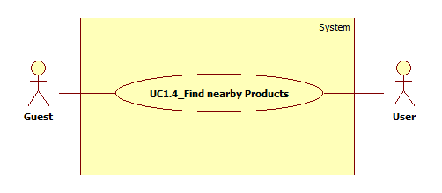

Figure : <Guest> <User> Find nearby Products UC

|  |  |  |  |  |  |
| --- | --- | --- | --- | --- | --- |
| **USE CASE – UC1.4_ Find nearby Products** | | | | | |
| **Use Case No.** | UC1.4 | **Use Case Version** | | 1.0 | |
| **Use Case Name** | Find nearby Products | | | | |
| **Author** | Dinh Cong Duc | | | | |
| **Date** | 05/06/2017 | | **Priority** | | High |
| **Actor:**   * Guest, User   **Summary:**   * This use case allows Guest or User to find products located around them.   **Goal:**   * Guest or User can find quickly products located around them.   **Triggers:**   * User clicks “QUANH ĐÂY” button on home page. * User selects the searching range.   **Preconditions:**   * Actor must be Guest or already logged in with their account as a User role.   **Post Conditions:**   * **Success:** List of products around are shown on screen. * **Fail:** System shows error message on screen.   **Main Success Scenario:**   |  |  |  | | --- | --- | --- | | **Step** | **Actor Action** | **System Response** | | 1 | User clicks “QUANH ĐÂY” button on home page. | System shows “PHẠM VI” drop down | | 2 | User selects the searching range  [Alternative 1] | System shows all products that have been posted.  [Exception 1]  [Exception 2] |   **Alternative 1:**   |  |  |  | | --- | --- | --- | | **Step** | **Cause** | **System Response** | | 1 | User input the searching range. | System shows all products that have been posted in this range. |   **Exceptions 1:**   |  |  |  | | --- | --- | --- | | **Step** | **Cause** | **System Response** | | 1 | There is no result have the same info with inputted information. | System shows empty result. |   **Exceptions 2:**   |  |  |  | | --- | --- | --- | | **Step** | **Cause** | **System Response** | | 1 | Connecting database error. | System shows error message. |   **Relationship:** N/A  **Business Rules:**   * List of products includes post buying, selling, exchanging and charity. * List of products will be sorted by distance from near to far. | | | | | |

Table : <Guest> <User> Find nearby Products UC

* + - * 1. <Guest> <User> Find posted Products

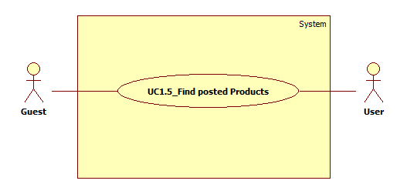

Figure : <Guest> <User> Find posted Products UC

|  |  |  |  |  |  |
| --- | --- | --- | --- | --- | --- |
| **USE CASE – UC1.5_Find posted Products** | | | | | |
| **Use Case No.** | UC1.5 | **Use Case Version** | | 1.0 | |
| **Use Case Name** | Find posted Products | | | | |
| **Author** | Dinh Cong Duc | | | | |
| **Date** | 05/06/2017 | | **Priority** | | Normal |
| **Actor:**   * Guest, User   **Summary:**   * This use case allows Guest or User to find products posted. * It can be: post buying, selling, exchanging and charity.   **Goal:**   * Guest ot User can find appropriate product quickly by product name, product description.   **Triggers:**   * Actor input keyword (product name, product description) to search field. * Click “Search” icon button.   **Preconditions:**   * Actor must be Guest or already logged in with their account as a User role. * Guest or User has keyword to search.   **Post Conditions:**   * **Success:** List of posted products are shown on screen. * **Fail:** System shows error message on screen.   **Main Success Scenario:**   |  |  |  | | --- | --- | --- | | **Step** | **Actor Action** | **System Response** | | 1 | Guest or User inputs keyword into search field.  [Alternative 1]  [Alternative 2] |  | | 2 | Click “Search” icon button. | System shows all products with inputted information.  [Exception 1]  [Exception 2] |   **Alternative 1:**   |  |  |  | | --- | --- | --- | | **Step** | **Cause** | **System Response** | | 1 | Guest or User selects product category. | System shows all products with selected product category. |   **Alternative 2:**   |  |  |  | | --- | --- | --- | | **Step** | **Cause** | **System Response** | | 1 | Guest or User does not input keyword into search field. | System shows all products. |   **Exception 1:**   |  |  |  | | --- | --- | --- | | **Step** | **Cause** | **System Response** | | 1 | There is no result have the same info with inputted information. | System shows empty result. |   **Exceptions 2:**   |  |  |  | | --- | --- | --- | | **Step** | **Cause** | **System Response** | | 1 | Connecting database error. | System shows error message. |   **Relationship:** N/A  **Business Rules:**  - System were searched by product name, product description.  - There are maximum 100 results were display per page. | | | | | |

Table : <Guest> <User> Find posted Products UC

* + - 1. User Overview Use Case

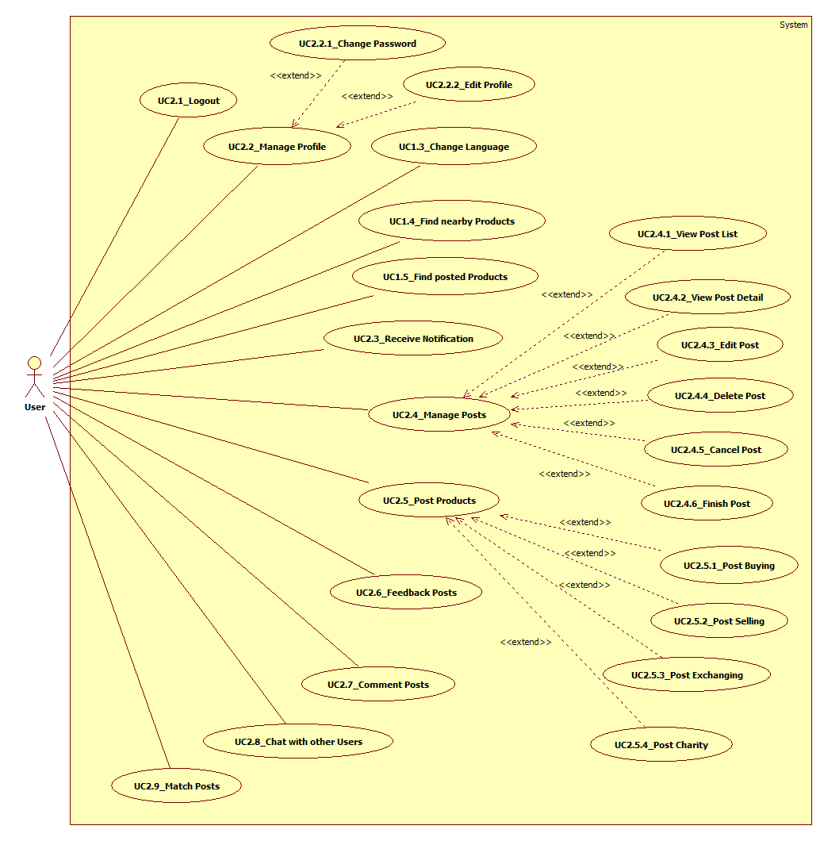

Figure : User Overview UC

* + - * 1. <User> <Admin> Logout

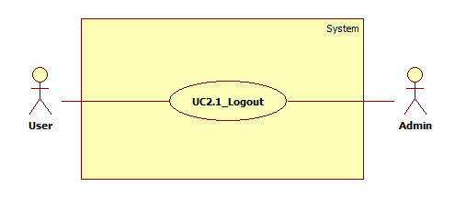

Figure : <User> <Admin> Logout UC

|  |  |  |  |  |  |
| --- | --- | --- | --- | --- | --- |
| **USE CASE – UC2.1_Logout** | | | | | |
| **Use Case No.** | UC2.1 | **Use Case Version** | | 1.0 | |
| **Use Case Name** | Logout | | | | |
| **Author** | Dinh Cong Duc | | | | |
| **Date** | 05/06/2017 | | **Priority** | | Low |
| **Actor:**   * User, Admin   **Summary:**   * This use case allows User or Admin to log out of the system.   **Goal:**   * User or Admin can log out of current account and have role Guest.   **Triggers:**   * On home page, click “ĐĂNG XUẤT” hyberlink.   **Preconditions:**   * User or Admin logged into the system.   **Post Conditions:**   * **Success:** Log out successfully. * **Fail:** System shows error message on screen.   **Main Success Scenario:**   |  |  |  | | --- | --- | --- | | **Step** | **Actor Action** | **System Response** | | 1 | User or Admin click “ĐĂNG XUẤT” hyberlink.  [Alternative 1] | System will remove current session of user or admin and have role Guest. |   **Alternative 1:**   |  |  |  | | --- | --- | --- | | **Step** | **Cause** | **System Response** | | 1 | Do not use the website 30 minutes. | The account will be automatically log out. |   **Exceptions:** N/A  **Relationship:** N/A  **Business Rules:**  **-** If user or admin do not use the website in 30 minutes, session will be expired and they will be auto logout.  **-** After log out of system, user will have Guest role. | | | | | |

Table : <User> <Admin> Logout UC

* + - * 1. <User> <Admin> Manage Profile

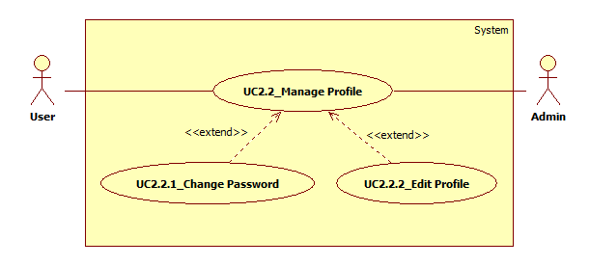

Figure : <User> <Admin> Manage Profile UC

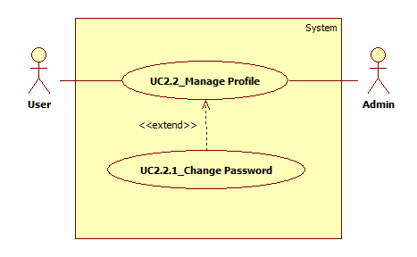

Figure : <User> <Admin> Change Password UC

|  |  |  |  |  |  |
| --- | --- | --- | --- | --- | --- |
| **USE CASE – UC_2.2.1_Change Password** | | | | | |
| **Use Case No.** | UC_2.2.1 | **Use Case Version** | | 1.0 | |
| **Use Case Name** | Change Password | | | | |
| **Author** | Dinh Cong Duc | | | | |
| **Date** | 05/06/2017 | | **Priority** | | Normal |
| **Actor:**   * User, Admin   **Summary:**   * This use case allows User or Admin to change their password.   **Goal:**   * User or Admin can change their password.   **Triggers:**   * User or Admin clicks “TÀI KHOẢN CỦA TÔI” link on home page.   **Preconditions:**   * Actor must be logged in the system with User or Admin role.   **Post Conditions:**   * **Success:** Password is changed. * **Fail:** System shows error message on screen.   **Main Success Scenario:**   |  |  |  | | --- | --- | --- | | **Step** | **Actor Action** | **System Response** | | 1 | User or Admin clicks “TÀI KHOẢN CỦA TÔI” link on home page. | System shows “Đổi mật khẩu” screen with a form including:  Đổi mật khẩu   * + Mật khẩu cũ: password   + Mật khẩu mới: password   + Xác nhận mật khẩu: password   + “LƯU THAY ĐỔI” button | | 2 | User or Admin enters all required fields and clicks “LƯU THAY ĐỔI” button. | System validates all input fields.  [Exception 1]  System shows message: “Lưu thành công”. |   **Alternative:** N/A  **Exceptions 1:**   |  |  |  | | --- | --- | --- | | **Step** | **Cause** | **System Response** | | 1 | User enters invalid values or empty. | System shows error message invalid field(s) or empty: “Thất bại”. |   **Relationship:** <<extend>> Manage Profile  **Business Rules:**  **-** “Mật khẩu mới” và “Xác nhận mật khẩu” must be matching.  **-** The symbol (*) is required.  **-** Password must have uppercase, lowercase, special character and digit. | | | | | |

Table : <User> <Admin> Change Password UC

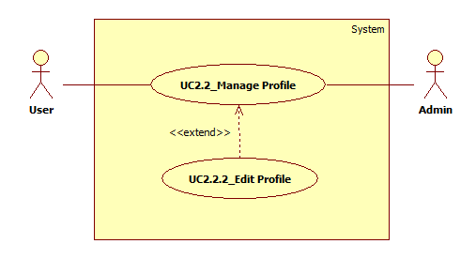

Figure : <User> <Admin> Edit Profile UC

|  |  |  |  |  |  |
| --- | --- | --- | --- | --- | --- |
| **USE CASE – UC_2.2.2_Edit Profile** | | | | | |
| **Use Case No.** | UC_2.2.2 | **Use Case Version** | | 1.0 | |
| **Use Case Name** | Edit Profile | | | | |
| **Author** | Dinh Cong Duc | | | | |
| **Date** | 05/06/2017 | | **Priority** | | Normal |
| **Actor:**   * User, Admin   **Summary:**   * This use case allows User or Admin to edit their profile information.   **Goal:**   * User or Admin can change their profile information.   **Triggers:**   * User or Admin clicks “TÀI KHOẢN CỦA TÔI” link on home page.   **Preconditions:**   * Actor must be logged in the system with User or Admin role.   **Post Conditions:**   * **Success:** Profile information was changed. * **Fail:** System shows error message on screen.   **Main Success Scenario:**   |  |  |  | | --- | --- | --- | | **Step** | **Actor Action** | **System Response** | | 1 | User or Admin clicks “TÀI KHOẢN CỦA TÔI” link on home page. | System shows “Thông tin tài khoản của bạn” screen with a form including:  Thông tin tài khoản của bạn:   * + Họ và tên: textbox   + Số điện thoại: textbox   + Địa chỉ: textbox   + Sinh nhật: dd/mm/yyyy   + Giới tính: radio button   + “LƯU THAY ĐỔI” button | | 2 | User or Admin edits information and clicks “LƯU THAY ĐỔI” button. | System validates all input fields.  [Exception 1]  System shows message: “Lưu thành công”. |   **Alternative:** N/A  **Exceptions 1:**   |  |  |  | | --- | --- | --- | | **Step** | **Cause** | **System Response** | | 1 | User or Admin enters invalid values or empty. | System shows error message invalid field(s) or empty: “Thất bại”. |   **Relationship:** <<extend>> Manage Profile  **Business Rules:**  **-** The symbol (*) is required. | | | | | |

Table : <User> <Admin> Edit Profile UC

* + - * 1. <User> Receive Notification

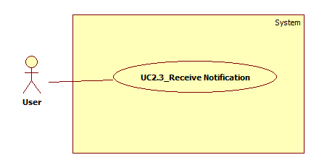

Figure : <User> Receive Notification UC

|  |  |  |  |  |  |
| --- | --- | --- | --- | --- | --- |
| **USE CASE – UC_2.3_Receive Notification** | | | | | |
| **Use Case No.** | UC_2.3 | **Use Case Version** | | 1.0 | |
| **Use Case Name** | Receive Notification | | | | |
| **Author** | Dinh Cong Duc | | | | |
| **Date** | 05/06/2017 | | **Priority** | | Normal |
| **Actor:**   * User   **Summary:**   * This use case allows User to receive their notification.   **Goal:**   * User can receive their notification.   **Triggers:**   * N/A   **Preconditions:**   * Actor must be logged in the system with User role.   **Post Conditions:**   * **Success:** User can see notification. * **Fail:** User cannot see notification.   **Main Success Scenario:**   |  |  |  | | --- | --- | --- | | **Step** | **Actor Action** | **System Response** | | 1 | User has comment, chat from other users and match posts on their posts.  [Alternative 1] | System shows a list of current notifications. |   **Alternative 1:**   |  |  |  | | --- | --- | --- | | **Step** | **Cause** | **System Response** | | 1 | User does not have comment, chat from other users or match posts on their posts. | System does not show the current notifications. |   **Exceptions:** N/A  **Relationship:** N/A  **Business Rules:**  **-** User will receive notification when have comment, chat on the posts and match posts. | | | | | |

Table : <User> Receive Notification UC

* + - * 1. <User> Manage Posts

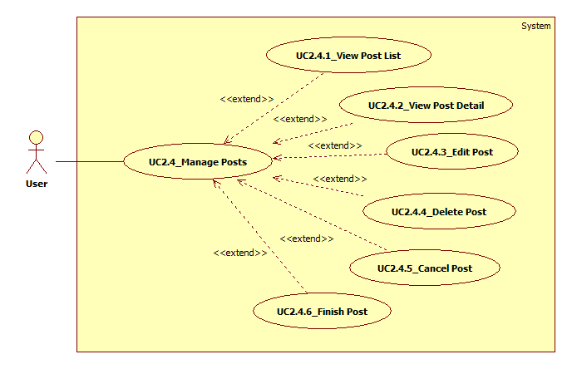

Figure : <User> Manage Posts UC

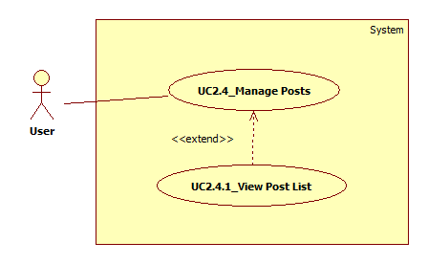

Figure : <User> View Post List UC

|  |  |  |  |  |  |
| --- | --- | --- | --- | --- | --- |
| **USE CASE – UC2.4.1_View Post List** | | | | | |
| **Use Case No.** | UC2.4.1 | **Use Case Version** | | 1.0 | |
| **Use Case Name** | View Post List | | | | |
| **Author** | Dinh Cong Duc | | | | |
| **Date** | 05/06/2017 | | **Priority** | | Normal |
| **Actor:**   * User   **Summary:**   * This use case allows User to view a list all posts that they posted.   **Goal:**   * User can view posts that they posted.   **Triggers:**   * User clicks “QUẢN LÝ BÀI ĐĂNG” hyberlink on home page.   **Preconditions:**   * Actor must be logged in the system with User role.   **Post Conditions:**   * **Success:** User sees the list of posts displayed. * **Fail:** System shows error message on screen.   **Main Success Scenario:**   |  |  |  | | --- | --- | --- | | **Step** | **Actor Action** | **System Response** | | 1 | User clicks “QUẢN LÝ BÀI ĐĂNG” hyberlink on home page. | System shows a list all posts that they posted. | | 2 | User clicks a tab. | System shows a list all posts of this status.  [Exception 1] |   **Alternative:** N/A  **Exceptions 1:**   |  |  |  | | --- | --- | --- | | **Step** | **Cause** | **System Response** | | 1 | List of posts does not have posts. | System shows empty result. |   **Relationship:** <<extend>> Manage Posts  **Business Rules:**  **-** The post list is divided into statuses: examining, matching, matched, stopped, expired, finished. | | | | | |

Table : <User> View Post List UC

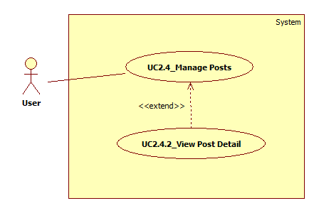

Figure : <User> View Post Detail UC

|  |  |  |  |  |  |
| --- | --- | --- | --- | --- | --- |
| **USE CASE – UC_2.4.2_View Post Detail** | | | | | |
| **Use Case No.** | UC_2.4.2 | **Use Case Version** | | 1.0 | |
| **Use Case Name** | View Post Detail | | | | |
| **Author** | Dinh Cong Duc | | | | |
| **Date** | 05/06/2017 | | **Priority** | | Normal |
| **Actor:**   * User   **Summary:**   * This use case allows User to see detail a post that they posted.   **Goal:**   * User can see detail a post that they posted.   **Triggers:**   * User clicks “QUẢN LÝ BÀI ĐĂNG” hyberlink on home page. * User clicks a post.   **Preconditions:**   * Actor must be logged in the system with User role.   **Post Conditions:**   * **Success:** Detail a post is displayed. * **Fail:** System shows error message on screen.   **Main Success Scenario:**   |  |  |  | | --- | --- | --- | | **Step** | **Actor Action** | **System Response** | | 1 | User clicks “QUẢN LÝ BÀI ĐĂNG” hyberlink on home page. | System shows a list all posts that they posted.  [Exception 1] | | 2 | User clicks a post. | System shows detail information detail of this post. |   **Alternative:** N/A  **Exceptions 1:**   |  |  |  | | --- | --- | --- | | **Step** | **Cause** | **System Response** | | 1 | List of posts does not have posts. | System shows empty result. |   **Relationship:** <<extend>> Manage Posts  **Business Rules:**  **-** List of posts that are displayed include image, title, price, full name of user.  **-** Detail information of posts that are displayed include all necessary information. | | | | | |

Table : <User> View Post Detail UC

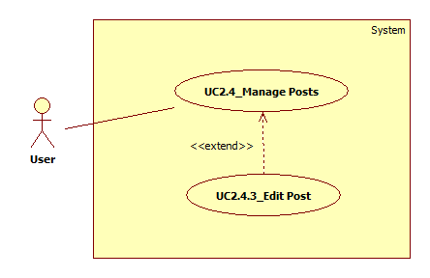

Figure : <User> Edit Post UC

|  |  |  |  |  |  |
| --- | --- | --- | --- | --- | --- |
| **USE CASE – UC_2.4.3_Edit Post** | | | | | |
| **Use Case No.** | UC_2.4.3 | **Use Case Version** | | 1.0 | |
| **Use Case Name** | Edit Post | | | | |
| **Author** | Dinh Cong Duc | | | | |
| **Date** | 05/06/2017 | | **Priority** | | Normal |
| **Actor:**   * User   **Summary:**   * This use case allows User to edit information of posts that they posted.   **Goal:**   * User can edit posts that they posted.   **Triggers:**   * User clicks “QUẢN LÝ BÀI ĐĂNG” hyberlink on home page. * User clicks “Chỉnh sửa” in menu drop down. * User clicks “CHỈNH SỬA” button.   **Preconditions:**   * Actor must be logged in the system with User role.   **Post Conditions:**   * **Success:** Post information has been changed. * **Fail:** System shows error message on screen.   **Main Success Scenario:**   |  |  |  | | --- | --- | --- | | **Step** | **Actor Action** | **System Response** | | 1 | User clicks “QUẢN LÝ BÀI ĐĂNG” hyberlink on home page. | System shows a list all posts that they posted.  [Exception 1] | | 3 | User clicks “Chỉnh sửa” in menu drop down. | System shows this post screen with a form including:   * + Chọn danh mục: drop down   + Tên sản phẩm của bạn: textbox   + Mô tả sản phẩm: textbox   + Giá: textbox   + Số điện thoại liên hệ: textbox   + Vị trí của bạn: textbox   + Nhận thông báo: drop down   + Hình ảnh (tối đa 6 ảnh): image   + THÔNG TIN NÂNG CAO: button   + Thẻ tag: textbox   + “CHỈNH SỬA” button | | 4 | User edits information of post and clicks “CHỈNH SỬA” button.  [Alternative 1] | System shows message: “Sửa thành công!”.  System shows detail information of post that has been changed. |   **Alternative 1:**   |  |  |  | | --- | --- | --- | | **Step** | **Cause** | **System Response** | | 1 | User edits invalid input or empty. | System shows error message below invalid field(s) or empty: “Vui lòng nhập đầy đủ thông tin!”. |   **Exceptions 1:**   |  |  |  | | --- | --- | --- | | **Step** | **Cause** | **System Response** | | 1 | List of posts does not have posts. | System shows empty result. |   **Relationship:** <<extend>> Manage Posts  **Business Rules:**  **-** The symbol (*) is required. | | | | | |

Table : <User> Edit Post UC

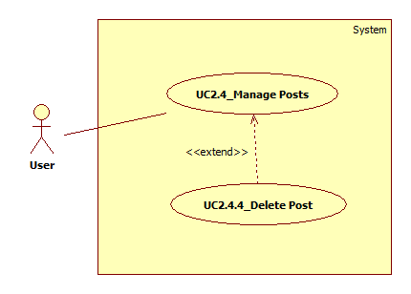

Figure : <User> Delete Post UC

|  |  |  |  |  |  |
| --- | --- | --- | --- | --- | --- |
| **USE CASE – UC_2.4.4_Delete Post** | | | | | |
| **Use Case No.** | UC_2.4.4 | **Use Case Version** | | 1.0 | |
| **Use Case Name** | Delete Post | | | | |
| **Author** | Dinh Cong Duc | | | | |
| **Date** | 05/06/2017 | | **Priority** | | Normal |
| **Actor:**   * User   **Summary:**   * This use case allows User to delete posts that they posted.   **Goal:**   * User can delete quickly their posts.   **Triggers:**   * User clicks “QUẢN LÝ BÀI ĐĂNG” hyberlink on home page. * User clicks “Xóa bài viết” in menu drop down.   **Preconditions:**   * Actor must be logged in the system with User role.   **Post Conditions:**   * **Success:** Post has been deleted. * **Fail:** System shows error message on screen.   **Main Success Scenario:**   |  |  |  | | --- | --- | --- | | **Step** | **Actor Action** | **System Response** | | 1 | User clicks “QUẢN LÝ BÀI ĐĂNG” hyberlink on home page. | System shows a list all posts that they posted.  [Exception 1] | | 2 | User clicks “Xóa bài viết” in menu drop down. | System shows message: “Sửa thành công!”.  System deletes this post. |   **Alternative:** N/A  **Exceptions 1:**   |  |  |  | | --- | --- | --- | | **Step** | **Cause** | **System Response** | | 1 | List of posts does not have posts. | System shows empty result. |   **Relationship:** <<extend>> Manage Profile  **Business Rules:**  - Deleting a post is turn this post into remove status.  **-** Deleted post cannot change status. | | | | | |

Table : <User> Delete Post UC

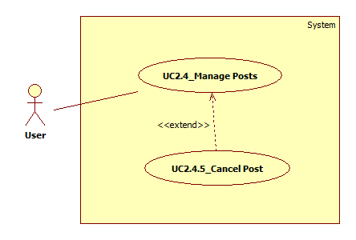

Figure : <User> Cancel Post UC

|  |  |  |  |  |  |
| --- | --- | --- | --- | --- | --- |
| **USE CASE – UC_2.4.5_Cancel Post** | | | | | |
| **Use Case No.** | UC_2.4.5 | **Use Case Version** | | 1.0 | |
| **Use Case Name** | Cancel Post | | | | |
| **Author** | Dinh Cong Duc | | | | |
| **Date** | 05/06/2017 | | **Priority** | | Normal |
| **Actor:**   * User   **Summary:**   * This use case allows User to cancel post what does not display in system.   **Goal:**   * User can cancel post what does not display.   **Triggers:**   * User clicks “QUẢN LÝ BÀI ĐĂNG” hyberlink on home page. * User clicks “Tạm dừng” in menu drop down.   **Preconditions:**   * Actor must be logged in the system with User role.   **Post Conditions:**   * **Success:** Canceled post cannot be displayed. * **Fail:** System shows error message on screen.   **Main Success Scenario:**   |  |  |  | | --- | --- | --- | | **Step** | **Actor Action** | **System Response** | | 1 | User clicks “QUẢN LÝ BÀI ĐĂNG” hyberlink on home page. | System shows a list all posts that they posted.  [Exception 1] | | 2 | User clicks “Tạm dừng” in menu drop down.  [Alternative 1] | System shows message: “Sửa thành công!”.  System changes this post to stopped status. The post cannot display. |   **Alternative 1:**   |  |  |  | | --- | --- | --- | | **Step** | **Cause** | **System Response** | | 1 | User clicks “Chạy lại” in menu drop down. | System shows message: “Sửa thành công”.  System changes this post status. The post can display. |   **Exceptions 1:**   |  |  |  | | --- | --- | --- | | **Step** | **Cause** | **System Response** | | 1 | List of posts does not have posts. | System shows empty result. |   **Relationship:** <<extend>> Manage Posts  **Business Rules:**  - Canceled post cannot display or search.  - Canceled post can open to display in the system. | | | | | |

Table : <User> Cancel Post UC

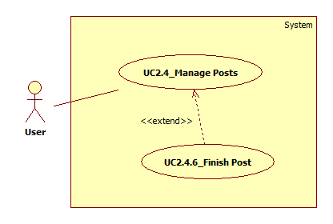

Figure : <User> Finish Post UC

|  |  |  |  |  |  |
| --- | --- | --- | --- | --- | --- |
| **USE CASE – UC_2.4.6_Finish Post** | | | | | |
| **Use Case No.** | UC_2.4.6 | **Use Case Version** | | 1.0 | |
| **Use Case Name** | Finish Post | | | | |
| **Author** | Dinh Cong Duc | | | | |
| **Date** | 05/06/2017 | | **Priority** | | Normal |
| **Actor:**   * User   **Summary:**   * This use case allows User to finish post after successful transaction.   **Goal:**   * User can finish post.   **Triggers:**   * User clicks “QUẢN LÝ BÀI ĐĂNG” hyberlink on home page. * User clicks “Đã kết thúc” in menu drop down.   **Preconditions:**   * Actor must be logged in the system with User role. * The post must be matching or matched status.   **Post Conditions:**   * **Success:** The post has been finished. * **Fail:** System shows error message on screen.   **Main Success Scenario:**   |  |  |  | | --- | --- | --- | | **Step** | **Actor Action** | **System Response** | | 1 | User clicks “QUẢN LÝ BÀI ĐĂNG” hyberlink on home page. | System shows a list all posts that they posted.  [Exception 1] | | 2 | User clicks “Đã kết thúc” in menu drop down. | System shows message: “Sửa thành công!”.  System changes this post to finished status. The post cannot display. |   **Alternative:** N/A  **Exceptions 1:**   |  |  |  | | --- | --- | --- | | **Step** | **Cause** | **System Response** | | 1 | List of posts does not have posts. | System shows empty result. |   **Relationship:** <<extend>> Manage Posts  **Business Rules:**  - The post must be matching or matched status.  - Finish post cannot open to display in the system. | | | | | |

Table : <User> Finish Post UC

* + - * 1. <User> Post Products

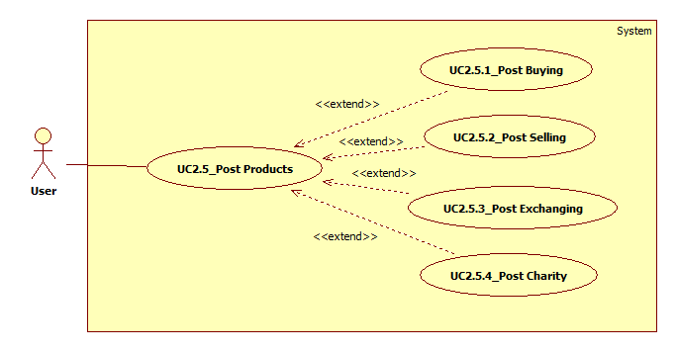

Figure : <User> Post Products UC

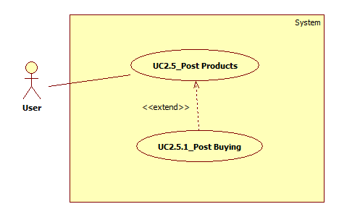

Figure : <User> Post Buying UC

|  |  |  |  |  |  |
| --- | --- | --- | --- | --- | --- |
| **USE CASE – UC2.5.1_Post Buying** | | | | | |
| **Use Case No.** | UC2.5.1 | **Use Case Version** | | 1.0 | |
| **Use Case Name** | Post Buying | | | | |
| **Author** | Dinh Cong Duc | | | | |
| **Date** | 05/06/2017 | | **Priority** | | High |
| **Actor:**   * User   **Summary:**   * This use case allows User to post products that they want to buy.   **Goal:**   * User can post products that they want to buy fast.   **Triggers:**   * User clicks “MUA” button on home page.   **Preconditions:**   * Actor must be logged in the system with User role.   **Post Conditions:**   * **Success:** Product is successfully posted. * **Fail:**  System shows error message on screen.   **Main Success Scenario:**   |  |  |  | | --- | --- | --- | | **Step** | **Actor Action** | **System Response** | | 1 | User clicks “MUA” button on home page. | System shows “ĐĂNG TÌM” screen with a form including:   * + Chọn danh mục: drop down   + Tên sản phẩm bạn cần: textbox   + Mô tả sản phẩm: textbox   + Giá: textbox   + Số điện thoại: textbox   + Vị trí của bạn: textbox   + Nhận thông báo: drop down   + Hình ảnh (tối đa 6 ảnh): image   + “THÔNG TIN NÂNG CAO” button   + Thẻ tag: textbox   + “ĐĂNG TIN” button | | 2 | User enters all required fields and clicks “ĐĂNG TIN” button.  [Alternative 1] | System validates all input fields.  [Exception 1]  System shows message: “Đăng bài thành công!”. |   **Alternative 1:**   |  |  |  | | --- | --- | --- | | **Step** | **Cause** | **System Response** | | 1 | User clicks other button. | System redirects User to that screen. |   **Exceptions 1:**   |  |  |  | | --- | --- | --- | | **Step** | **Cause** | **System Response** | | 1 | User enters invalid values or empty. | System shows error message invalid field(s) or empty: “Vui lòng nhập đầy đủ thông tin!”. |   **Relationship:** <<extend>> Post Products  **Business Rules:**  **-** The symbol (*) is required.  **-** A post buying can post up to six images.  **-** When a buying post has been posted, it is in examining status.  **-**  The time of post buying is 30 days, it can be extended. | | | | | |

Table : <User> Post Buying UC

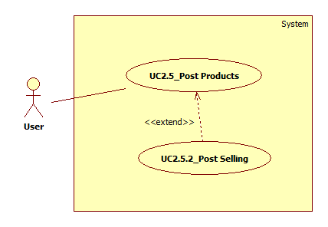

Figure : <User> Post Selling UC

|  |  |  |  |  |  |
| --- | --- | --- | --- | --- | --- |
| **USE CASE – UC_2.5.2_Post Selling** | | | | | |
| **Use Case No.** | UC_2.5.2 | **Use Case Version** | | 1.0 | |
| **Use Case Name** | Post Selling | | | | |
| **Author** | Dinh Cong Duc | | | | |
| **Date** | 05/06/2017 | | **Priority** | | High |
| **Actor:**   * User   **Summary:**   * This use case allows User to post products that they want to sell.   **Goal:**   * User can post products that they want to sell fast.   **Triggers:**   * User clicks “BÁN” button on home page.   **Preconditions:**   * Actor must be logged in the system with User role.   **Post Conditions:**   * **Success:** Product is successfully posted. * **Fail:** System shows error message on screen.   **Main Success Scenario:**   |  |  |  | | --- | --- | --- | | **Step** | **Actor Action** | **System Response** | | 1 | User clicks “BÁN” button on home page. | System shows “ĐĂNG TIN” screen with a form including:   * + Chọn danh mục: drop down   + Tên sản phẩm của bạn: textbox   + Mô tả sản phẩm: textbox   + Giá: textbox   + Số điện thoại liên hệ: textbox   + Vị trí của bạn: textbox   + Nhận thông báo: drop down   + Hình ảnh (tối đa 6 ảnh): image   + “THÔNG TIN NÂNG CAO” button   + Thẻ tag: textbox   + “ĐĂNG TIN” button | | 2 | User enters all required fields and clicks “ĐĂNG TIN” button.  [Alternative 1] | System validates all input fields.  [Exception 1]  System shows message: “Đăng bài thành công!”. |   **Alternative 1:**   |  |  |  | | --- | --- | --- | | **Step** | **Cause** | **System Response** | | 1 | User clicks other button. | System redirects User to that screen. |   **Exceptions 1:**   |  |  |  | | --- | --- | --- | | **Step** | **Cause** | **System Response** | | 1 | User enters invalid values or empty. | System shows error message invalid field(s) or empty: “Vui lòng nhập đầy đủ thông tin!”. |   **Relationship:** <<extend>> Post Products  **Business Rules:**  **-** The symbol (*) is required.  **-** A post selling can post up to six images.  **-** When a selling post has been posted, it is in examining status.  **-** The time of post buying is 30 days, it can be extended. | | | | | |

Table : <User> Post Selling UC

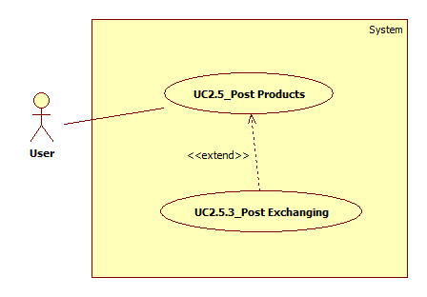

Figure : <User> Post Exchanging UC

|  |  |  |  |  |  |
| --- | --- | --- | --- | --- | --- |
| **USE CASE – UC_2.5.3_Post Exchanging** | | | | | |
| **Use Case No.** | UC_2.5.3 | **Use Case Version** | | 1.0 | |
| **Use Case Name** | Post Exchanging | | | | |
| **Author** | Dinh Cong Duc | | | | |
| **Date** | 05/06/2017 | | **Priority** | | High |
| **Actor:**   * User   **Summary:**   * This use case allows User to post products that they want to exchange with other products.   **Goal:**   * User can post products that they want to exchange fast.   **Triggers:**   * User clicks “TRAO ĐỔI” button on home page.   **Preconditions:**   * Actor must be logged in the system with User role.   **Post Conditions:**   * **Success:** Product is successfully posted. * **Fail:** System shows error message on screen.   **Main Success Scenario:**   |  |  |  | | --- | --- | --- | | **Step** | **Actor Action** | **System Response** | | 1 | User clicks “TRAO ĐỔI” button on home page. | System shows “TRAO ĐỔI” screen with two tab. “TÔI CẦN” tab form including:   * + Chọn danh mục: drop down   + Tên sản phẩm bạn cần: textbox   + Mô tả sản phẩm: textbox   + Số điện thoại: textbox   + Vị trí của bạn: textbox   + Nhận thông báo: drop down   + Hình ảnh (tối đa 6 ảnh): image   + “THÔNG TIN NÂNG CAO” button   + Thẻ tag: textbox   + “ĐĂNG TIN” button | | 2 | User enters all required fields of “TÔI CẦN” tab. |  | | 3 | User clicks “TÔI CÓ” tab. | System shows “TÔI CÓ” tab form including:   * + Tên sản phẩm bạn cần: textbox   + Mô tả sản phẩm: textbox   + Số điện thoại: textbox   + Vị trí của bạn: textbox   + Nhận thông báo: drop down   + Hình ảnh (tối đa 6 ảnh): image   + “THÔNG TIN NÂNG CAO” button   + Thẻ tag: textbox   + “ĐĂNG TIN” button | | 4 | User enters all required fields of “TÔI CÓ” tab and click “ĐĂNG TIN” button.  [Alternative 1] | System validates all input fields.  [Exception 1]  System shows message: “Đăng bài thành công!”. |   **Alternative 1:**   |  |  |  | | --- | --- | --- | | **Step** | **Cause** | **System Response** | | 1 | User clicks other button. | System redirects User to that screen. |   **Exceptions 1:**   |  |  |  | | --- | --- | --- | | **Step** | **Cause** | **System Response** | | 1 | User enters invalid values or empty. | System shows error message invalid field(s) or empty: “Vui lòng nhập đầy đủ thông tin!”. |   **Relationship:** <<extend>> Post Products  **Business Rules:**  **-** The symbol (*) is required.  **-** A post exchanging can post up to six images.  **-** When an exchanging post has been posted, it is in examining status.  **-** The time of post exchanging is 30 days, it can be extended. | | | | | |

Table : <User> Post Exchanging UC

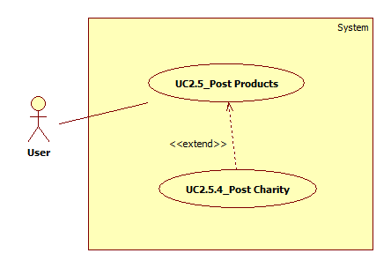

Figure : <User> Post Charity UC

|  |  |  |  |  |  |
| --- | --- | --- | --- | --- | --- |
| **USE CASE – UC_2.5.4_Post Charity** | | | | | |
| **Use Case No.** | UC_2.5.4 | **Use Case Version** | | 1.0 | |
| **Use Case Name** | Post Charity | | | | |
| **Author** | Dinh Cong Duc | | | | |
| **Date** | 05/06/2017 | | **Priority** | | Normal |
| **Actor:**   * User   **Summary:**   * This use case allows User to post products that they want to help charity campaigns.   **Goal:**   * User can post products that they want to help charity campaigns.   **Triggers:**   * User clicks “SỰ KIỆN” button on home page. * User clicks a charity campaign. * User clicks “ỦNG HỘ NGAY” button.   **Preconditions:**   * Actor must be logged in the system with User role.   **Post Conditions:**   * **Success:** Product is successfully posted. * **Fail:** System shows error message on screen.   **Main Success Scenario:**   |  |  |  | | --- | --- | --- | | **Step** | **Actor Action** | **System Response** | | 1 | User clicks “SỰ KIỆN” button on home page. | System shows a list of existing charity campaigns.  [Exception 1] | | 2 | User chooses a charity event. | System shows detail information of this event. | | 3 | User clicks “ỦNG HỘ NGAY” button. | System shows “Đăng tin từ thiện” screen with a form including:   * + Chọn danh mục: drop down   + Tên sản phẩm của bạn: textbox   + Mô tả sản phẩm: textbox   + Số điện thoại liên hệ: textbox   + Vị trí của bạn: textbox   + Hình ảnh (tối đa 6 ảnh): image   + “THÔNG TIN NÂNG CAO” button   + Thẻ tag: textbox   + “ĐĂNG TIN” button | | 3 | User enters all required fields and clicks “ĐĂNG TIN” button.  [Alternative 1] | System validates all input fields.  [Exception 2]  System shows message: “Đăng bài thành công!”. |   **Alternative 1:**   |  |  |  | | --- | --- | --- | | **Step** | **Cause** | **System Response** | | 1 | User clicks “X” icon button. | System closes “Đăng tin từ thiện” screen. |   **Exceptions 1:**   |  |  |  | | --- | --- | --- | | **Step** | **Cause** | **System Response** | | 1 | List of charity campaigns does not have campaign. | System shows empty result. |   **Exceptions 2:**   |  |  |  | | --- | --- | --- | | **Step** | **Cause** | **System Response** | | 1 | User enters invalid values or empty. | System shows error message invalid field(s) or empty: “Vui lòng nhập đầy đủ thông tin!”. |   **Relationship:** <<extend>> Post Products  **Business Rules:**  **-** The symbol (*) is required.  **-** A post charity can post up to six images.  **-** When a charity post has been posted, it is in donated status. | | | | | |

Table : <User> Post Charity UC

* + - * 1. <User> Feedback Posts

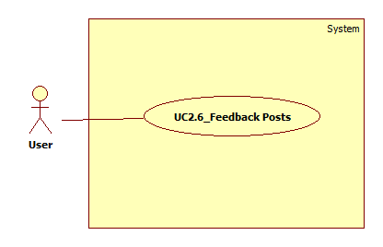

Figure : <User> Feedback Posts UC

|  |  |  |  |  |  |
| --- | --- | --- | --- | --- | --- |
| **USE CASE – UC2.6_Feedback Posts** | | | | | |
| **Use Case No.** | UC2.6 | **Use Case Version** | | 1.0 | |
| **Use Case Name** | Feedback Posts | | | | |
| **Author** | Dinh Cong Duc | | | | |
| **Date** | 05/06/2017 | | **Priority** | | Normal |
| **Actor:**   * User   **Summary:**   * This use case allows User to feedback their comments with posts for Admin of the system.   **Goal:**   * User can feedback posts for Admin.   **Triggers:**   * User clicks “Báo cáo bài viết” button.   **Preconditions:**   * Actor must be logged in the system with User role.   **Post Conditions:**   * **Success:** Feedback sent for Admin of system. * **Fail:**  System shows error message on screen.   **Main Success Scenario:**   |  |  |  | | --- | --- | --- | | **Step** | **Actor Action** | **System Response** | | 1 | User clicks a post. | System shows detail information of this post. | | 2 | User clicks “Báo cáo bài viết” button. | System shows a list of problems in the post. | | 3 | User chooses a problem and clicks “GỬI BÁO CÁO” button.  [Alternative 1] | Feedback has been sent for Admin of the system. |   **Alternative 1:**   |  |  |  | | --- | --- | --- | | **Step** | **Cause** | **System Response** | | 1 | User clicks “Close” icon button. | Close feedback. |   **Exceptions:** N/A  **Relationship:** N/A  **Business Rules:** N/A | | | | | |

Table : <User> Feedback Posts UC

* + - * 1. <User> Comment Posts

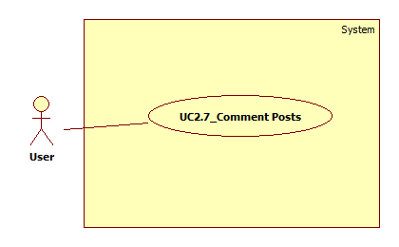

Figure : <User> Comment Posts UC

|  |  |  |  |  |  |
| --- | --- | --- | --- | --- | --- |
| **USE CASE – UC_2.7_Comment Posts** | | | | | |
| **Use Case No.** | UC_2.7 | **Use Case Version** | | 1.0 | |
| **Use Case Name** | Comment Posts | | | | |
| **Author** | Dinh Cong Duc | | | | |
| **Date** | 05/06/2017 | | **Priority** | | Normal |
| **Actor:**   * User   **Summary:**   * This use case allows User to comment posts of the system.   **Goal:**   * User can comment posts of the system.   **Triggers:**   * User clicks a post. * User inputs content and clicks “Enter” on keyboard.   **Preconditions:**   * Actor must be logged in the system with User role.   **Post Conditions:**   * **Success:** Comment has been posted. * **Fail:** System shows error message on screen.   **Main Success Scenario:**   |  |  |  | | --- | --- | --- | | **Step** | **Actor Action** | **System Response** | | 1 | User clicks a post. | System shows post detail of this post. | | 2 | User enters content of comment and clicks “Enter” on keyboard.  [Alternative 1] | System shows comment on this post. |   **Alternative 1:**   |  |  |  | | --- | --- | --- | | **Step** | **Cause** | **System Response** | | 1 | User does not input content of comment. | Comment dose not send. |   **Exceptions:** N/A  **Relationship:** N/A  **Business Rules:**  - System supports comment one level.  - Receive notification when other users comment. | | | | | |

Table : <User> Comment Posts UC

* + - * 1. <User> Chat with other Users

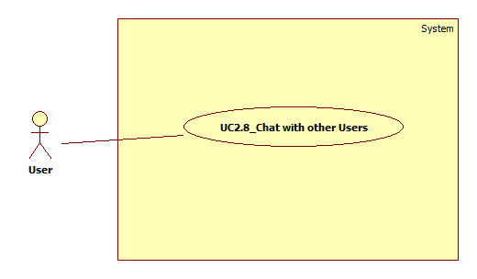

Figure : <User> Chat with other Users UC

|  |  |  |  |  |  |
| --- | --- | --- | --- | --- | --- |
| **USE CASE – UC2.8_ Chat with other Users** | | | | | |
| **Use Case No.** | UC2.8 | **Use Case Version** | | 1.0 | |
| **Use Case Name** | Chat with other Users | | | | |
| **Author** | Dinh Cong Duc | | | | |
| **Date** | 05/06/2017 | | **Priority** | | Normal |
| **Actor:**   * User   **Summary:**   * This use case allows User to chat with other users.   **Goal:**   * User can chat real time with other users.   **Triggers:**   * User clicks a post. * User inputs content and clicks send icon.   **Preconditions:**   * Actor must be logged in the system with User role.   **Post Conditions:**   * **Success:** Message sent successfully. * **Fail:**  System shows error message on screen.   **Main Success Scenario:**   |  |  |  | | --- | --- | --- | | **Step** | **Actor Action** | **System Response** | | 1 | User clicks a post.  [Alternative 1] | System shows post detail of this post. | | 2 | User inputs content and clicks send icon.  [Alternative 2] | System sends the message content successfully. |   **Alternative 1:**   |  |  |  | | --- | --- | --- | | **Step** | **Cause** | **System Response** | | 1 | User click “TIN NHẮN” hyberlink on home page. | System shows a chat history list. |   **Alternative 2:**   |  |  |  | | --- | --- | --- | | **Step** | **Cause** | **System Response** | | 1 | User does not input content and send message. | System shows chatbox with that user. |   **Exceptions:** N/A  **Relationship:** N/A  **Business Rules:**  - Receive notification when other users send message. | | | | | |

Table : <User> Chat with other Users UC

* + - * 1. <User> Match Posts

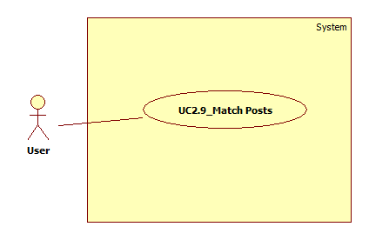

Figure : <User> Match Posts UC

|  |  |  |  |  |  |
| --- | --- | --- | --- | --- | --- |
| **USE CASE – UC2.9_Match Posts** | | | | | |
| **Use Case No.** | UC2.9 | **Use Case Version** | | 1.0 | |
| **Use Case Name** | Match Posts | | | | |
| **Author** | Dinh Cong Duc | | | | |
| **Date** | 05/06/2017 | | **Priority** | | Normal |
| **Actor:**   * User   **Summary:**   * This use case allows User to connect a post with related posts.   **Goal:**   * User can quickly connect a post with related posts.   **Triggers:**   * User clicks a post.   **Preconditions:**   * Actor must be logged in the system with User role.   **Post Conditions:**   * **Success:** System shows related posts. * **Fail:**  System shows error message on screen.   **Main Success Scenario:**   |  |  |  | | --- | --- | --- | | **Step** | **Actor Action** | **System Response** | | 1 | User clicks a post. | System shows post detail of this post. | | 2 | User sees related posts. | System shows related posts.  [Exception 1] |   **Alternative:** N/A  **Exceptions 1:**   |  |  |  | | --- | --- | --- | | **Step** | **Cause** | **System Response** | | 1 | A post does not have related posts. | System shows empty result. |   **Relationship:** N/A  **Business Rules:**  - Related posts are matched by tags that are entered when posting. | | | | | |

Table : <User> Match Posts UC

* + - 1. Administrator Overview Use Case

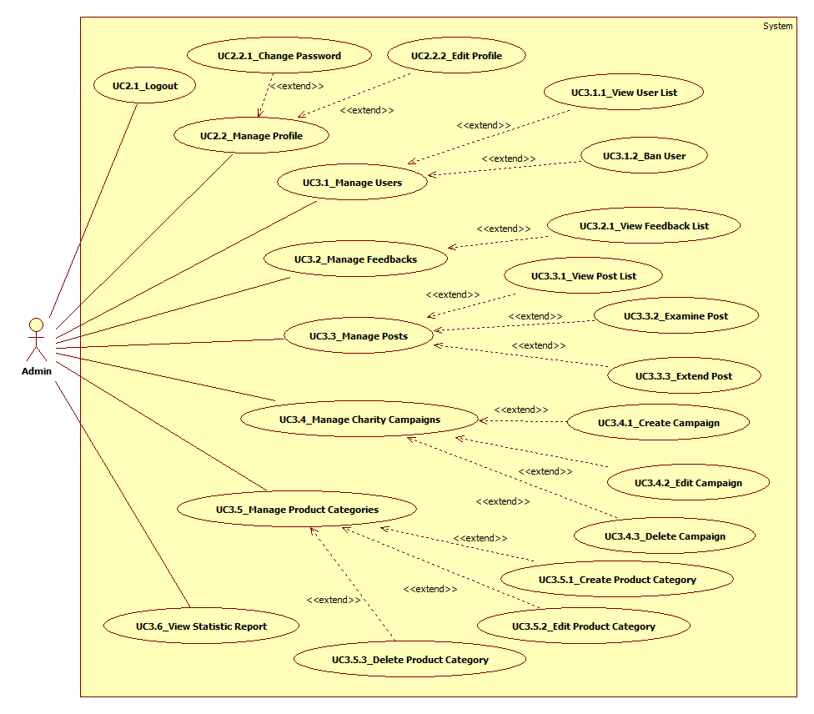

Figure : Administrator Overview UC

* + - * 1. <Admin> Manage Users

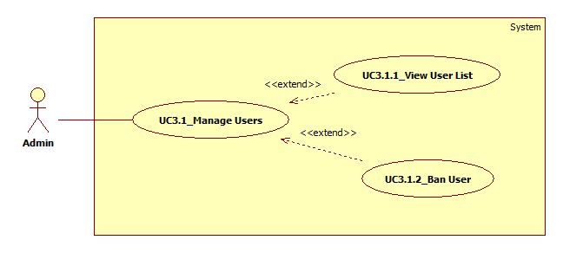

Figure : <Admin> Manage Users UC

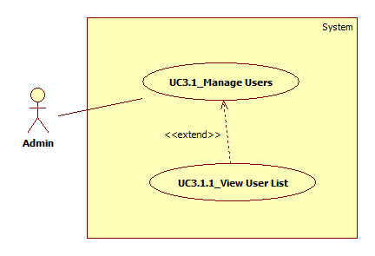

Figure : <Admin> View User List UC

|  |  |  |  |  |  |
| --- | --- | --- | --- | --- | --- |
| **USE CASE – UC3.1.1_View User List** | | | | | |
| **Use Case No.** | UC3.1.1 | **Use Case Version** | | 1.0 | |
| **Use Case Name** | View User List | | | | |
| **Author** | Dinh Cong Duc | | | | |
| **Date** | 05/06/2017 | | **Priority** | | Normal |
| **Actor:**   * Admin   **Summary:**   * This use case allows Admin to view list all users of the system.   **Goal:**   * Admin can view list all users of the system.   **Triggers:**   * Admin clicks “Người dùng” button on admin page.   **Preconditions:**   * Actor must be logged in the system with Admin role.   **Post Conditions:**   * **Success:** List all users is displayed. * **Fail:**  System shows error message on screen.   **Main Success Scenario:**   |  |  |  | | --- | --- | --- | | **Step** | **Actor Action** | **System Response** | | 1 | Admin clicks “Người dùng” button on admin page.  [Alternative 1] | System shows list all users of the system.  [Exception 1] |   **Alternative 1:**   |  |  |  | | --- | --- | --- | | **Step** | **Cause** | **System Response** | | 1 | Admin clicks other button. | System redirects Admin to that screen. |   **Exceptions 1:**   |  |  |  | | --- | --- | --- | | **Step** | **Cause** | **System Response** | | 1 | List of users does not have user. | System shows empty result. |   **Relationship:** <<extend>> Manage Users  **Business Rules:** N/A | | | | | |

Table : <Admin> View User List UC

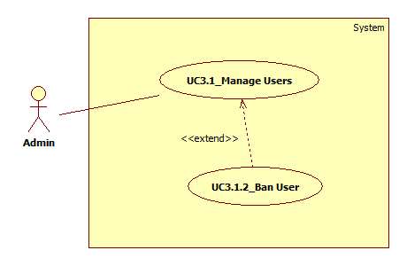

Figure : <Admin> Ban User UC

|  |  |  |  |  |  |
| --- | --- | --- | --- | --- | --- |
| **USE CASE – UC3.1.2_Ban User** | | | | | |
| **Use Case No.** | UC3.1.2 | **Use Case Version** | | 1.0 | |
| **Use Case Name** | Ban User | | | | |
| **Author** | Dinh Cong Duc | | | | |
| **Date** | 05/06/2017 | | **Priority** | | Normal |
| **Actor:**   * Admin   **Summary:**   * This use case allows Admin to ban user of the system.   **Goal:**   * Admin can ban user of the system.   **Triggers:**   * Admin clicks “Người dùng” button on admin page. * Admin clicks “Ban” icon button.   **Preconditions:**   * Actor must be logged in the system with Admin role.   **Post Conditions:**   * **Success:** User has been banned. * **Fail:**  System shows error message on screen.   **Main Success Scenario:**   |  |  |  | | --- | --- | --- | | **Step** | **Actor Action** | **System Response** | | 1 | Admin clicks “Người dùng” button on admin page.  [Alternative 1] | System shows list all users of the system.  [Exception 1] | | 2 | Admin chooses a user and clicks “Khóa người dùng” icon button. | System shows notification: “Người dùng này sẽ bị khóa?”. | | 3 | Admin clicks “Đồng ý!”.  [Alternative 2] | System shows “Đã khóa!”.  User is banned. |   **Alternative 1:**   |  |  |  | | --- | --- | --- | | **Step** | **Cause** | **System Response** | | 1 | Admin clicks other button. | System redirects Admin to that screen. |   **Alternative 2:**   |  |  |  | | --- | --- | --- | | **Step** | **Cause** | **System Response** | | 1 | Admin clicks “Hủy”. | User is not banned. |   **Exceptions 1:**   |  |  |  | | --- | --- | --- | | **Step** | **Cause** | **System Response** | | 1 | List of users does not have user. | System shows empty result. |   **Relationship:** <<extend>> Manage Users  **Business Rules:**  - The banned user will not be able to log in to the system. | | | | | |

Table : <Admin> Ban User UC

* + - * 1. <Admin> Manage Feedbacks

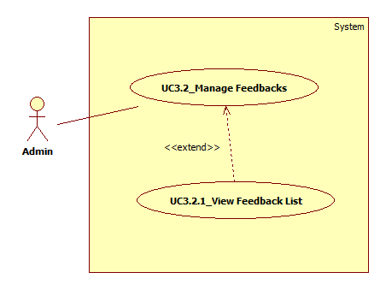

Figure : <Admin> Manage Feedbacks UC



Figure : <Admin> View Feedback List UC

|  |  |  |  |  |  |
| --- | --- | --- | --- | --- | --- |
| **USE CASE – UC3.2.1_View Feedback List** | | | | | |
| **Use Case No.** | UC3.2.1 | **Use Case Version** | | 1.0 | |
| **Use Case Name** | View Feedback List | | | | |
| **Author** | Dinh Cong Duc | | | | |
| **Date** | 05/06/2017 | | **Priority** | | Normal |
| **Actor:**   * Admin   **Summary:**   * This use case allows Admin to view list all feedbacks of the system.   **Goal:**   * Admin can view list all feedbacks of the system.   **Triggers:**   * Admin clicks “Khiếu nại” button on admin page. * Admin clicks “Phản hồi” icon button.   **Preconditions:**   * Actor must be logged in the system with Admin role.   **Post Conditions:**   * **Success:** List all feedbacks is displayed. * **Fail:**  System shows error message on screen.   **Main Success Scenario:**   |  |  |  | | --- | --- | --- | | **Step** | **Actor Action** | **System Response** | | 1 | Admin clicks “Khiếu nại” button on admin page.  [Alternative 1] | System shows list all posts of the system.  [Exception 1] | | 2 | Admin clicks “Phản hồi” icon button | System shows list all feedbacks of this post.  [Exception 2] |   **Alternative 1:**   |  |  |  | | --- | --- | --- | | **Step** | **Cause** | **System Response** | | 1 | Admin clicks other button. | System redirects Admin to that screen. |   **Exceptions 1:**   |  |  |  | | --- | --- | --- | | **Step** | **Cause** | **System Response** | | 1 | List of posts does not have post. | System shows empty result. |   **Exceptions 2:**   |  |  |  | | --- | --- | --- | | **Step** | **Cause** | **System Response** | | 1 | List of feedbacks does not have feedback. | System shows empty result. |   **Relationship:** <<extend>> Manage Feedbacks  **Business Rules:** N/A | | | | | |

Table : <Admin> View Feedback List UC

* + - * 1. <Admin> Manage Posts

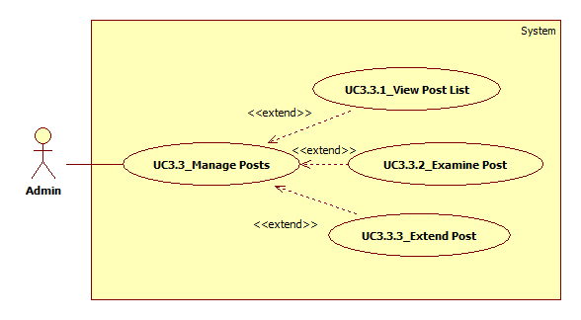

Figure : <Admin> Manage Posts UC

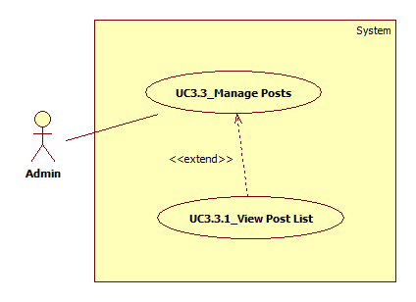

Figure : <Admin> View Post List UC

|  |  |  |  |  |  |
| --- | --- | --- | --- | --- | --- |
| **USE CASE – UC3.3.1_View Post List** | | | | | |
| **Use Case No.** | UC3.3.1 | **Use Case Version** | | 1.0 | |
| **Use Case Name** | View Post List | | | | |
| **Author** | Dinh Cong Duc | | | | |
| **Date** | 05/06/2017 | | **Priority** | | Normal |
| **Actor:**   * Admin   **Summary:**   * This use case allows Admin to view list all posts of the system.   **Goal:**   * Admin can view list all posts of the system.   **Triggers:**   * Admin clicks “Bài đăng” button on admin page.   **Preconditions:**   * Actor must be logged in the system with Admin role.   **Post Conditions:**   * **Success:** List all posts is displayed. * **Fail:**  System shows error message on screen.   **Main Success Scenario:**   |  |  |  | | --- | --- | --- | | **Step** | **Actor Action** | **System Response** | | 1 | Admin clicks “Bài đăng” button on admin page.  [Alternative 1] | System shows list all posts of the system.  [Exception 1] |   **Alternative 1:**   |  |  |  | | --- | --- | --- | | **Step** | **Cause** | **System Response** | | 1 | Admin clicks other button. | System redirects Admin to that screen. |   **Exceptions 1:**   |  |  |  | | --- | --- | --- | | **Step** | **Cause** | **System Response** | | 1 | List of posts does not have post. | System shows empty result. |   **Relationship:** <<extend>> Manage Posts  **Business Rules:** N/A | | | | | |

Table : <Admin> View Post List UC

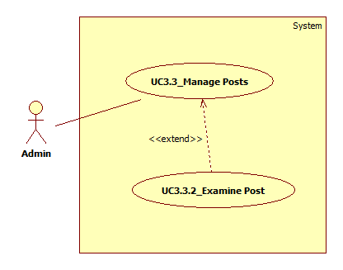

Figure : <Admin> Examine Post UC

|  |  |  |  |  |  |
| --- | --- | --- | --- | --- | --- |
| **USE CASE – UC3.3.2_Examine Post** | | | | | |
| **Use Case No.** | UC3.3.2 | **Use Case Version** | | 1.0 | |
| **Use Case Name** | Examine Post | | | | |
| **Author** | Dinh Cong Duc | | | | |
| **Date** | 05/06/2017 | | **Priority** | | High |
| **Actor:**   * Admin   **Summary:**   * This use case allows Admin to examine a new post of the system.   **Goal:**   * Admin can examine a new post.   **Triggers:**   * Admin clicks “Bài đăng” button on admin page. * Admin clicks “Duyệt bài” icon button.   **Preconditions:**   * Actor must be logged in the system with Admin role. * The post must be examining status.   **Post Conditions:**   * **Success:** The post was approved. * **Fail:**  System shows error message on screen.   **Main Success Scenario:**   |  |  |  | | --- | --- | --- | | **Step** | **Actor Action** | **System Response** | | 1 | Admin clicks “Bài đăng” button on admin page.  [Alternative 1] | System shows list all posts of the system.  [Exception 1] | | 2 | Admin chooses a post and clicks “Duyệt bài” icon button | System shows notification: “Bạn sẽ duyệt bài đăng này?”. | | 3 | Admin clicks “Duyệt!”.  [Alternative 2] | System shows: “Đã duyệt!”  Post is approved. |   **Alternative 1:**   |  |  |  | | --- | --- | --- | | **Step** | **Cause** | **System Response** | | 1 | Admin clicks other button. | System redirects Admin to that screen. |     **Alternative 2:**   |  |  |  | | --- | --- | --- | | **Step** | **Cause** | **System Response** | | 1 | Admin clicks “Hủy”. | Post is not approved. |   **Exceptions 1:**   |  |  |  | | --- | --- | --- | | **Step** | **Cause** | **System Response** | | 1 | List of posts does not have post. | System shows empty result. |   **Relationship:** <<extend>> Manage Posts  **Business Rules:**  **-** The post must be examining status.  **-** The approved posts will move to matching status. | | | | | |

Table : <Admin> Examine Post UC

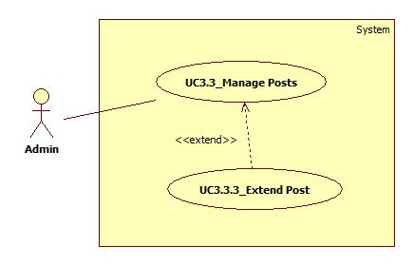

Figure : <Admin> Extend Post UC

|  |  |  |  |  |  |
| --- | --- | --- | --- | --- | --- |
| **USE CASE – UC3.3.3_Extend Post** | | | | | |
| **Use Case No.** | UC3.3.3 | **Use Case Version** | | 1.0 | |
| **Use Case Name** | Extend Post | | | | |
| **Author** | Dinh Cong Duc | | | | |
| **Date** | 05/06/2017 | | **Priority** | | Normal |
| **Actor:**   * Admin   **Summary:**   * This use case allows Admin to extend post that has expired.   **Goal:**   * Admin can extend post.   **Triggers:**   * Admin click “Bài đăng” button on admin page. * Admin click “Gia hạn” icon button.   **Preconditions:**   * Actor must be logged in the system with Admin role. * The post must be expired status.   **Post Conditions:**   * **Success:** The post was extended. * **Fail:**  System shows error message on screen.   **Main Success Scenario:**   |  |  |  | | --- | --- | --- | | **Step** | **Actor Action** | **System Response** | | 1 | Admin click “Bài đăng” button on admin page.  [Alternative 1] | System shows list all posts of the system.  [Exception 1] | | 2 | Admin chooses a post and clicks “Gia hạn” icon button. | System shows notification: “Bạn sẽ gia hạn cho bài đăng này?”. | | 3 | Admin clicks “Gia hạn!”.  [Alternative 2] | System shows: “Đã gia hạn!”  Post is extended. |   **Alternative 1:**   |  |  |  | | --- | --- | --- | | **Step** | **Cause** | **System Response** | | 1 | Admin clicks other button. | System redirects Admin to that screen. |   **Alternative 2:**   |  |  |  | | --- | --- | --- | | **Step** | **Cause** | **System Response** | | 1 | Admin clicks “Hủy”. | Post is not extended. |   **Exceptions 1:**   |  |  |  | | --- | --- | --- | | **Step** | **Cause** | **System Response** | | 1 | List of posts does not have post. | System shows empty result. |   **Relationship:** <<extend>> Manage Posts  **Business Rules:**  **-** Once extended for the post is seven days. | | | | | |

Table : <Admin> Extend Post UC

* + - * 1. <Admin> Manage Charity Campaigns

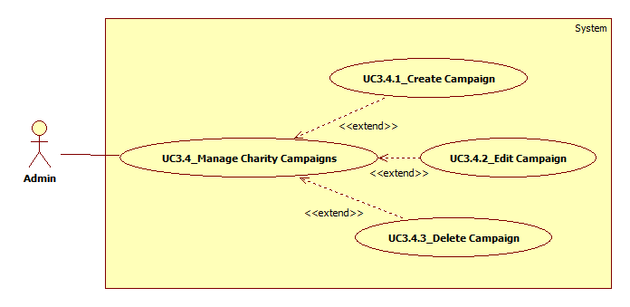

Figure : <Admin> Manage Posts UC

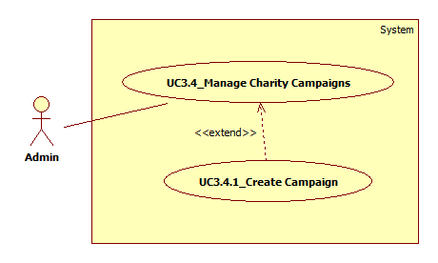

Figure : <Admin> Create Campaign UC

|  |  |  |  |  |  |
| --- | --- | --- | --- | --- | --- |
| **USE CASE – UC3.4.1_Create Campaign** | | | | | |
| **Use Case No.** | UC3.4.1 | **Use Case Version** | | 1.0 | |
| **Use Case Name** | Create Campaign | | | | |
| **Author** | Dinh Cong Duc | | | | |
| **Date** | 05/06/2017 | | **Priority** | | Normal |
| **Actor:**   * Admin   **Summary:**   * This use case allows Admin to create a new charity campaign in the system.   **Goal:**   * Admin can create a new charity campaign.   **Triggers:**   * Admin clicks “Sự kiện” button on admin page. * Admin clicks “Thêm sự kiện” button.   **Preconditions:**   * Actor must be logged in the system with Admin role.   **Post Conditions:**   * **Success:** New charity campaign has been created. * **Fail:**  System shows error message on screen.   **Main Success Scenario:**   |  |  |  | | --- | --- | --- | | **Step** | **Actor Action** | **System Response** | | 1 | Admin clicks “Sự kiện” button on admin page.  [Alternative 1] | System shows list all charity campaigns of the system.  [Exception 1] | | 2 | Admin clicks “Thêm sự kiện” button. | System shows “Quản lý sự kiện” screen with a form including:   * + Tiêu đề: textbox   + Slogan: textbox   + Ngày bắt đầu: datetime format   + Ngày kết thúc: datetime format   + Ảnh đại diện: image   + Nội dung: textbox   + “Thêm” button | | 3 | Admin enters all required fields and clicks “Thêm” button. | System validates all input fields.  [Exception 2]  System shows message: “Đăng sự kiện thành công!” |   **Alternative 1:**   |  |  |  | | --- | --- | --- | | **Step** | **Cause** | **System Response** | | 1 | Admin clicks other button. | System redirects Admin to that screen. |   **Exceptions 1:**   |  |  |  | | --- | --- | --- | | **Step** | **Cause** | **System Response** | | 1 | List of charity campaigns does not have campaign. | System shows empty result. |   **Exceptions 2:**   |  |  |  | | --- | --- | --- | | **Step** | **Cause** | **System Response** | | 1 | Admin enters invalid values or empty. | System shows error message invalid field(s) or empty: “Vui lòng điền vào trường này”. |   **Relationship:** <<extend>> Manage Charity Campaigns  **Business Rules:**  **-** Title, slogan, start date and end date are required. | | | | | |

Table : <Admin> Create Campaign UC

* + - * 1. <Admin> Manage Product Categories

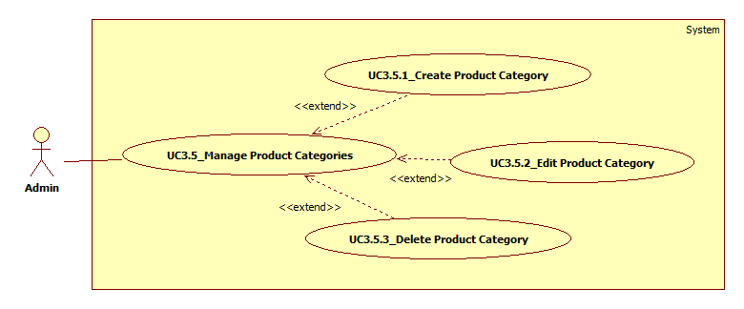

Figure : <Admin> Manage Product Categories UC

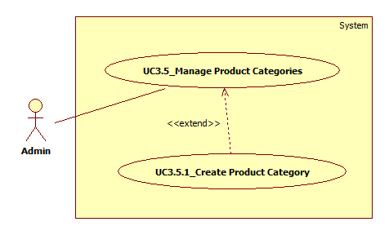

Figure : <Admin> Create Product Category UC

|  |  |  |  |  |  |
| --- | --- | --- | --- | --- | --- |
| **USE CASE – UC3.5.1_Create Product Category** | | | | | |
| **Use Case No.** | UC3.5.1 | **Use Case Version** | | 1.0 | |
| **Use Case Name** | Create Product Category | | | | |
| **Author** | Dinh Cong Duc | | | | |
| **Date** | 05/06/2017 | | **Priority** | | Normal |
| **Actor:**   * Admin   **Summary:**   * This use case allows Admin to create a new product category in the system.   **Goal:**   * Admin can create new product category.   **Triggers:**   * Admin clicks “Danh mục sản phẩm” button on admin page. * Admin clicks “Thêm danh mục sản phẩm” button.   **Preconditions:**   * Actor must be logged in the system with Admin role.   **Post Conditions:**   * **Success:** New product category has been created. * **Fail:**  System shows error message on screen.   **Main Success Scenario:**   |  |  |  | | --- | --- | --- | | **Step** | **Actor Action** | **System Response** | | 1 | Admin clicks “Danh mục sản phẩm” button on admin page.  [Alternative 1] | System shows list all product categories of the system.  [Exception 1] | | 2 | Admin clicks “Thêm danh mục sản phẩm” button. | System shows “Danh mục sản phẩm” screen with a form including:   * + Tên: textbox   + Hình ảnh: image   + “Thêm” button | | 3 | Admin enters all required fields and clicks “Thêm” button. | System validates all input fields.  [Exception 2]  System shows message: “Đăng thành công!” |   **Alternative 1:**   |  |  |  | | --- | --- | --- | | **Step** | **Cause** | **System Response** | | 1 | Admin clicks other button. | System redirects Admin to that screen. |   **Exceptions 1:**   |  |  |  | | --- | --- | --- | | **Step** | **Cause** | **System Response** | | 1 | List of product categories does not have product category. | System shows empty result. |   **Exceptions 2:**   |  |  |  | | --- | --- | --- | | **Step** | **Cause** | **System Response** | | 1 | Admin enters invalid values or empty. | System shows error message invalid field(s) or empty: “Vui lòng điền vào trường này”. |   **Relationship:** <<extend>> Manage Product Categories  **Business Rules:**  - Name of product category is required. | | | | | |

Table : <Admin> Create Product Category UC

* + - * 1. <Admin> View Statistic Report (chưa làm)

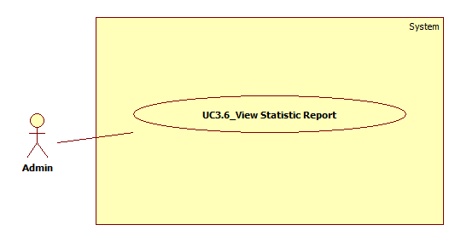

Figure : <Admin> View Statistic Report UC

|  |  |  |  |  |  |
| --- | --- | --- | --- | --- | --- |
| **USE CASE – UC3.6_View Statistic Report** | | | | | |
| **Use Case No.** | UC3.6 | **Use Case Version** | | 1.0 | |
| **Use Case Name** | View Statistic Report | | | | |
| **Author** | Dinh Cong Duc | | | | |
| **Date** | 05/06/2017 | | **Priority** | | Normal |
| **Actor:**   * Admin   **Summary:**   * This use case allows Admin to .   **Goal:**   * Loads Owner cancels an unmatched Order.   **Triggers:**   * Admin clicks “Trang chủ” button on admin page.   **Preconditions:**   * Actor must be logged in the system with Admin role. * Order must be unmatched (“Chưa có xe” or “Đã từ chối” status).   **Post Conditions:**   * **Success:** Order is canceled. * **Fail:**  System shows error message on screen.   **Main Success Scenario:**   |  |  |  | | --- | --- | --- | | **Step** | **Actor Action** | **System Response** | | 1 | Loads Owner clicks “Hủy đơn hàng” button on an Order in Order list. | System shows confirmation alert:   * + Message: “Bạn có chắc chắn muốn hủy đơn hàng này?”   + OK button   + Cancel button | | 2 | Loads Owner clicks “OK”.  [Alternative 1] | System updates selected Order and redirects Loads Owner to “Quản lí đơn hàng” screen. |   **Alternative 1:**   |  |  |  | | --- | --- | --- | | **Step** | **Cause** | **System Response** | | 1 | Loads Owner clicks “Cancel” button. | System closes confirmation alert. |   **Exceptions:** N/A  **Relationship:** N/A  **Business Rules:** N/A | | | | | |

Table : <Admin> View Statistic Report UC

1. Software Design Description
   1. Design Overview
      1. System Architectural Design

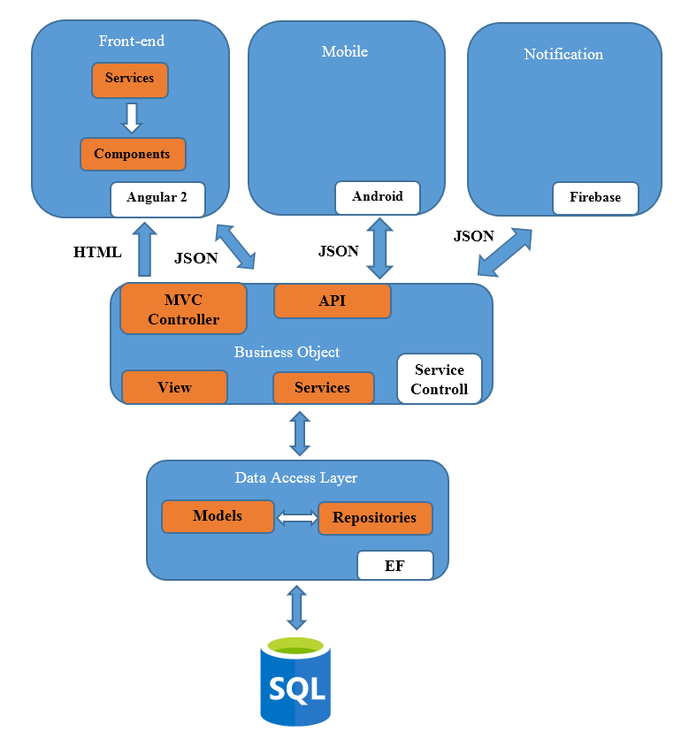

Figure : System Architecture

* + 1. System Architectural Description

The system uses a multi-layered architecture including:

* Data Access Layer: This layer contains entities and repository classes to access database (using Entity Framework).
* Business Layer: This layer contains business classes to handle business requirements and execute algorithm methods.
* Presentation Layer: This layer contains a Web application (MVC) using ASP.NET Core, Angular 2 and a Mobile application using Android (SDK 18 and above).
* Notification: This layer use external service of google platform to send and receive notification from server to client.

We are using Repository pattern to increase testability and have a loose coupling to underlying persistence technology.

* 1. Component Diagram
     1. Diagram

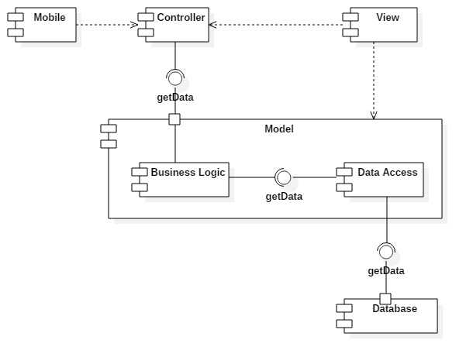

Figure : Component Diagram

* + 1. Components Dictionary

| **Components Dictionary: Describes components** | |
| --- | --- |
| Mobile | Component to use on mobile application |
| Controller | Component that handle request from web and mobile |
| View | Conponent contain all the view of the web |
| Business logic | Component to handle business logic of SEBS Server component |
| Data Access | Component that has model and repository that help interaction between the system and database |
| Database | Component to store data of system |
| Model | Component to controll the system. Contains sub component: Business Logic and Data Access |

Table : Components Dictionary

* 1. Class Diagram

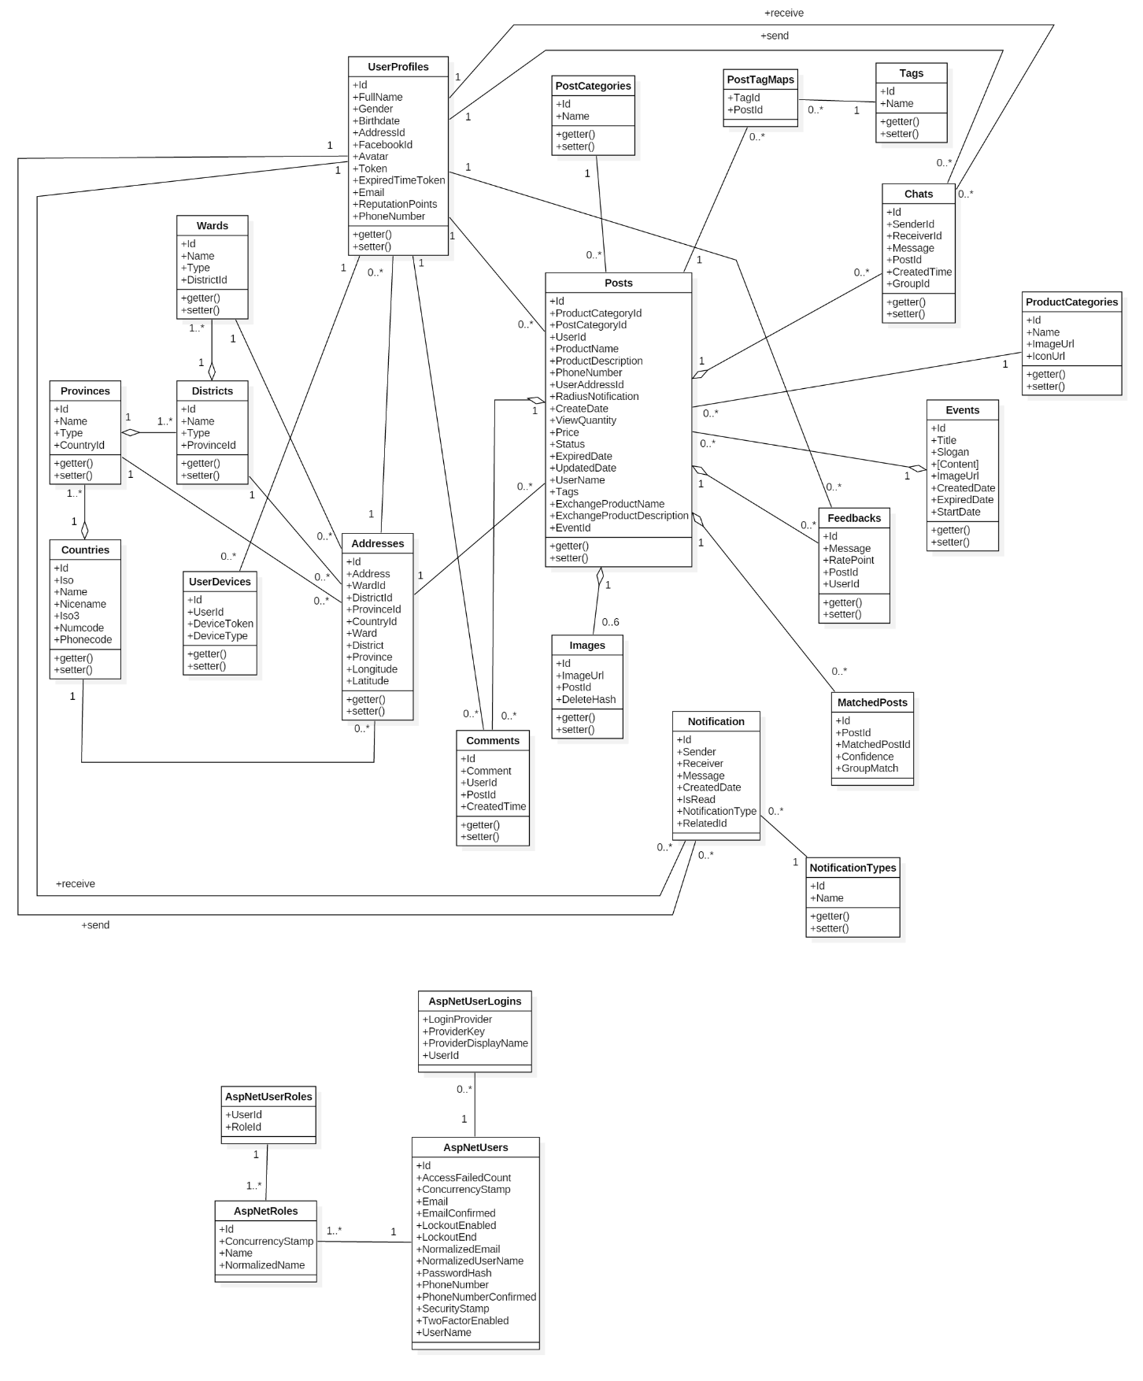

Figure : Class Diagram

* + 1. Class Diagram Explanation
       1. UserProfiles

|  |  |  |  |
| --- | --- | --- | --- |
| **Attribute** | **Type** | **Visibility** | **Description** |
| Id | Int | Public | Unique ID of each user |
| FullName | String | Public | Full name of this user |
| Gender | Int | Public | Gender of this user |
| Birthdate | Datetime | Public | Birthday of this user |
| AddressId | Int | Public | Id of address that user belongs to |
| FacebookId | String | Public | Id of Facebook when user login by Facebook |
| Avatar | String | Public | Avatar of this user |
| Token | String | Public | Token for authenticated user |
| ExpiredTimeToken | Datetime | Public | Time limit of token |
| Email | String | Public | Email of this user |
| ReputationPoints | Float | Public | Average rating point of user |
| PhoneNumber | String | Public | Phone number of this user |

* + - 1. Wards

|  |  |  |  |
| --- | --- | --- | --- |
| **Attribute** | **Type** | **Visibility** | **Description** |
| Id | Int | Public | Unique ID of each ward |
| Name | String | Public | Name of this ward |
| Type | String | Public | Type of this ward |
| DistrictId | Int | Public | Id of district that ward belongs to |

* + - 1. Districts

|  |  |  |  |
| --- | --- | --- | --- |
| **Attribute** | **Type** | **Visibility** | **Description** |
| Id | Int | Public | Unique ID of each district |
| Name | String | Public | Name of this district |
| Type | String | Public | Type of this district |
| ProvinceId | Int | Public | Id of province that district belongs to |

* + - 1. Provinces

|  |  |  |  |
| --- | --- | --- | --- |
| **Attribute** | **Type** | **Visibility** | **Description** |
| Id | Int | Public | Unique ID of each province |
| Name | Datetime | Public | Name of this province |
| Type | Datetime | Public | Type of this province |
| CountryId | Int | Public | Id of country that province belongs to |

* + - 1. Countries

|  |  |  |  |
| --- | --- | --- | --- |
| **Attribute** | **Type** | **Visibility** | **Description** |
| Id | Int | Public | Unique ID of each country |
| Iso | Char | Public | Abbreviation name of country (2 characters) |
| Name | String | Public | Name of this country |
| NiceName | String | Public | Official name of country |
| Iso3 | String | Public | Abbreviation name of country (3 characters) |
| Numcode | Int | Public | Numeric country code (iso3) |
| Phonecode | Int | Public | Telephone area code of country |

* + - 1. UserDevices

|  |  |  |  |
| --- | --- | --- | --- |
| **Attribute** | **Type** | **Visibility** | **Description** |
| Id | Int | Public | Unique ID of each user devices |
| UserId | Int | Public | Id of user that user device belongs to |
| DeviceToken | String | Public | Token of device for firebase send notification |
| DeviceType | Int | Public | Type of device such as mobile, desktop |

* + - 1. Addresses

|  |  |  |  |
| --- | --- | --- | --- |
| **Attribute** | **Type** | **Visibility** | **Description** |
| Id | Int | Public | Unique ID of each address |
| Address | String | Public | Address detail of this address |
| WardId | Int | Public | Id of ward that address belongs to |
| DistrictId | Int | Public | Id of district that address belongs to |
| ProvinceId | Int | Public | Id of province that address belongs to |
| CountryId | Int | Public | Id of country that address belongs to |
| Ward | String | Public | Ward of this address |
| District | String | Public | District of this address |
| Province | String | Public | Province of this address |
| Longitude | Float | Public | Longitude |
| Latitude | Float | Public | Latitude |

* + - 1. Comments

|  |  |  |  |
| --- | --- | --- | --- |
| **Attribute** | **Type** | **Visibility** | **Description** |
| Id | Int | Public | Unique ID of each comment |
| Comment | String | Public | Comment detail of this comment |
| UserId | Int | Public | Id of user that comment belongs to |
| PostId | Int | Public | Id of post that comment belongs to |
| CreatedTime | Datetime | Public | The time that comment was created |

* + - 1. Posts

|  |  |  |  |
| --- | --- | --- | --- |
| **Attribute** | **Type** | **Visibility** | **Description** |
| Id | Int | Public | Unique ID of each post |
| ProductCategoryId | Int | Public | Id of product category that post belongs to |
| PostCategoryId | Int | Public | Id of post category that post belongs to |
| UserId | Int | Public | Id of user that post belongs to |
| ProductName | String | Public | Product name of this post |
| ProductDescription | String | Public | Product description of this post |
| PhoneNumber | String | Public | Phone number of this post |
| UserAddressId | Int | Public | Id of user address that post belongs to |
| RadiusNotification | Int | Public | Radius receive notification |
| CreatDate | Datetime | Public | The time that post was created |
| ViewQuantity | Int | Public | Number of user view post |
| Price | Float | Public | Price of this post |
| Status | Int | Public | Status of this post |
| ExpiredDate | Datetime | Public | Expired time of this post |
| UpdatedDate | Datetime | Public | Updated time of this post |
| UserName | String | Public | Full name of user |
| Tags | String | Public | Tag of this post |
| ExchangeProductName | String | Public | Name of product for post exchanging |
| ExchangeProductDescription | String | Public | Description of product for post exchanging |
| EventId | Int | Public | Id of event that post belongs to |

* + - 1. Images

|  |  |  |  |
| --- | --- | --- | --- |
| **Attribute** | **Type** | **Visibility** | **Description** |
| Id | Int | Public | Unique ID of each image |
| ImageUrl | String | Public | The path contains the image |
| PostId | Int | Public | Id of post that image belongs to |
| DeleteHash | String | Public | Delete image on image url |

* + - 1. PostCategories

|  |  |  |  |
| --- | --- | --- | --- |
| **Attribute** | **Type** | **Visibility** | **Description** |
| Id | Int | Public | Unique ID of each post category |
| Name | Strong | Public | Name of this post category |

* + - 1. Chats

|  |  |  |  |
| --- | --- | --- | --- |
| **Attribute** | **Type** | **Visibility** | **Description** |
| Id | Int | Public | Unique ID of each chat |
| SenderId | Int | Public | Id of sender that chat belongs to |
| ReceiverId | Int | Public | Id of receiver that chat belongs to |
| Message | String | Public | Message detail of this chat |
| PostId | Int | Public | Id of post that chat belongs to |
| CreatedTime | Datetime | Public | Time to create a conversation |
| GroupId | String | Public | Group between two people chatting |

* + - 1. ProductCategories

|  |  |  |  |
| --- | --- | --- | --- |
| **Attribute** | **Type** | **Visibility** | **Description** |
| Id | Int | Public | Unique ID of each product category |
| Name | String | Public | Name of this product category |
| ImageUrl | String | Public | Image of this product category |
| IconUrl | String | Public | Icon of this product category in mobile |

* + - 1. Feedbacks

|  |  |  |  |
| --- | --- | --- | --- |
| **Attribute** | **Type** | **Visibility** | **Description** |
| Id | Int | Public | Unique ID of each feedback |
| Message | String | Public | Message detail of this feedback |
| RatePoint | Int | Public | Rate point of this feedback |
| PostId | Int | Public | Id of post that feedback belongs to |
| UserId | Int | Public | Id of user that feedback belongs to |

* + - 1. NotificationTypes

|  |  |  |  |
| --- | --- | --- | --- |
| **Attribute** | **Type** | **Visibility** | **Description** |
| Id | Int | Public | Unique ID of each notification type |
| Name | String | Public | Name of this notification type |

* + - 1. Notifications

|  |  |  |  |
| --- | --- | --- | --- |
| **Attribute** | **Type** | **Visibility** | **Description** |
| Id | Int | Public | Unique ID of each notification |
| Sender | Int | Public | Id of notification sender |
| Receiver | Int | Public | Id of notification receiver |
| Message | String | Public | Message detail of this notification |
| CreatedDate | Datetime | Public | The time that notification was created |
| IsRead | Bit | Public | Notification has been read or not |
| NotificationType | Int | Public | Id of notification type that notification belongs to |
| RelatedId | Int | Public | Id of related posts |

* + - 1. PostTagMaps

|  |  |  |  |
| --- | --- | --- | --- |
| **Attribute** | **Type** | **Visibility** | **Description** |
| TagId | Int | Public | Unique ID of each tag, id of tag |
| PostId | Int | Public | Unique ID of each post, id of post |

* + - 1. Tags

|  |  |  |  |
| --- | --- | --- | --- |
| **Attribute** | **Type** | **Visibility** | **Description** |
| Id | Int | Public | Unique ID of each tag |
| Name | String | Public | Name of this tag |

* + - 1. MatchedPosts

|  |  |  |  |
| --- | --- | --- | --- |
| **Attribute** | **Type** | **Visibility** | **Description** |
| Id | Int | Public | Unique ID of each matched post |
| PostId | Int | Public | Id of post 1 |
| MatchedPostId | Int | Public | Id of post 2 |
| Confidence | Float | Public | The correlation between two posts |
| GroupMatch | String | Public | Group between products were matched |

* + - 1. Events

|  |  |  |  |
| --- | --- | --- | --- |
| **Attribute** | **Type** | **Visibility** | **Description** |
| Id | Int | Public | Unique ID of each event |
| Title | String | Public | Title of this event |
| Slogan | String | Public | Slogan of this event |
| Content | Float | Public | Content of this event |
| ImageUrl | String | Public | Image of this event |
| CreatedDate | Datetime | Public | The time to create this event |
| ExpiredTime | Datetime | Public | The time to end this event |
| StartDate | Datetime | Public | The time that event starts |

* + - 1. AspNetUserLogins

|  |  |  |  |
| --- | --- | --- | --- |
| **Attribute** | **Type** | **Visibility** | **Description** |
| LoginProvider | String | Public | Provider to login (Facebook, Google) |
| ProviderKey | String | Public | Key of each user |
| ProviderDisplayName | String | Public | Display name of the provider |
| UserId | Int | Public | Id of user that external user belongs to |

* + - 1. AspNetUsers

|  |  |  |  |
| --- | --- | --- | --- |
| **Attribute** | **Type** | **Visibility** | **Description** |
| Id | Int | Public | Unique ID of each user |
| AccessFailedCount | Int | Public | Counting the number of logins failed |
| ConcurrencyStamp | String | Public | Stamp based concurrency control |
| Email | String | Public | Email of user |
| EmailConfirmed | Bit | Public | Confirm email of user |
| LockoutEnabled | Bit | Public | User state is locked or not |
| LockoutEnd | Datetimeoffset | Public | The time to end user locking |
| NormalizedEmail | String | Public | Normalized email to check |
| NormalizedUserName | String | Public | Normalized user name to check |
| PasswordHash | String | Public | Password |
| PhoneNumber | String | Public | Phone number of user |
| PhoneNumberConfirmed | Bit | Public | Confirm phone number of user |
| SecurityStamp | String | Public | The current snapshot of user's credentials |
| TwoFactorEnabled | Bit | Public | Login 2 steps |
| UserName | String | Public | Full name of user |

* + - 1. AspNetUserRoles

|  |  |  |  |
| --- | --- | --- | --- |
| **Attribute** | **Type** | **Visibility** | **Description** |
| UserId | Int | Public | Unique ID of each user role, id of user |
| RoleId | Int | Public | Unique ID of each user role, id of role |

* + - 1. AspNetRoles

|  |  |  |  |
| --- | --- | --- | --- |
| **Attribute** | **Type** | **Visibility** | **Description** |
| Id | Int | Public | Unique ID of each role |
| ConcurrencyStamp | String | Public | Stamp based concurrency control |
| Name | String | Public | Name of this role |
| NormalizedName | String | Public | Normalized role name to check |

* 1. Interaction Diagram
     1. SEBS Web application
        1. <Guest> Register as an User

Author: Mai Que Tung

Summary: This diagram show process of a Guest registering a User account.

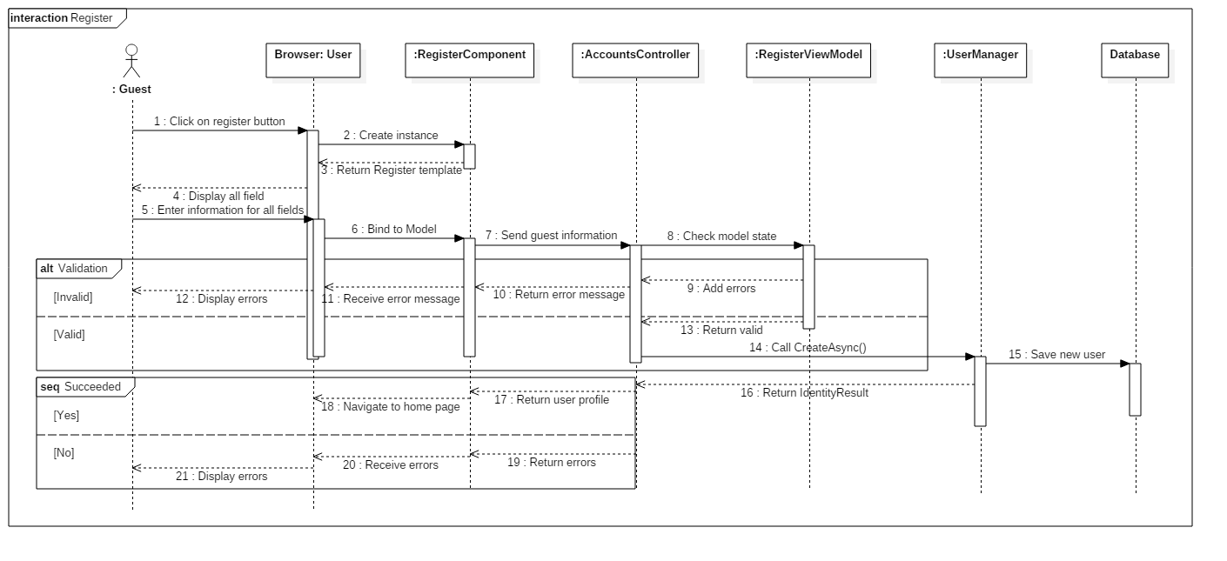

Figure : <Guest> Register as an User SD

* + - 1. <Guest> Login

Author: Mai Que Tung

Summary: This diagram show process of a Guest logging in account.

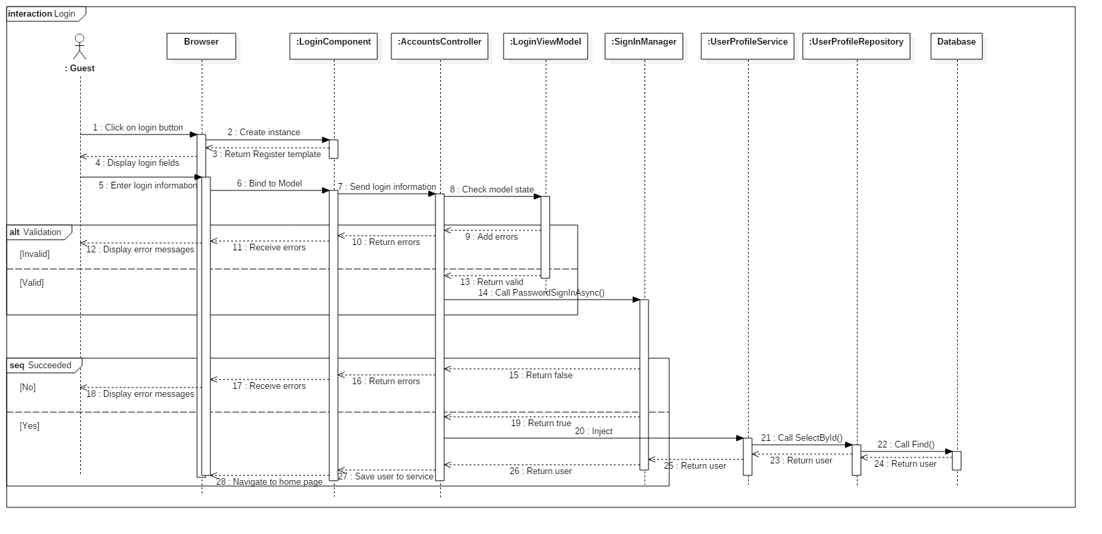

Figure : <Guest> Login SD

* + - 1. <User> Create Post

Author: Mai Que Tung

Summary: This diagram show process of a User creating a post.

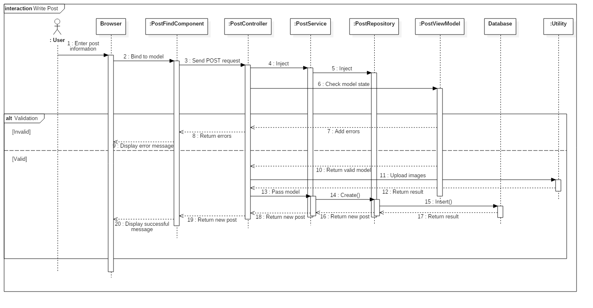

Figure : <User> Create Post SD

* + - 1. <User> Get New Post

Author: Mai Que Tung

Summary: This diagram show process of a User getting new post list.

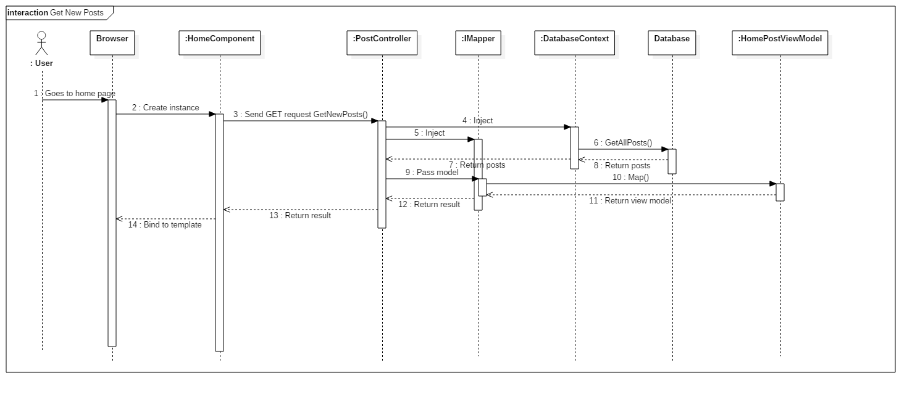

Figure : <User> Get New Post SD

* + - 1. <User> Get Post Detail

Author: Mai Que Tung

Summary: This diagram show process of a User getting post detail.

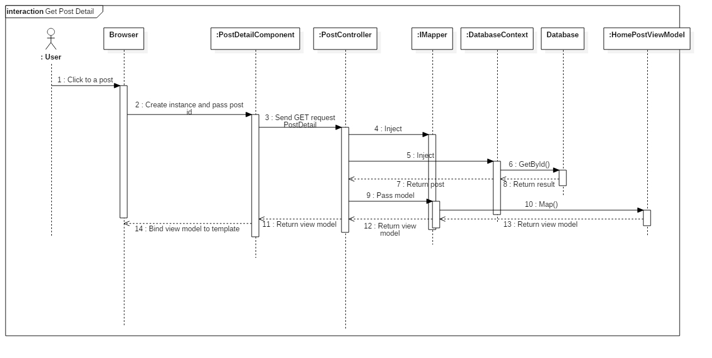

Figure : <User> Get Post Detail SD

* + - 1. <User> Get Chat List

Author: Mai Que Tung

Summary: This diagram show process of a User getting chat list.

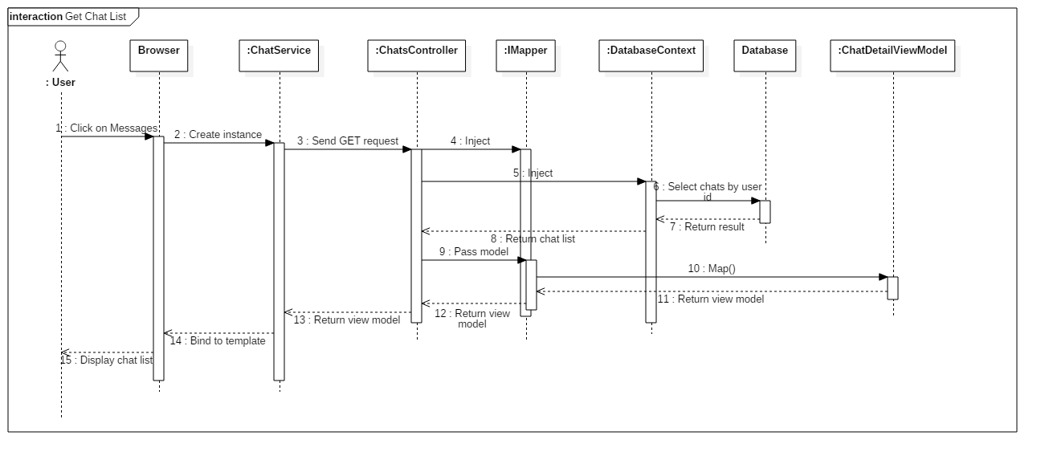

Figure : <User> Get Chat List SD

* + - 1. <User> Chat

Author: Mai Que Tung

Summary: This diagram show process of a User chatting with other Users.

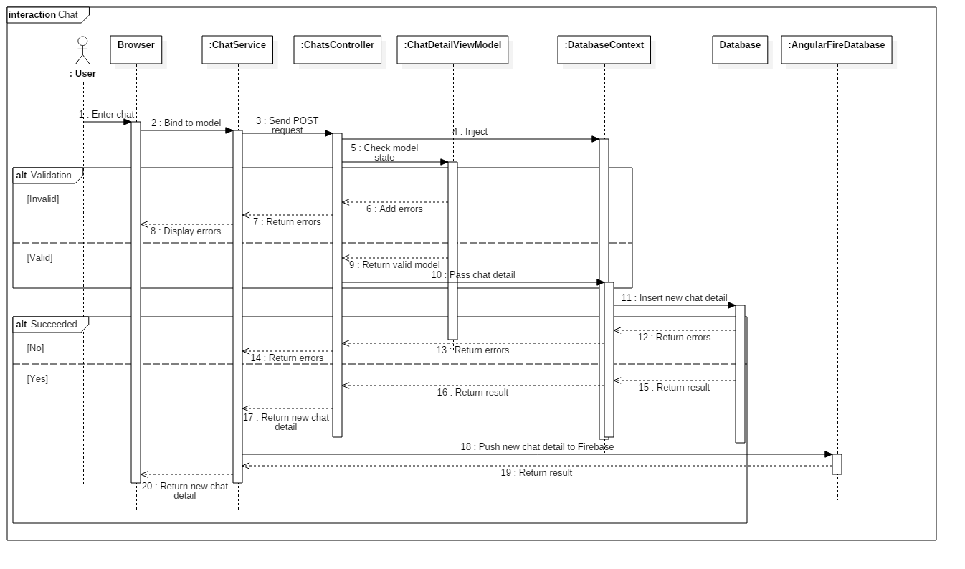

Figure : <User> Chat SD

* + - 1. <User> Get Comment List

Author: Mai Que Tung

Summary: This diagram show process of a User getting comment list.

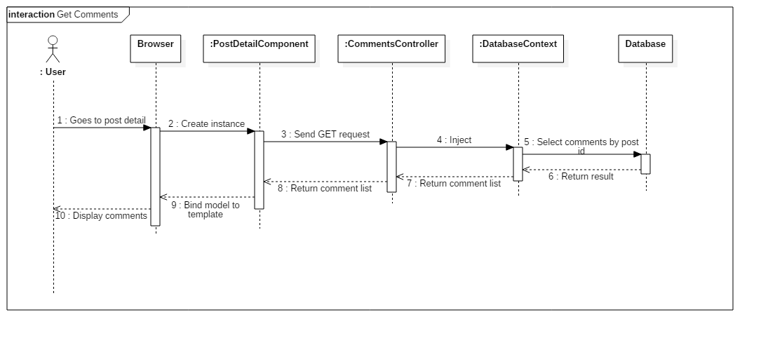

Figure : <User> Get Comment List SD

* + - 1. <User> Comment Post

Author: Mai Que Tung

Summary: This diagram show process of a User getting comment list.

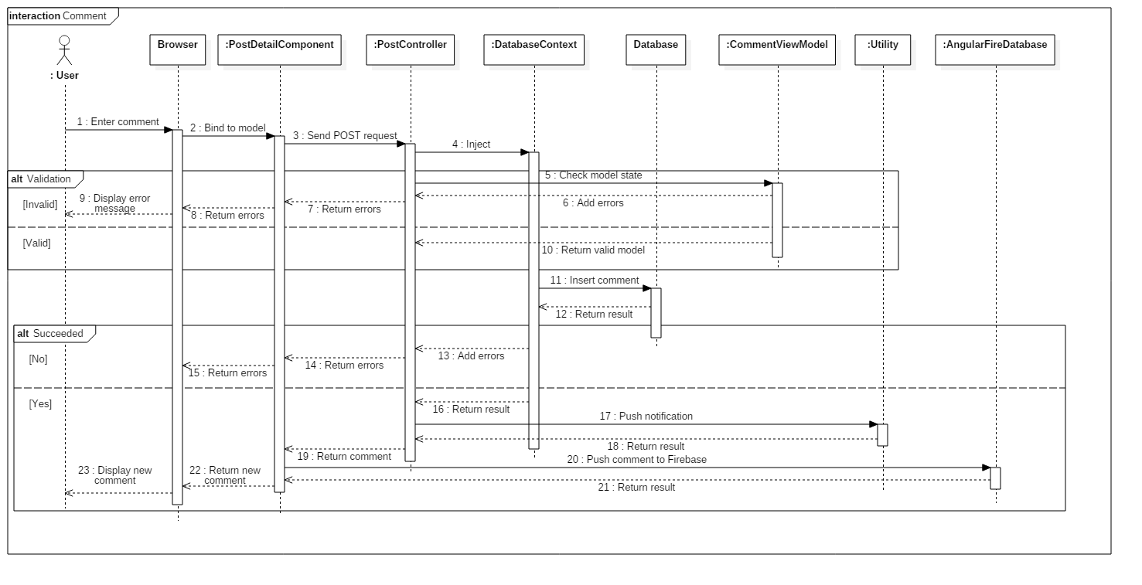

Figure : <User> Comment Post SD

* + - 1. <Admin> View Product Category

Author: Mai Que Tung

Summary: This diagram show process of Admin viewing product category list.

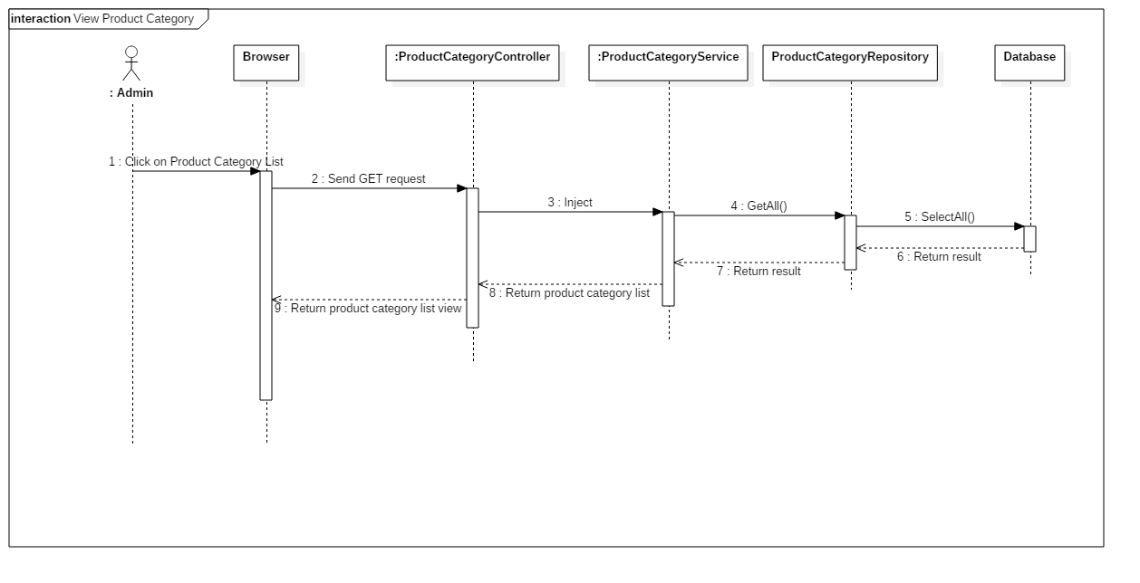

Figure : <Admin> View Product Category SD

* + - 1. <Admin> Create Product Category

Author: Mai Que Tung

Summary: This diagram show process of Admin creating new product category.

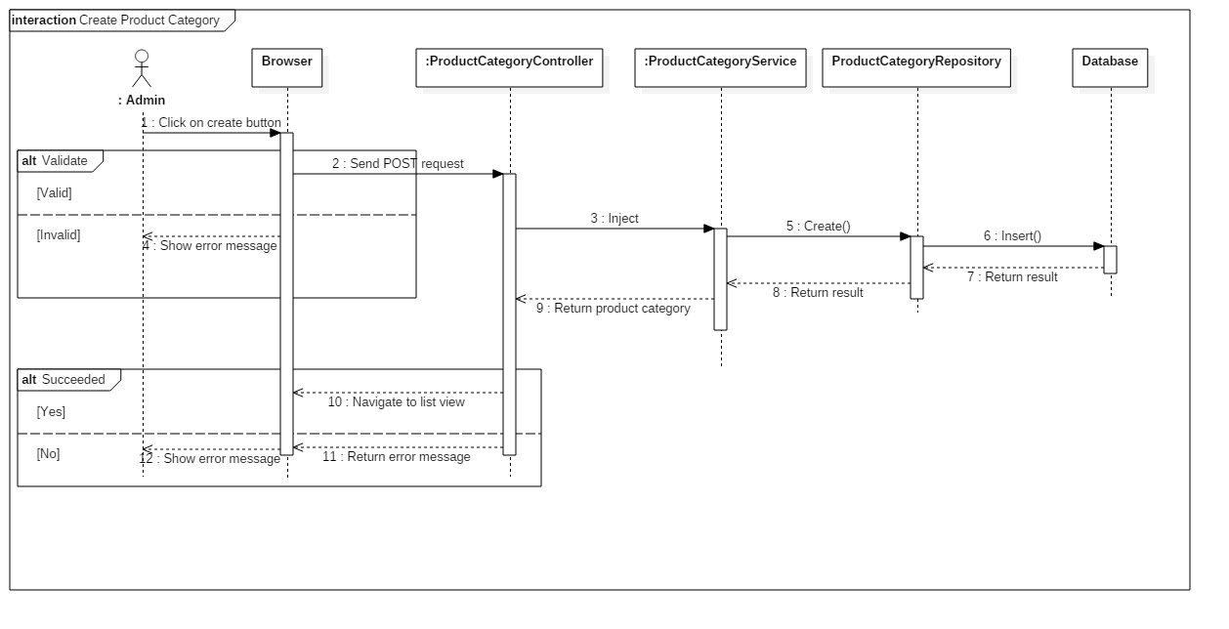

Figure : <Admin> Create Product Category SD

* + - 1. <Admin> Edit Product Category

Author: Mai Que Tung

Summary: This diagram show process of Admin editing product category.

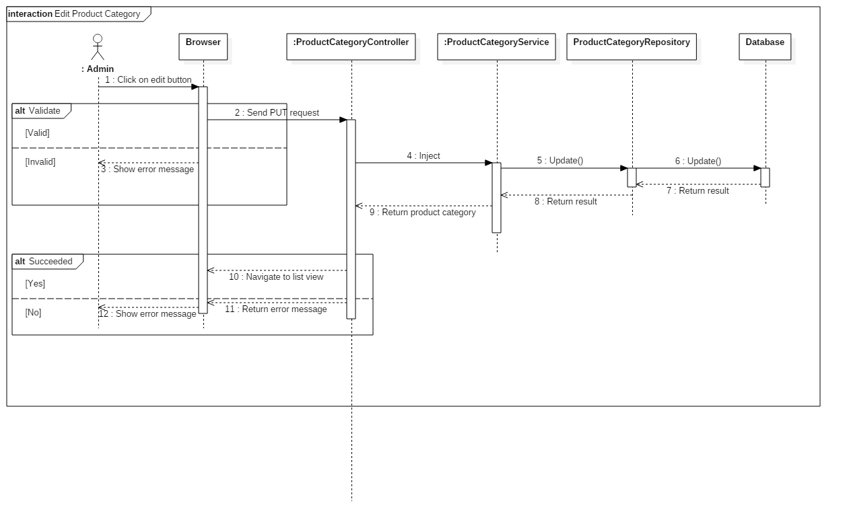

Figure : <Admin> Edit Product Category SD

* + - 1. <Admin> Delete Product Category

Author: Mai Que Tung

Summary: This diagram show process of Admin deleting product category.

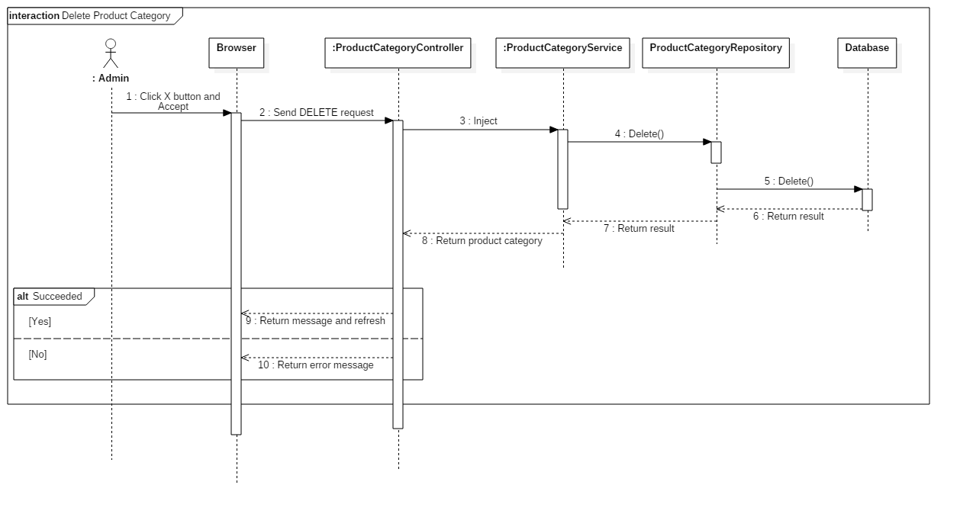

Figure : <Admin> Delete Product Category SD

* + 1. SEBS Mobile Application
       1. <Driver> View current Route

Author: Trần Nhật Khánh

Summary: This diagram show process of a Driver viewing his/her current Route.

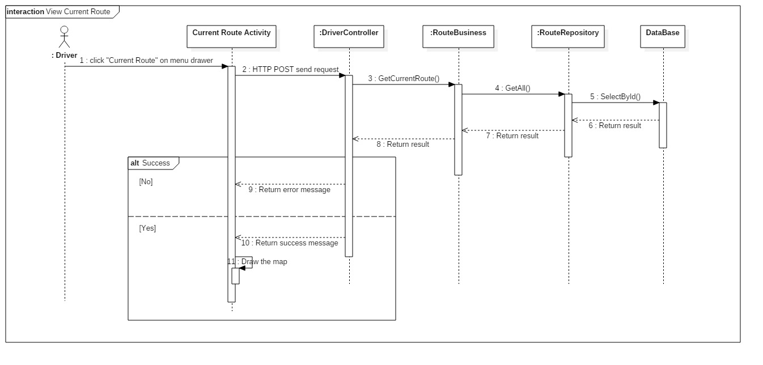

Figure : <Driver> View current Route SD

* + - 1. <Driver> Create Route

Author: Trần Nhật Khánh

Summary: This diagram show process of a Driver creating a Route.

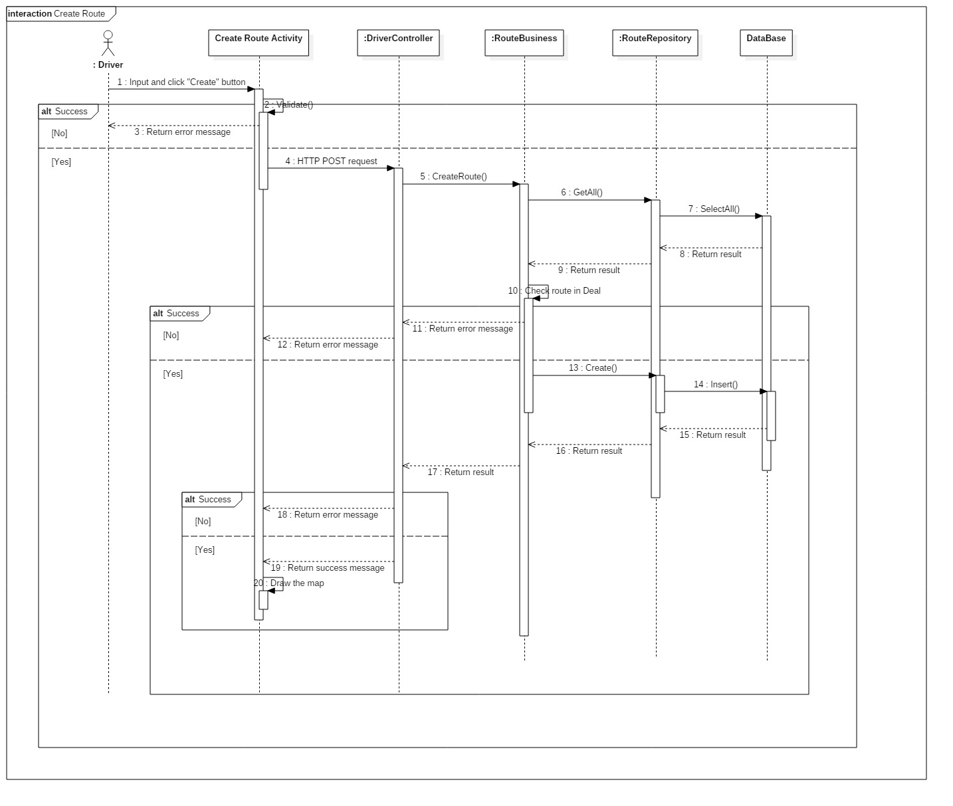

Figure : <Driver> Create Route SD

* + - 1. <Driver> Cancel Route

Author: Trần Nhật Khánh

Summary: This diagram show process of a Driver canceling a Route.

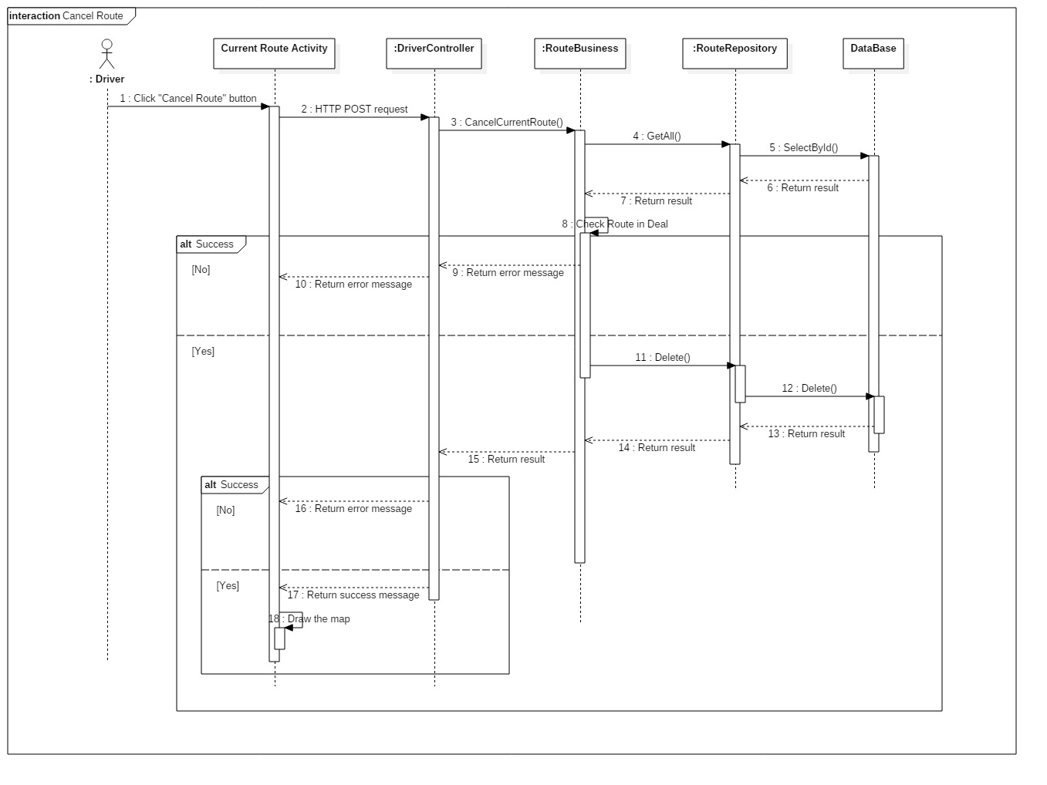

Figure : <Driver> Cancel Route SD

* + - 1. <Driver> Mark Order as Loaded

Author: Trần Nhật Khánh

Summary: This diagram show process of a Driver changing Order’s status to Loaded.

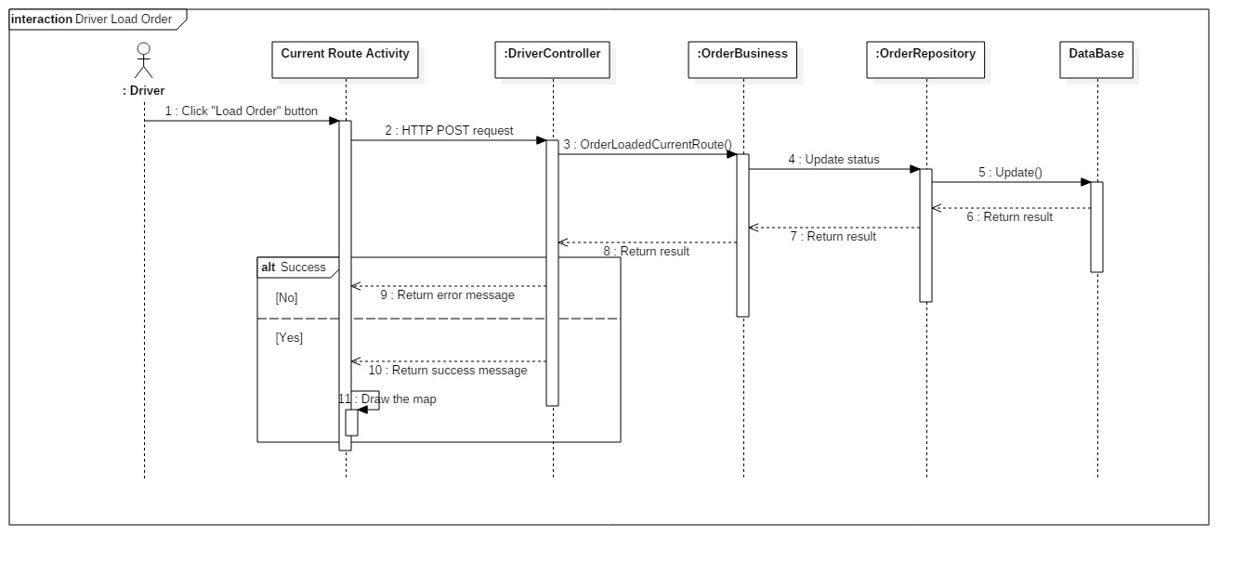

Figure : <Driver> Mark Order as Loaded SD

* + - 1. <Driver> Mark Order as Completed

Author: Trần Nhật Khánh

Summary: This diagram show process of a Guest registering a Loads Owner account.

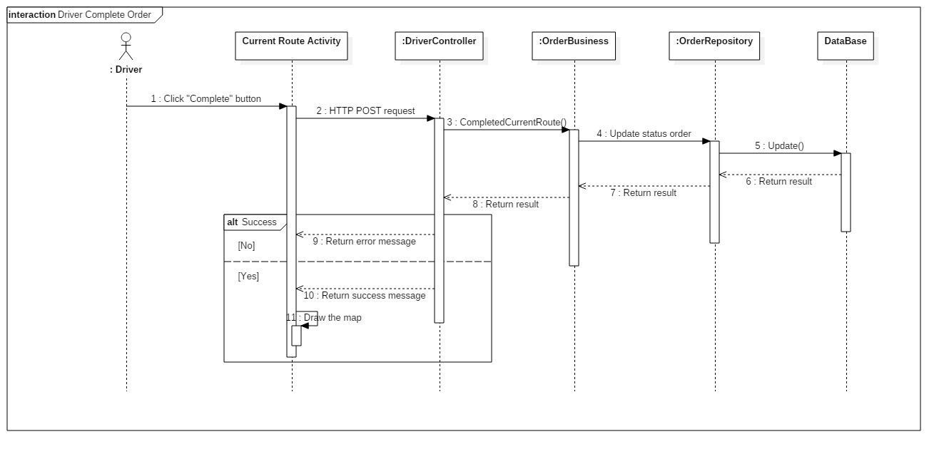

Figure : <Driver> Mark Order as Completed SD

* + - 1. <Loads Owner> Deal

Author: Phan Nhật Lâm

Summary: This diagram show process of a Guest registering a Loads Owner account.

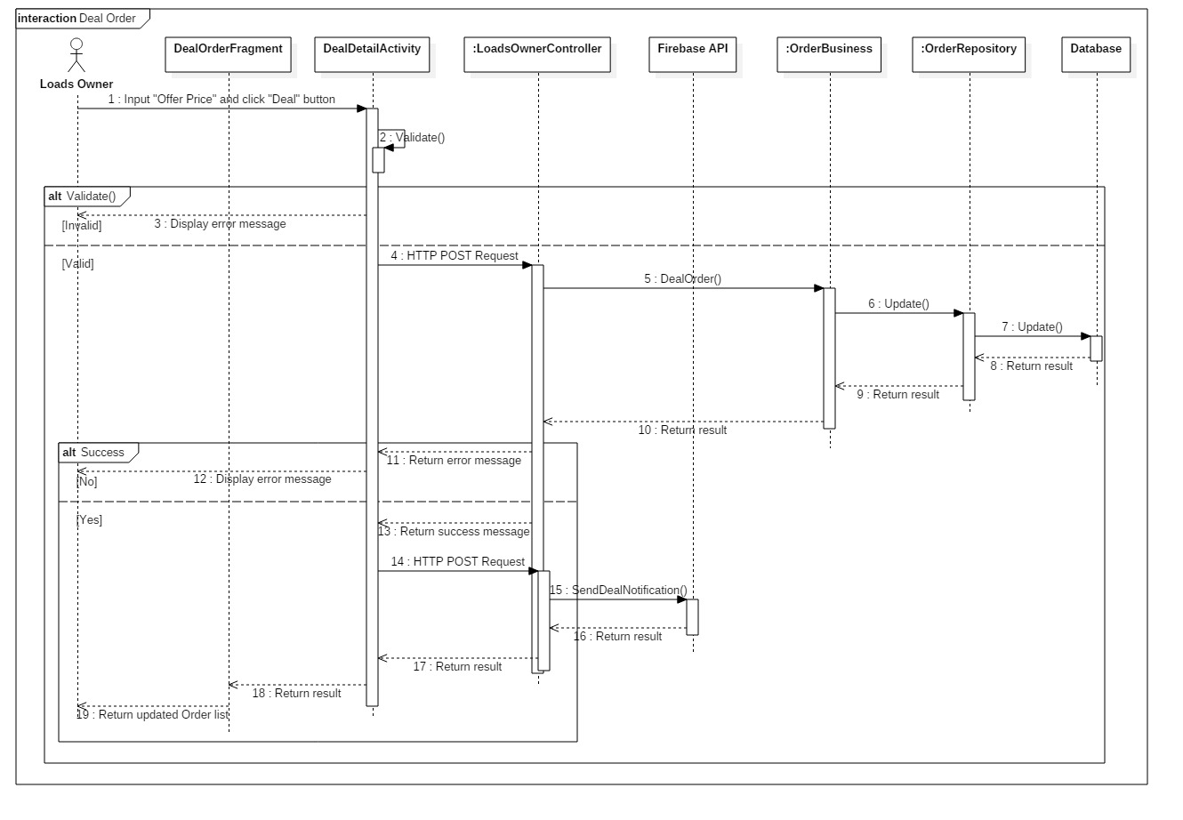

Figure : <Loads Owner> Deal SD

* + - 1. <Loads Owner> Accept Deal

Author: Phan Nhật Lâm

Summary: This diagram show process of a Guest registering a Loads Owner account.

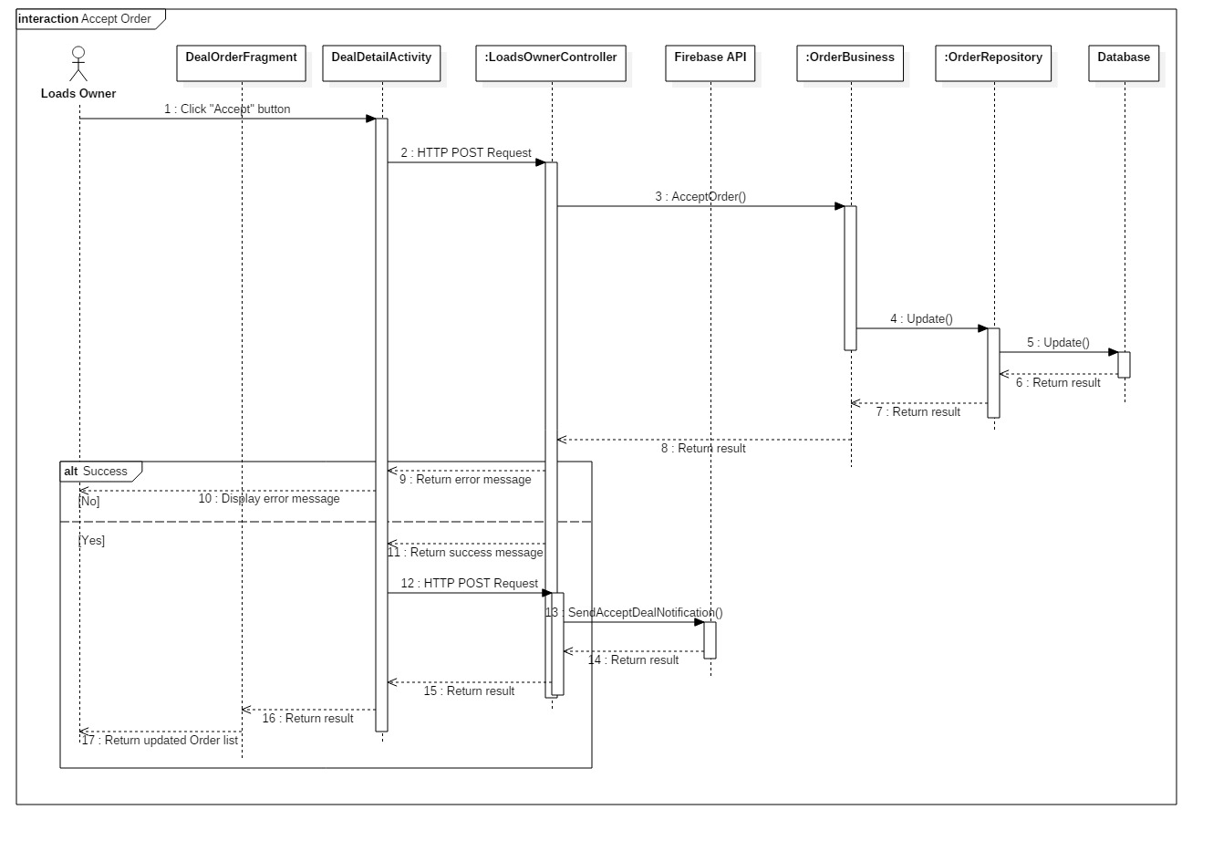

Figure : <Loads Owner> Accept Deal SD

* + - 1. <Loads Owner> Reject Deal

Author: Phan Nhật Lâm

Summary: This diagram show process of a Guest registering a Loads Owner account.

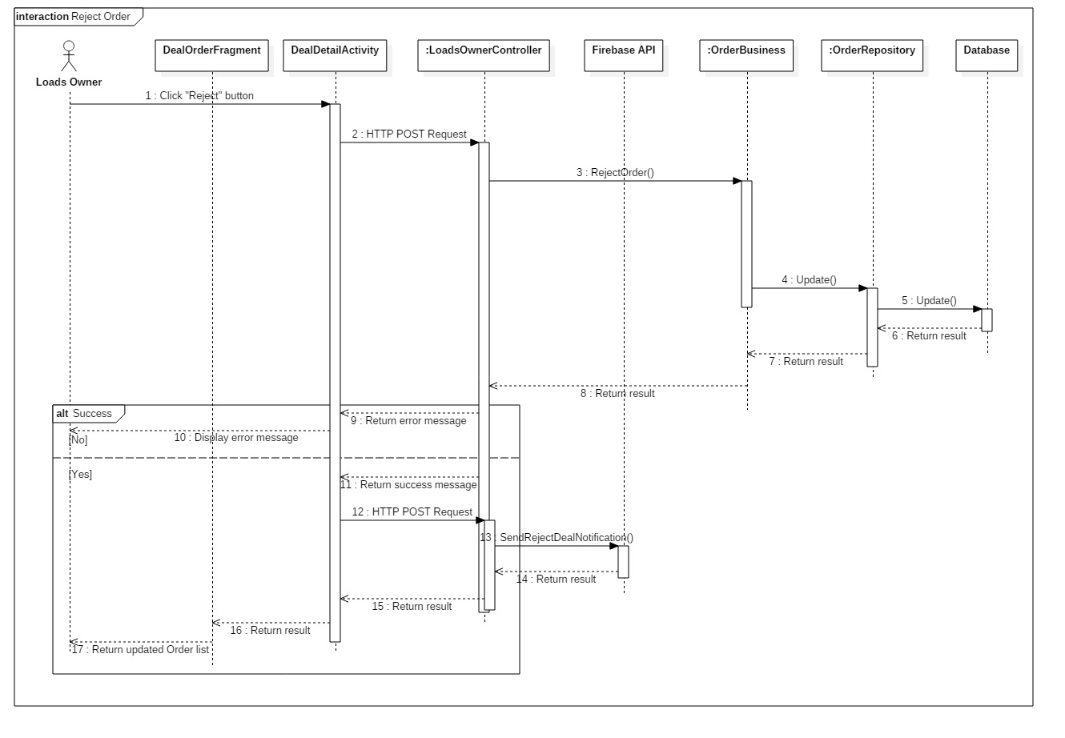

Figure : <Loads Owner> Reject Deal SD

* 1. Interface
     1. Component Interface

N/A

* + 1. User interface design
       1. <Web> Login

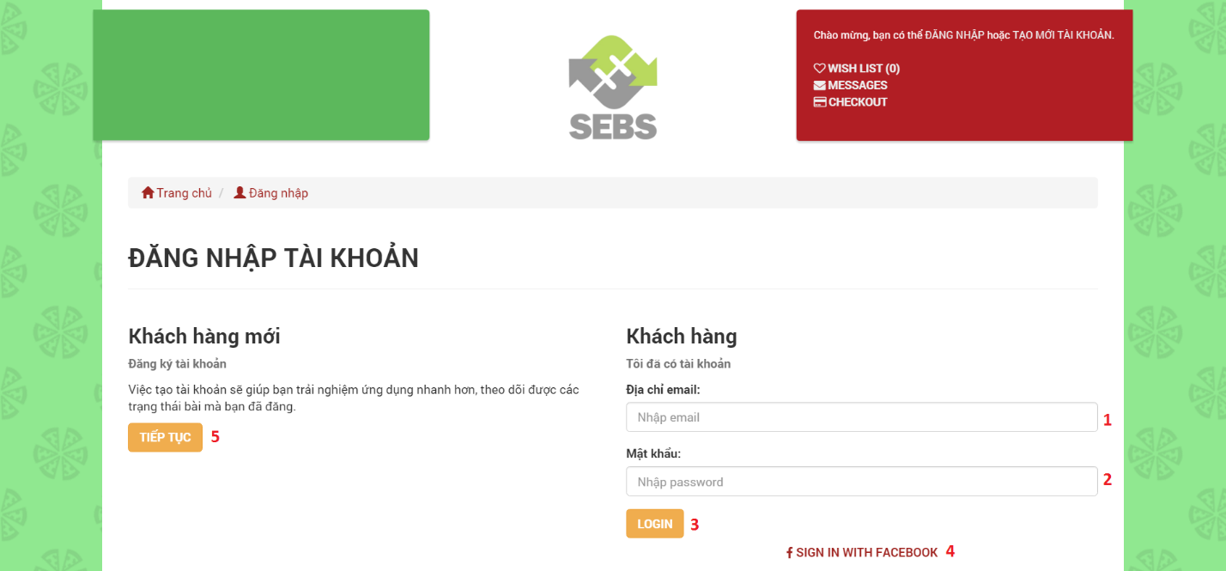

Figure : <Web> Login UI

**Fields**

|  |  |  |  |  |  |  |  |
| --- | --- | --- | --- | --- | --- | --- | --- |
| **No** | **Field Name** | **Description** | **Read Only** | **Mandatory** | **Control Type** | **Data Type** | **Length** |
| 1 | Email | Fill user email | No | Yes | Textbox | String | N/A |
| 2 | Password | Fill password | No | Yes | Password | String | N/A |

**Button/ Hyperlinks**

|  |  |  |  |  |
| --- | --- | --- | --- | --- |
| **No** | **Function** | **Description** | **Validation** | **Outcome** |
| 3 | LOGIN | Click “LOGIN” to login the system | N/A | User redirects to home page |
| 4 | SIGN IN WITH FACEBOOK | Click “SIGN IN WITH FACEBOOK” to login the system by Facebook | N/A | User redirects to home page |
| 5 | CONTINUE | Click “TIẾP TỤC” to redirects to register page | N/A | Guest redirects to register page |

* + - 1. <Web> Register as an User

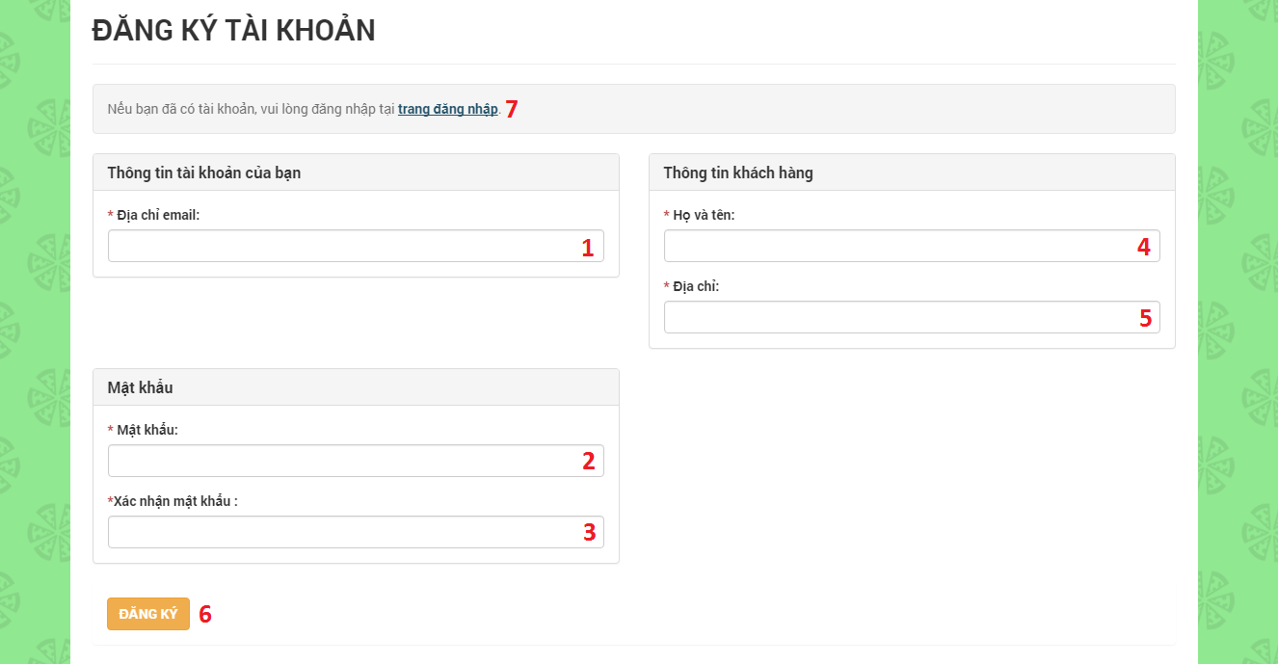

Figure : <Web> Register as an User UI

**Fields**

|  |  |  |  |  |  |  |  |
| --- | --- | --- | --- | --- | --- | --- | --- |
| **No** | **Field Name** | **Description** | **Read Only** | **Mandatory** | **Control Type** | **Data Type** | **Length** |
| 1 | Email | Email of user | No | Yes | Textbox | String | N/A |
| 2 | Password | Password of user | No | Yes | Password | String | N/A |
| 3 | Confirm Password | Confirm password of user | No | Yes | Password | String | N/A |
| 4 | Full name | Full name of user | No | Yes | Textbox | String | N/A |
| 5 | Address | Address of user | No | Yes | Textbox | String | N/A |

**Button/ Hyperlinks**

|  |  |  |  |  |
| --- | --- | --- | --- | --- |
| **No** | **Function** | **Description** | **Validation** | **Outcome** |
| 6 | Register | Click “ĐĂNG KÝ” to create a user | N/A | Create a new user |
| 7 | Login page | Click “trang đăng nhập” to redirects to login page | N/A | Guest redirects to login page |

* + - 1. <Web> Find nearby Products

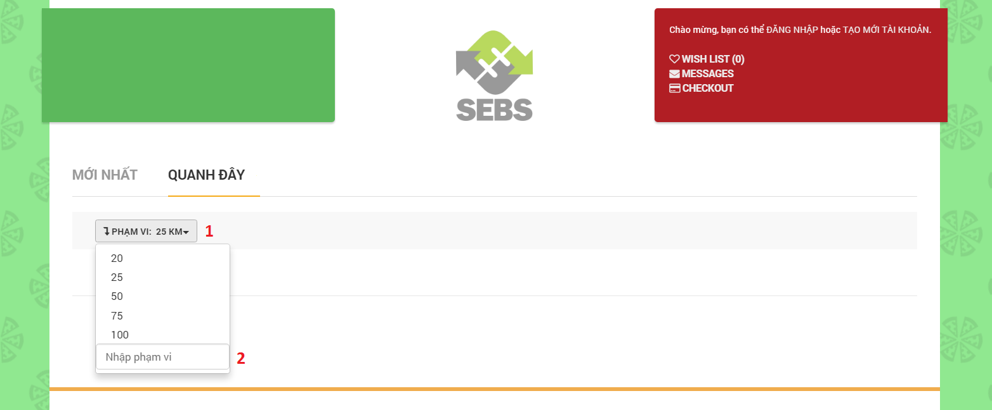

Figure : <Web> Find nearby Products UI

**Fields**

|  |  |  |  |  |  |  |  |
| --- | --- | --- | --- | --- | --- | --- | --- |
| **No** | **Field Name** | **Description** | **Read Only** | **Mandatory** | **Control Type** | **Data Type** | **Length** |
| 1 | Range | Range of searching | No | Yes | Drop down | Int | N/A |
| 2 | Input range | Input range of searching | No | Yes | Textbox | Int | N/A |

* + - 1. <Web> Find posted Products

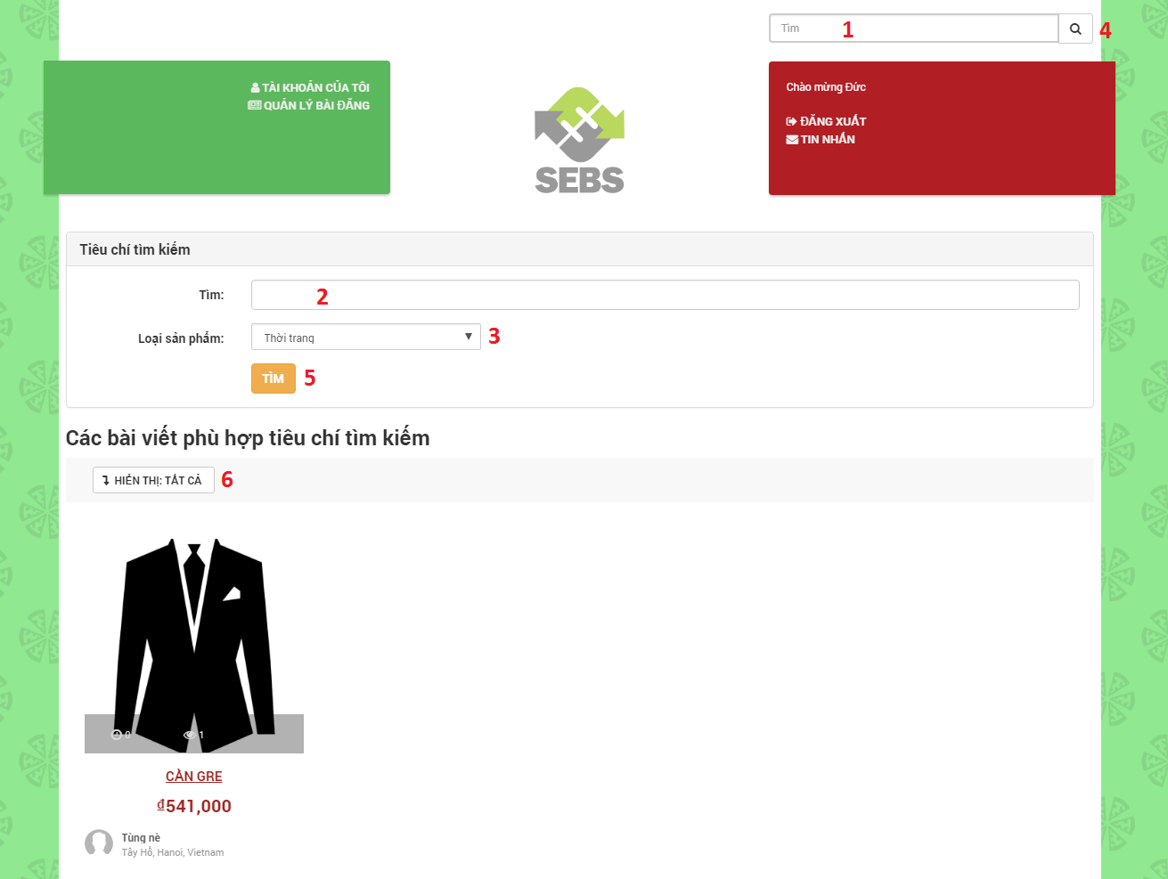

Figure : <Web> Find posted Products UI

**Fields**

|  |  |  |  |  |  |  |  |
| --- | --- | --- | --- | --- | --- | --- | --- |
| **No** | **Field Name** | **Description** | **Read Only** | **Mandatory** | **Control Type** | **Data Type** | **Length** |
| 1 | Search | Input searching keyword | No | Yes | Textbox | String | N/A |
| 2 | Search | Input searching keyword | No | Yes | Textbox | String | N/A |
| 3 | Product category | Search by product category | No | Yes | Drop down | String | N/A |
| 6 | Show | Number of products displayed | No | Yes | Drop down | Int | N/A |

**Button/ Hyperlinks**

|  |  |  |  |  |
| --- | --- | --- | --- | --- |
| **No** | **Function** | **Description** | **Validation** | **Outcome** |
| 4 | Search | Click “Search” icon | N/A | Search product |
| 5 | Search | Click “TÌM” button | N/A | Search product |

* + - 1. <Web> Post Buying

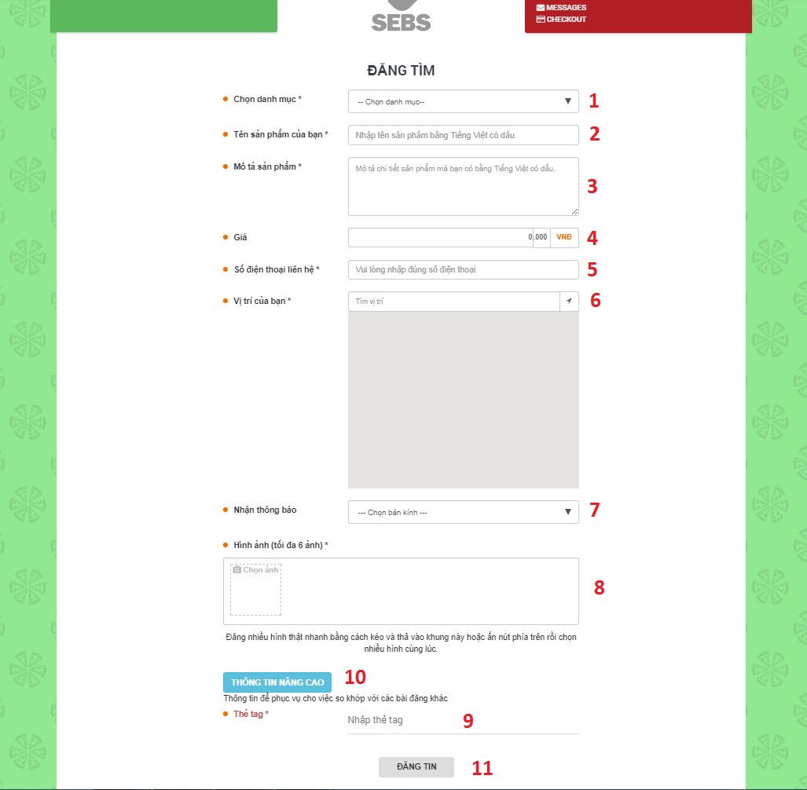

Figure : <Web> Post Buying UI

**Fields**

|  |  |  |  |  |  |  |  |
| --- | --- | --- | --- | --- | --- | --- | --- |
| **No** | **Field Name** | **Description** | **Read Only** | **Mandatory** | **Control Type** | **Data Type** | **Length** |
| 1 | Product category | Product category of post | No | Yes | Drop down | String | N/A |
| 2 | Product name | Product name of post | No | Yes | Textbox | String | N/A |
| 3 | Product description | Product description of post | No | Yes | Textbox | String | N/A |
| 4 | Price | Product price of post | No | No | Textbox | String | N/A |
| 5 | Phone number | Phone number of poster | No | Yes | Textbox | String | N/A |
| 6 | Address | Location or address of poster | No | Yes | Textbox | String | N/A |
| 7 | Receive notification | Radius receives notification | No | No | Drop down | String | N/A |
| 9 | Tags | Tags of post | No | No | Textbox | String | N/A |

**Button/ Hyperlinks**

|  |  |  |  |  |
| --- | --- | --- | --- | --- |
| **No** | **Function** | **Description** | **Validation** | **Outcome** |
| 8 | Image (maximum: 6) | Click “Chọn ảnh” icon | N/A | Upload images of product |
| 10 | Advanced information | Click “THÔNG TIN NÂNG CAO” button | N/A | Open form to input tag |
| 11 | POST | Click “ĐĂNG TIN” button | N/A | Create a new post buying |

* + - 1. <Web> Post Selling

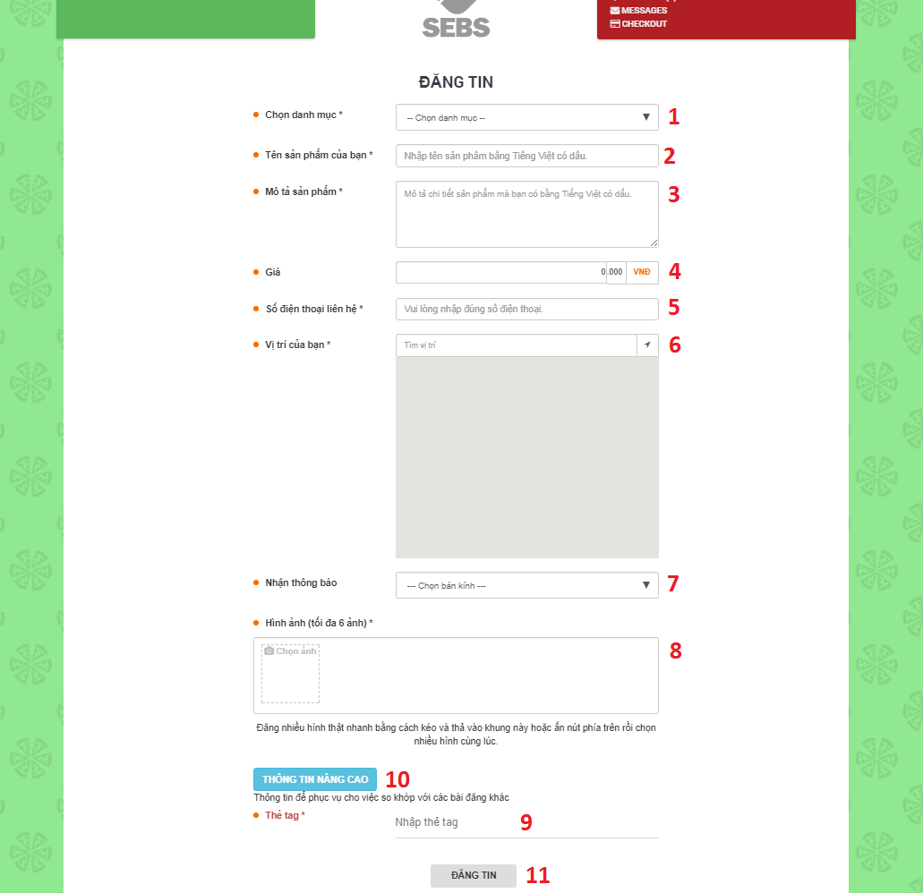

Figure : <Web> Post Selling UI

**Fields**

|  |  |  |  |  |  |  |  |
| --- | --- | --- | --- | --- | --- | --- | --- |
| **No** | **Field Name** | **Description** | **Read Only** | **Mandatory** | **Control Type** | **Data Type** | **Length** |
| 1 | Product category | Product category of post | No | Yes | Drop down | String | N/A |
| 2 | Product name | Product name of post | No | Yes | Textbox | String | N/A |
| 3 | Product description | Product description of post | No | Yes | Textbox | String | N/A |
| 4 | Price | Product price of post | No | No | Textbox | String | N/A |
| 5 | Phone number | Phone number of poster | No | Yes | Textbox | String | N/A |
| 6 | Address | Location or address of poster | No | Yes | Textbox | String | N/A |
| 7 | Receive notification | Radius receives notification | No | No | Drop down | String | N/A |
| 9 | Tags | Tags of post | No | No | Textbox | String | N/A |

**Button/ Hyperlinks**

|  |  |  |  |  |
| --- | --- | --- | --- | --- |
| **No** | **Function** | **Description** | **Validation** | **Outcome** |
| 8 | Image (maximum: 6) | Click “Chọn ảnh” icon | N/A | Upload images of product |
| 10 | Advanced information | Click “THÔNG TIN NÂNG CAO” button | N/A | Open form to input tag |
| 11 | POST | Click “ĐĂNG TIN” button | N/A | Create a new post selling |

* + - 1. <Web> Post Exchanging

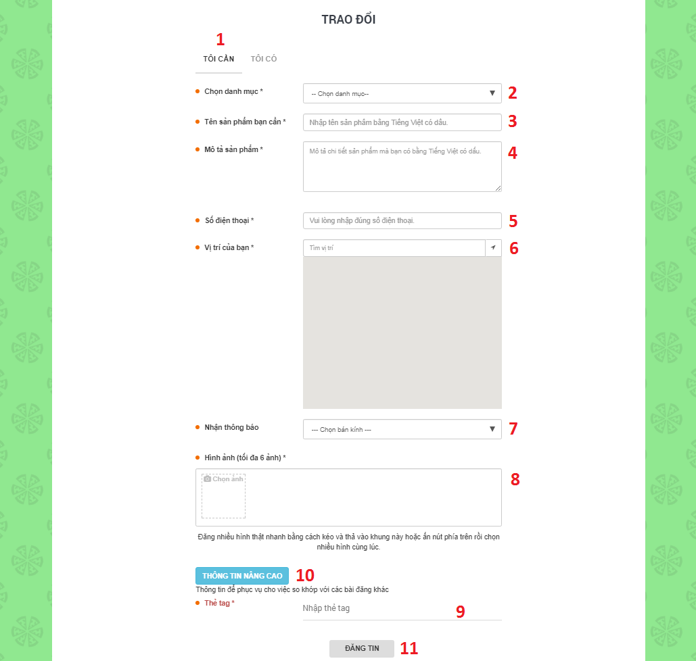

Figure : <Web> Post Exchanging (1) UI

**Fields**

|  |  |  |  |  |  |  |  |
| --- | --- | --- | --- | --- | --- | --- | --- |
| **No** | **Field Name** | **Description** | **Read Only** | **Mandatory** | **Control Type** | **Data Type** | **Length** |
| 1 | I NEED | Product that poster needs | Yes | Yes | Tab | String | N/A |
| 2 | Product category | Product category that poster needs | No | Yes | Drop down | String | N/A |
| 3 | Product name | Product name that poster needs | No | Yes | Textbox | String | N/A |
| 4 | Product description | Product description that poster needs | No | Yes | Textbox | String | N/A |
| 5 | Phone number | Phone number of poster | No | Yes | Textbox | String | N/A |
| 6 | Address | Location or address of poster | No | Yes | Textbox | String | N/A |
| 7 | Receive notification | Radius receives notification | No | No | Drop down | String | N/A |
| 9 | Tags | Tags of post | No | No | Textbox | String | N/A |

**Button/ Hyperlinks**

|  |  |  |  |  |
| --- | --- | --- | --- | --- |
| **No** | **Function** | **Description** | **Validation** | **Outcome** |
| 8 | Image (maximum: 6) | Click “Chọn ảnh” icon | N/A | Upload images that poster needs |
| 10 | Advanced information | Click “THÔNG TIN NÂNG CAO” button | N/A | Open form to input tag |
| 11 | POST | Click “ĐĂNG TIN” button | N/A | Create a new post exchanging |

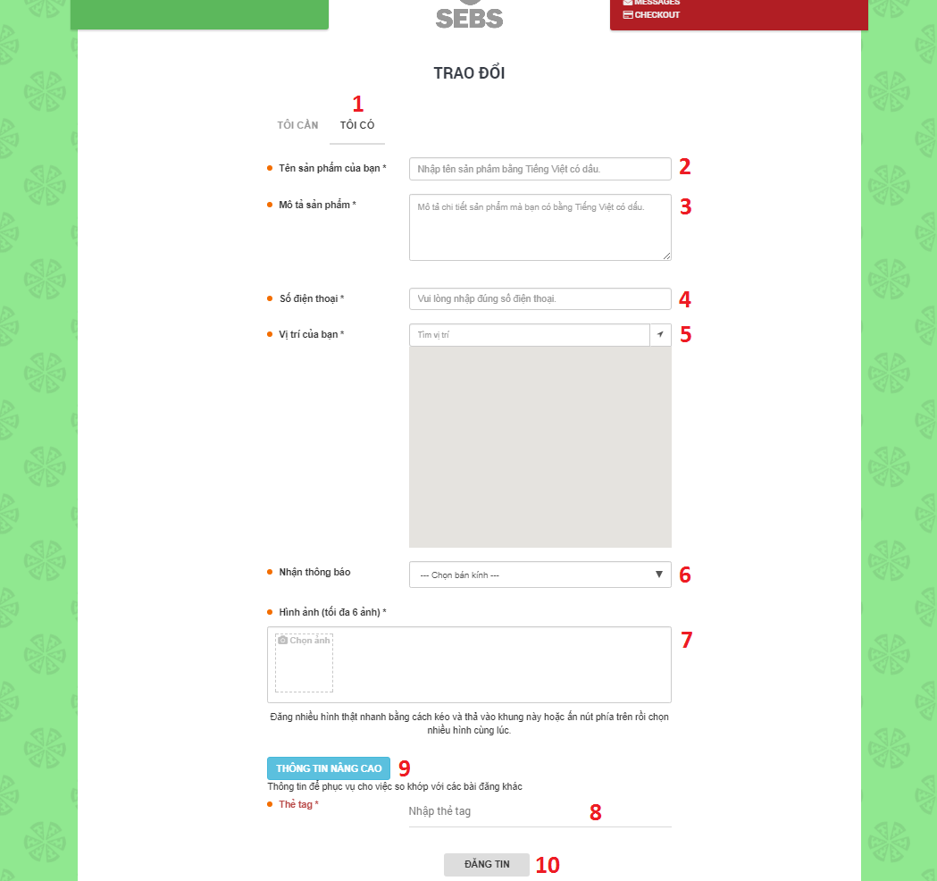

Figure : <Web> Post Exchanging (2) UI

**Fields**

|  |  |  |  |  |  |  |  |
| --- | --- | --- | --- | --- | --- | --- | --- |
| **No** | **Field Name** | **Description** | **Read Only** | **Mandatory** | **Control Type** | **Data Type** | **Length** |
| 1 | I HAVE | Product that poster has | Yes | Yes | Tab | String | N/A |
| 2 | Product name | Product name that poster has | No | Yes | Textbox | String | N/A |
| 3 | Product Description | Product description that poster has | No | Yes | Textbox | String | N/A |
| 4 | Phone number | Phone number of poster | No | Yes | Textbox | String | N/A |
| 5 | Address | Location or address of poster | No | Yes | Textbox | String | N/A |
| 6 | Receive notification | Radius receives notification | No | No | Drop down | String | N/A |
| 8 | Tags | Tag of post | No | No | Textbox | String | N/A |

**Button/ Hyperlinks**

|  |  |  |  |  |
| --- | --- | --- | --- | --- |
| **No** | **Function** | **Description** | **Validation** | **Outcome** |
| 7 | Image (maximum: 6) | Click “Chọn ảnh” icon | N/A | Upload images that poster has |
| 9 | Advanced information | Click “THÔNG TIN NÂNG CAO” button | N/A | Open form to input tag |
| 10 | POST | Click “ĐĂNG TIN” button | N/A | Create a new post exchanging |

* + - 1. <Web> Post Charity

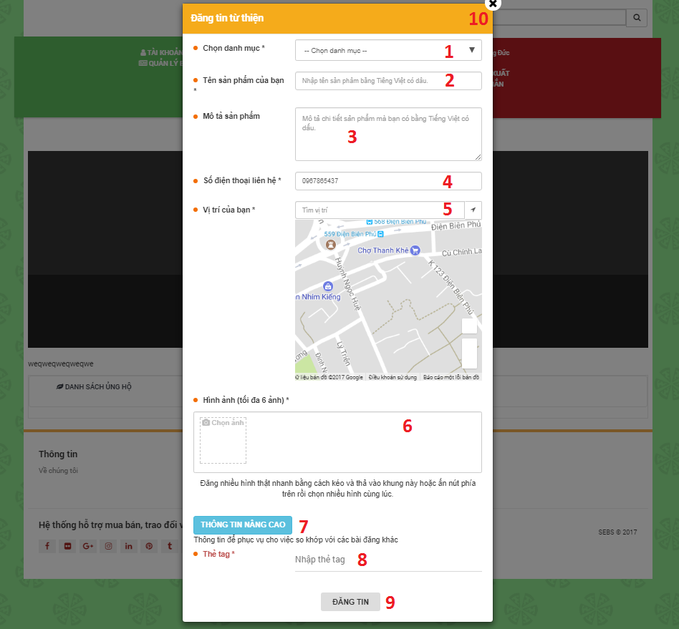

Figure : <Web> Post Charity UI

**Fields**

|  |  |  |  |  |  |  |  |
| --- | --- | --- | --- | --- | --- | --- | --- |
| **No** | **Field Name** | **Description** | **Read Only** | **Mandatory** | **Control Type** | **Data Type** | **Length** |
| 1 | Product category | Product category of post | No | Yes | Drop down | String | N/A |
| 2 | Product name | Product name of post | No | Yes | Textbox | String | N/A |
| 3 | Product description | Product description of post | No | Yes | Textbox | String | N/A |
| 4 | Phone number | Phone number of poster | No | Yes | Textbox | String | N/A |
| 5 | Address | Location or address of poster | No | Yes | Textbox | String | N/A |
| 8 | Tags | Tags of post | No | No | Textbox | String | N/A |

**Button/ Hyperlinks**

|  |  |  |  |  |
| --- | --- | --- | --- | --- |
| **No** | **Function** | **Description** | **Validation** | **Outcome** |
| 6 | Image (maximum: 6) | Click “Chọn ảnh” icon | N/A | Upload images of product |
| 7 | Advanced information | Click “THÔNG TIN NÂNG CAO” button | N/A | Open form to input tag |
| 9 | POST | Click “ĐĂNG TIN” button | N/A | Create a new post charity |
| 10 | Close | Click “X” icon button | N/A | Close |

* + - 1. <Web> Manage Profile

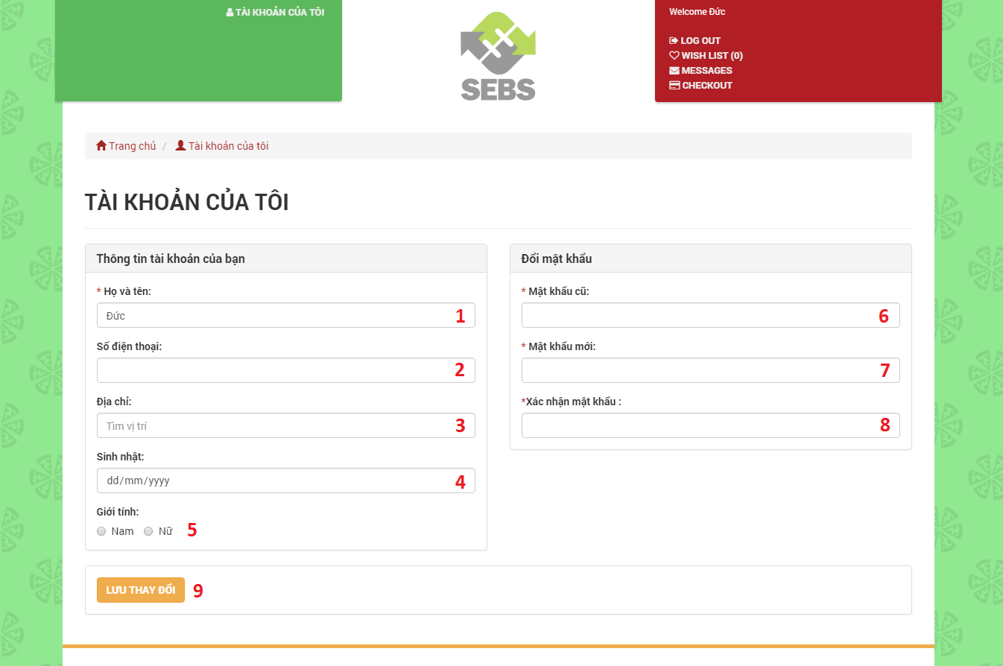

Figure : <Web> Manage Profile UI

**Fields**

|  |  |  |  |  |  |  |  |
| --- | --- | --- | --- | --- | --- | --- | --- |
| **No** | **Field Name** | **Description** | **Read Only** | **Mandatory** | **Control Type** | **Data Type** | **Length** |
| 1 | Full name | Full name of user | No | Yes | Textbox | String | N/A |
| 2 | Phone number | Phone number of user | No | No | Textbox | String | N/A |
| 3 | Address | Address of user | No | No | Textbox | String | N/A |
| 4 | Birthday | Birthday of user | No | No | Textbox | Datetime | N/A |
| 5 | Gender | Gender of user | No | No | Radio button | Int | N/A |
| 6 | Old password | Current password of user | No | No | Password | String | N/A |
| 7 | New password | New password of user | No | No | Password | String | N/A |
| 8 | Confirm password | Confirm new password of user | No | No | Password | String | N/A |

**Button/ Hyperlinks**

|  |  |  |  |  |
| --- | --- | --- | --- | --- |
| **No** | **Function** | **Description** | **Validation** | **Outcome** |
| 9 | SAVE CHANGE | Click “LƯU THAY ĐỔI” to edit profile of user | N/A | Edit profile |

* + - 1. <Web> Chat with other Users

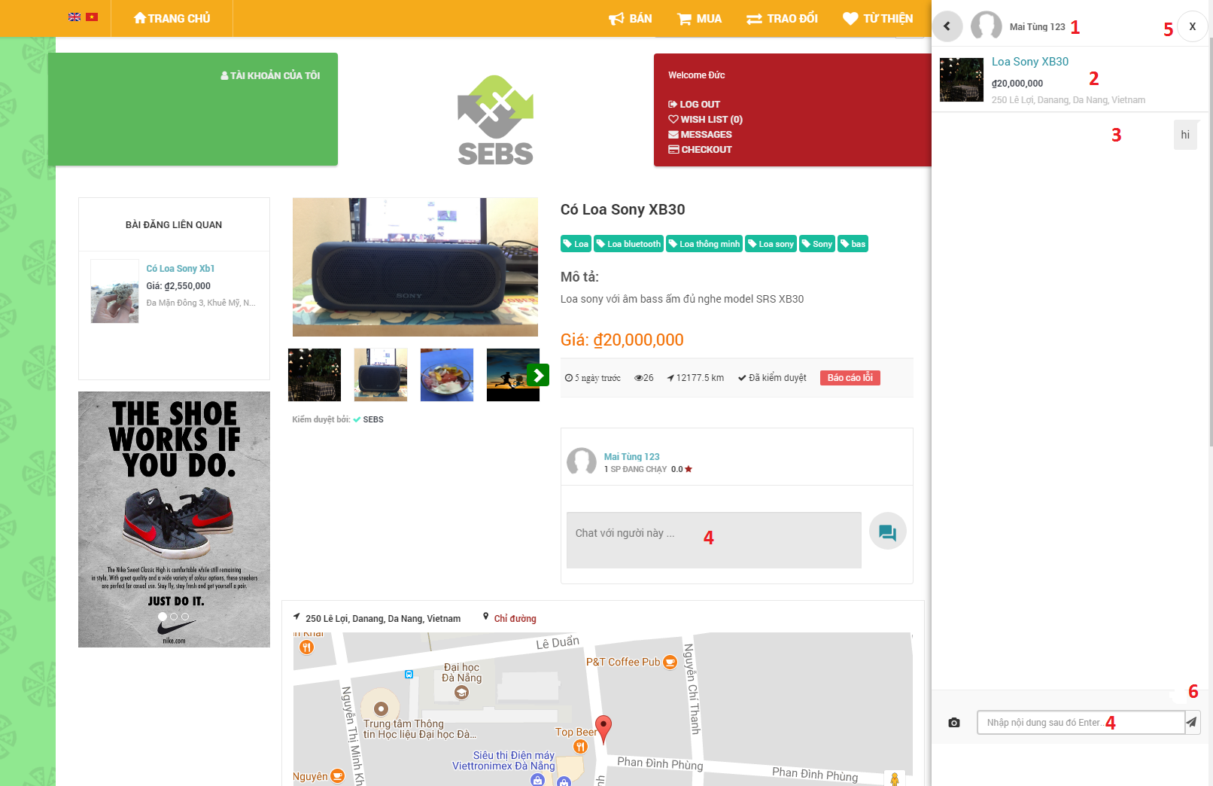

Figure : <Web> Chat with other Users UI

**Fields**

|  |  |  |  |  |  |  |  |
| --- | --- | --- | --- | --- | --- | --- | --- |
| **No** | **Field Name** | **Description** | **Read Only** | **Mandatory** | **Control Type** | **Data Type** | **Length** |
| 1 | Name of receiver | Full name of receiver | Yes | Yes | Text | String | N/A |
| 2 | Information of post | Name, price and address of post | Yes | Yes | Text | String | N/A |
| 3 | Message content | Message content of sender and receiver | Yes | Yes | Text | String | N/A |
| 4 | Chatbox | Box input message content | No | Yes | Textbox | String | N/A |

**Button/ Hyperlinks**

|  |  |  |  |  |
| --- | --- | --- | --- | --- |
| **No** | **Function** | **Description** | **Validation** | **Outcome** |
| 5 | Close chatbox | Click “X” button to close chatbox | N/A | Chatbox is closed |
| 6 | Send message | Click ”send” button to send message | N/A | Send message |

* + - 1. <Web> Comment Posts

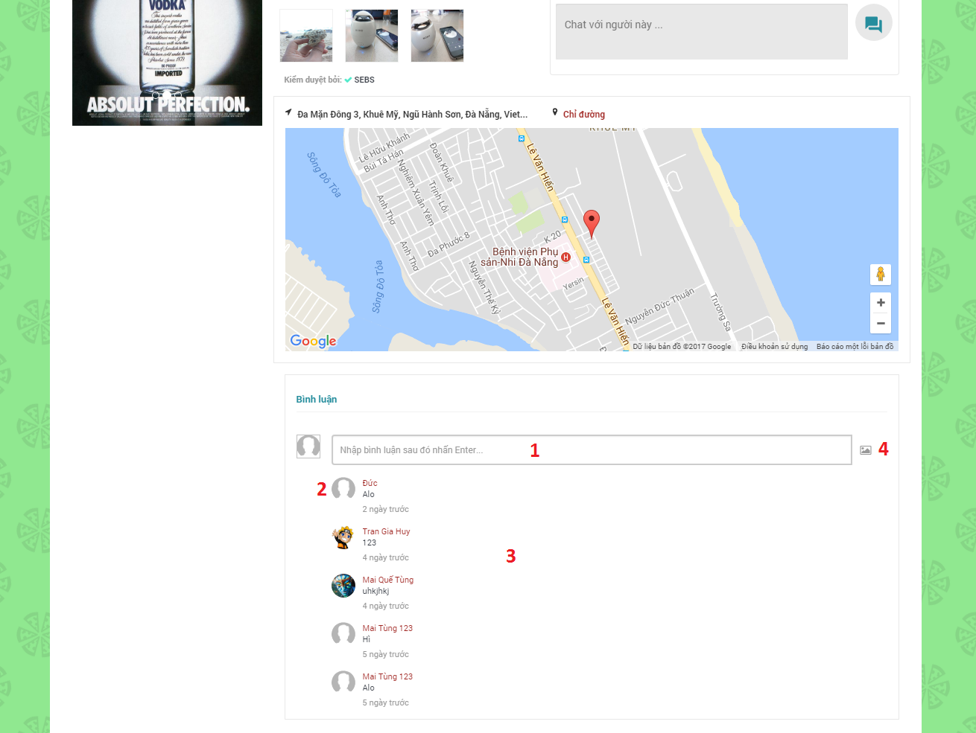

Figure : <Web> Comment Posts UI

**Fields**

|  |  |  |  |  |  |  |  |
| --- | --- | --- | --- | --- | --- | --- | --- |
| **No** | **Field Name** | **Description** | **Read Only** | **Mandatory** | **Control Type** | **Data Type** | **Length** |
| 1 | Comment | Box input comment content | No | Yes | Textbox | String | N/A |
| 2 | Name of commentator | Full name of commentator | Yes | Yes | Text | String | N/A |
| 3 | Comment content | Comment content of users | Yes | Yes | Text | String | N/A |

**Button/ Hyperlinks**

|  |  |  |  |  |
| --- | --- | --- | --- | --- |
| **No** | **Function** | **Description** | **Validation** | **Outcome** |
| 4 | Send comment | Click “send” button to send comment | N/A | Send comment |

* + - 1. <Web> Feedback Posts

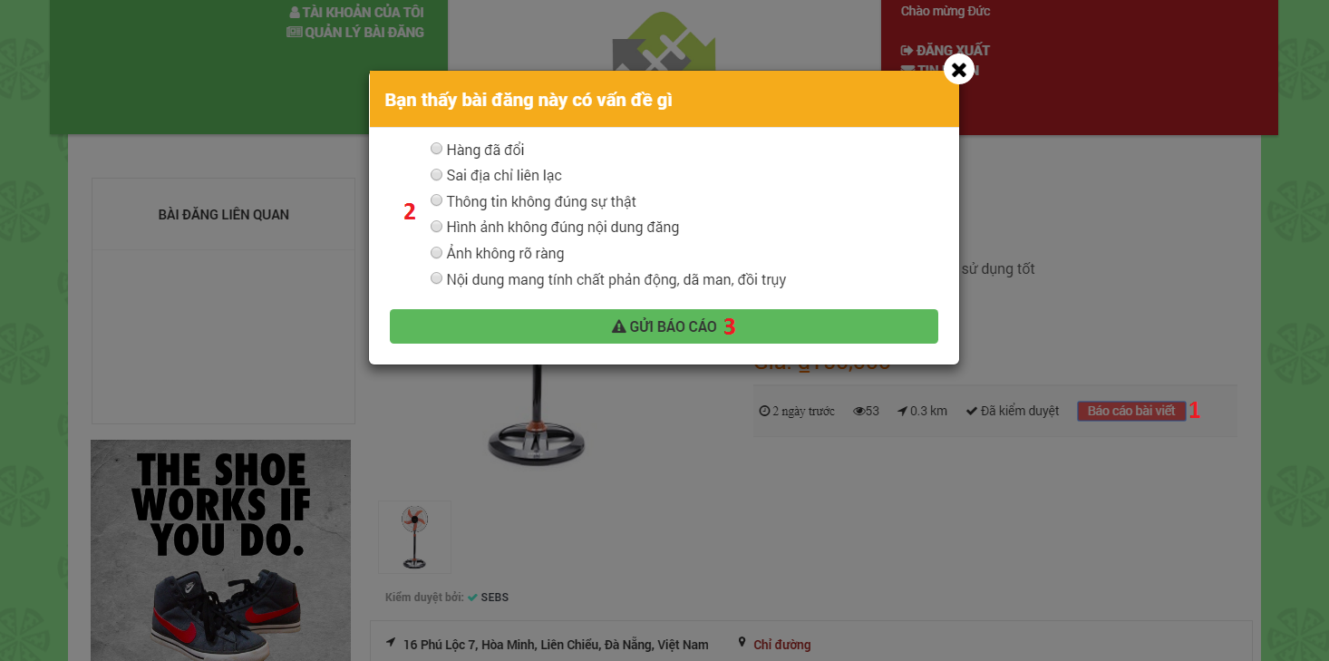

Figure : <Web> Feedback Posts UI

**Fields**

|  |  |  |  |  |  |  |  |
| --- | --- | --- | --- | --- | --- | --- | --- |
| **No** | **Field Name** | **Description** | **Read Only** | **Mandatory** | **Control Type** | **Data Type** | **Length** |
| 2 | Problems | Problems want to feedback | No | Yes | Radio button | String | N/A |

**Button/ Hyperlinks**

|  |  |  |  |  |
| --- | --- | --- | --- | --- |
| **No** | **Function** | **Description** | **Validation** | **Outcome** |
| 1 | Feedback post | Click “Báo cáo bài viết” button to feedback post | N/A | Feedback post |
| 3 | Send feedback | Click “GỬI BÁO CÁO” button to send feedbacks | N/A | Send feedback |

* + - 1. <Web> View Post Detail

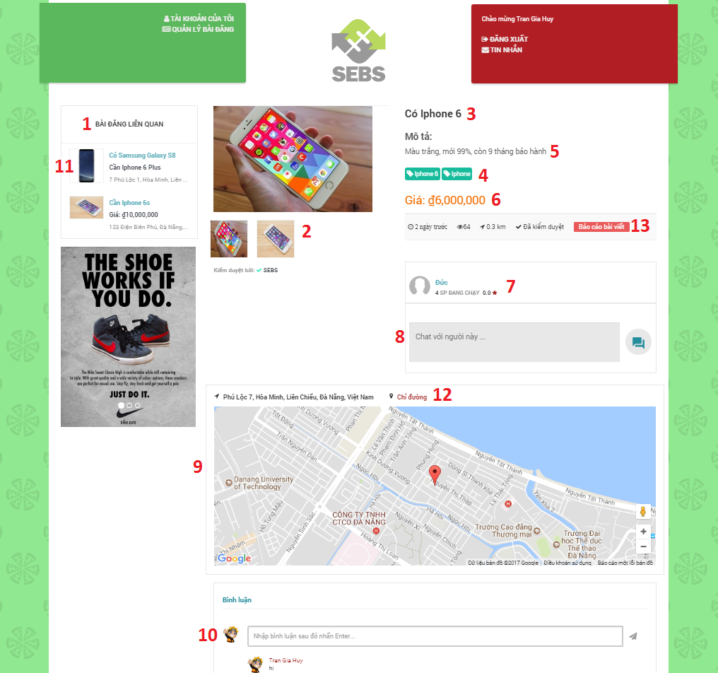

Figure : <Web> View Post Detail UI

**Fields**

|  |  |  |  |  |  |  |  |
| --- | --- | --- | --- | --- | --- | --- | --- |
| **No** | **Field Name** | **Description** | **Read Only** | **Mandatory** | **Control Type** | **Data Type** | **Length** |
| 1 | Related posts | Related posts with current post | Yes | Yes | Text | String | N/A |
| 2 | Image | Images of product | Yes | Yes | Image | String | N/A |
| 3 | Product name | Product name of post | Yes | Yes | Text | String | N/A |
| 4 | Tags | Tag tags for related posts | Yes | No | Text | String | N/A |
| 5 | Product description | Detailed description of the product | Yes | Yes | Text | String | N/A |
| 6 | Price | Price of product | Yes | No | Text | String | N/A |
| 7 | Information of poster | Full name and avatar of poster | Yes | Yes | Text | String | N/A |
| 8 | Chat | Chat with this user | No | Yes | Textbox | String | N/A |
| 9 | Address | Address (map) of post | Yes | Yes | Text | String | N/A |
| 10 | Comment | Comment on this post | No | Yes | Textbox | String | N/A |

**Button/ Hyperlinks**

|  |  |  |  |  |
| --- | --- | --- | --- | --- |
| **No** | **Function** | **Description** | **Validation** | **Outcome** |
| 11 | Related posts | Click a related posts to view this post detail | N/A | View this related post |
| 12 | Guide | Click “chỉ đường” to google map | N/A | Guide by google map |
| 13 | Feedback posts | Click “Báo cáo bài viết” to feedback post | N/A | Feedback posts |

* + - 1. <Web> Manage Posts

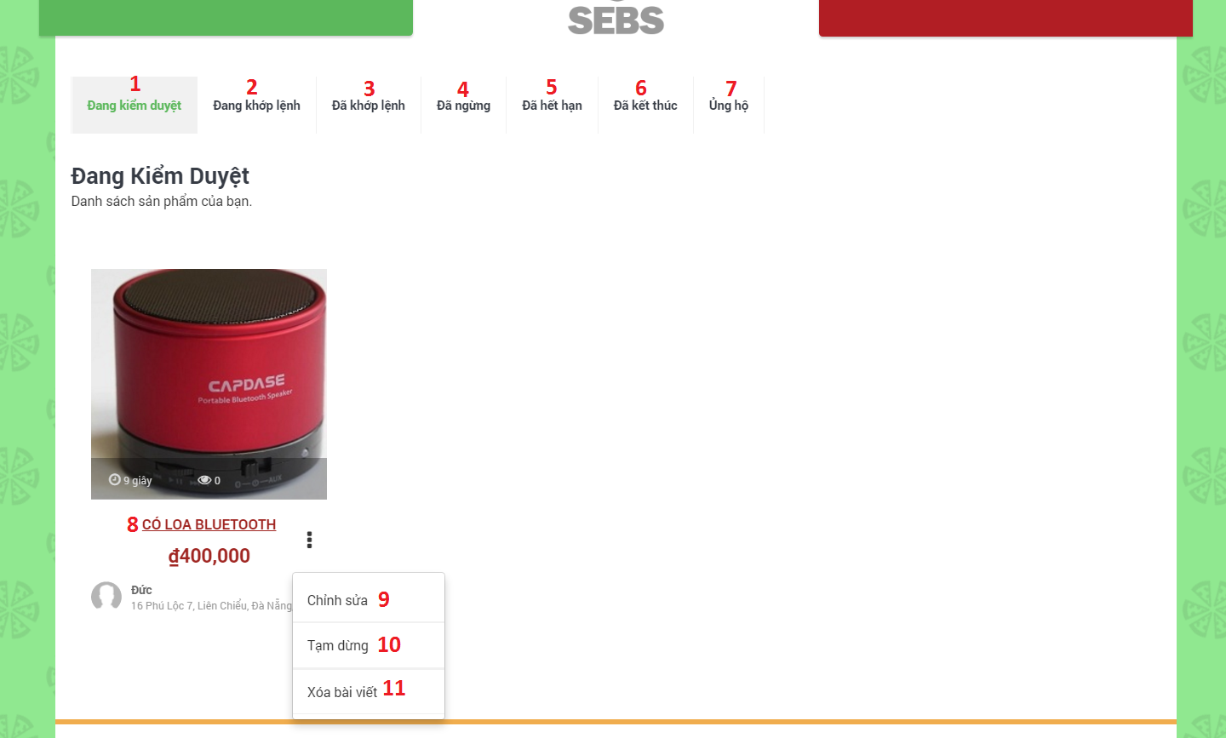

Figure : <Web> Manage Posts UI

**Fields**

|  |  |  |  |  |  |  |  |
| --- | --- | --- | --- | --- | --- | --- | --- |
| **No** | **Field Name** | **Description** | **Read Only** | **Mandatory** | **Control Type** | **Data Type** | **Length** |
| 1 | Examining | Posts are examining of admin | Yes | Yes | Tab | String | N/A |
| 2 | Matching | Posts are matching | Yes | Yes | Tab | String | N/A |
| 3 | Matched | Posts matched | Yes | Yes | Tab | String | N/A |
| 4 | Stopped | Posts stopped by user | Yes | Yes | Tab | String | N/A |
| 5 | Expired | Posts expired | Yes | Yes | Tab | String | N/A |
| 6 | Finished | Posts finished | Yes | Yes | Tab | String | N/A |
| 7 | Donated | Posts donated | Yes | Yes | Tab | String | N/A |

**Button/ Hyperlinks**

|  |  |  |  |  |
| --- | --- | --- | --- | --- |
| **No** | **Function** | **Description** | **Validation** | **Outcome** |
| 8 | View post detail | View a post detail | N/A | View post detail |
| 9 | Edit | Click “Chỉnh sửa” to edit information | N/A | Edit information of this post |
| 10 | Stop | Click “Tạm dừng” to stop post | N/A | Stop post |
| 11 | Delete | Click “Xóa bài viết” to delete post | N/A | Delete post |

* + - 1. <Web> Admin Dashboard

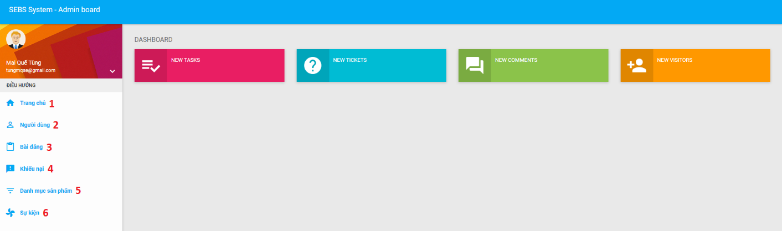

Figure : <Web> Admin Dashboard UI

**Button/ Hyperlinks**

|  |  |  |  |  |
| --- | --- | --- | --- | --- |
| **No** | **Function** | **Description** | **Validation** | **Outcome** |
| 1 | View dashboard | Click “Trang chủ” to view admin dashboard | N/A | View dashboard |
| 2 | Manage users | Click “Người dùng” to manage users | N/A | Manage users |
| 3 | Manage posts | Click “Bài đăng” to manage posts | N/A | Manage posts |
| 4 | Manage feedbacks | Click “Khiếu nại” to manage feedbacks | N/A | Manage feedbacks |
| 5 | Manage product categories | Click “Danh mục sản phẩm” to manage product categories | N/A | Manage product categories |
| 6 | Manage charity campaigns | Click “Sự kiện” to manage charity campaigns | N/A | Manage charity campaigns |

* + - 1. <Web> Admin Manage Product Categories

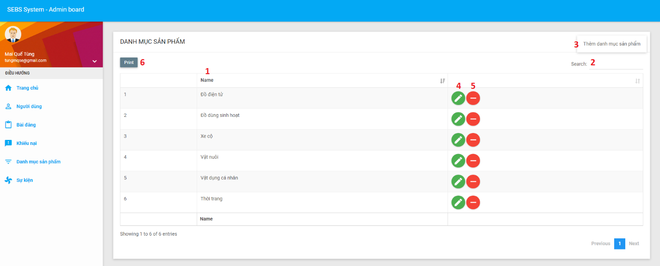

Figure : <Web> Admin Manage Product Categories UI

**Fields**

|  |  |  |  |  |  |  |  |
| --- | --- | --- | --- | --- | --- | --- | --- |
| **No** | **Field Name** | **Description** | **Read Only** | **Mandatory** | **Control Type** | **Data Type** | **Length** |
| 1 | Name | Name of product category | Yes | Yes | Text | String | N/A |
| 2 | Search | Input searching keyword | No | No | Textbox | String | N/A |

**Button/ Hyperlinks**

|  |  |  |  |  |
| --- | --- | --- | --- | --- |
| **No** | **Function** | **Description** | **Validation** | **Outcome** |
| 3 | Create product category | Click “Thêm danh mục sản phẩm” button to create a new product category | N/A | Create new product category |
| 4 | Edit product category | Click “Edit” icon button to edit product category | N/A | Edit product category |
| 5 | Delete product category | Click “Delete” icon button to delete product category | N/A | Delete product category |
| 6 | Print to pdf | Click “Print” button to print to pdf | N/A | Print to pdf |

* + - 1. <Web> Admin Manage Charity Campaigns

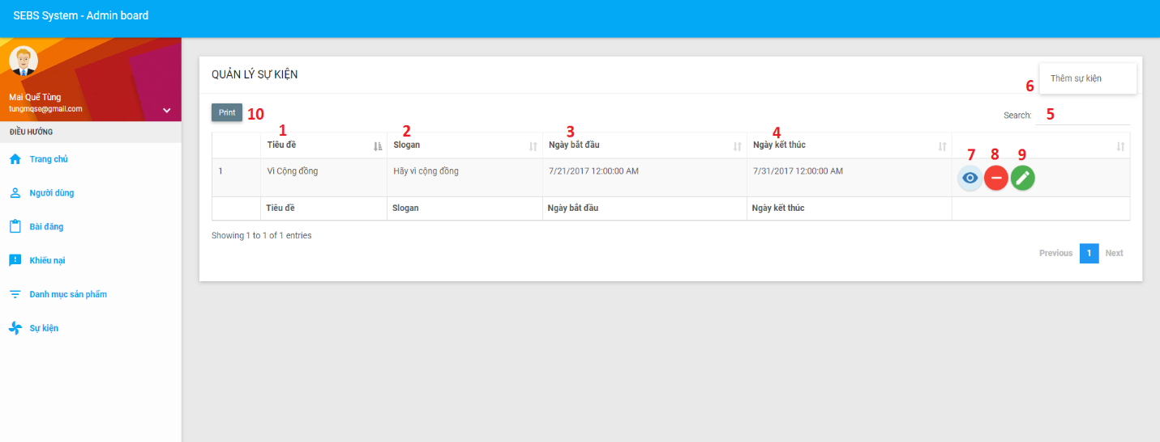

Figure : <Web> Admin Manage Charity Campaigns UI

**Fields**

|  |  |  |  |  |  |  |  |
| --- | --- | --- | --- | --- | --- | --- | --- |
| **No** | **Field Name** | **Description** | **Read Only** | **Mandatory** | **Control Type** | **Data Type** | **Length** |
| 1 | Title | Title of charity campaign | Yes | Yes | Text | String | N/A |
| 2 | Slogan | Slogan of charity campaign | Yes | Yes | Text | String | N/A |
| 3 | Start date | Start date of charity campaign | Yes | Yes | Text | String | N/A |
| 4 | End date | End date of charity campaign | Yes | Yes | Text | String | N/A |
| 5 | Search | Input searching keyword | No | No | Textbox | String | N/A |

**Button/ Hyperlinks**

|  |  |  |  |  |
| --- | --- | --- | --- | --- |
| **No** | **Function** | **Description** | **Validation** | **Outcome** |
| 6 | Create charity campaign | Click “Thêm sự kiện” button to create a new charity campaign | N/A | Create new charity campaign |
| 7 | View charity campaign detail | Click “View detail” icon button to view charity campaign detail | N/A | View charity campaign detail |
| 8 | Delete charity campaign | Click “Delete” icon button to delete charity campaign | N/A | Delete charity campaign |
| 9 | Edit charity campaign | Click “Edit” icon button to edit charity campaign | N/A | Edit charity campaign |
| 10 | Print to pdf | Click “Print” button to print to pdf | N/A | Print to pdf |

* + - 1. <Web> Admin Manage Posts

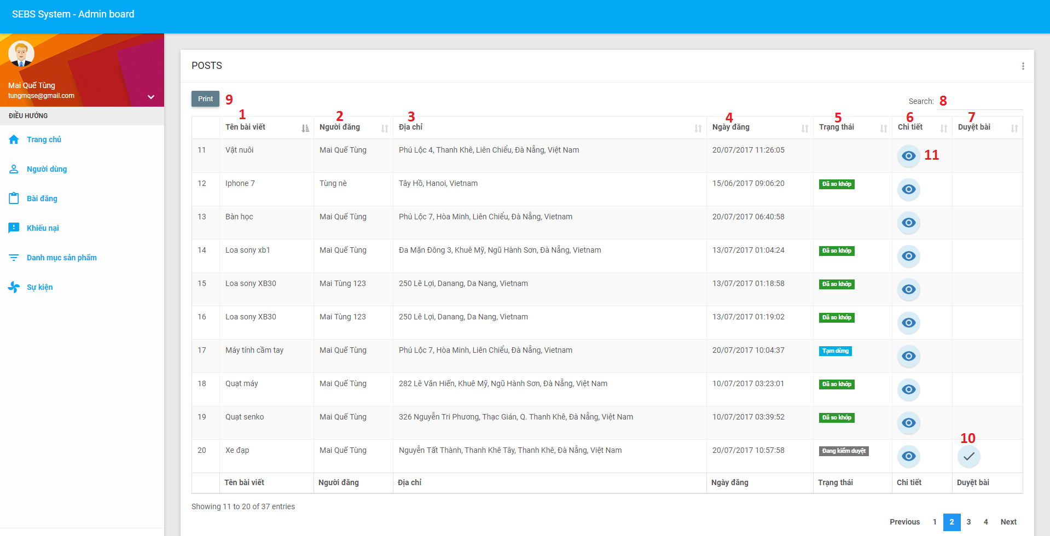

Figure : <Web> Admin Manage Posts UI

**Fields**

|  |  |  |  |  |  |  |  |
| --- | --- | --- | --- | --- | --- | --- | --- |
| **No** | **Field Name** | **Description** | **Read Only** | **Mandatory** | **Control Type** | **Data Type** | **Length** |
| 1 | Name | Full name of the post | Yes | Yes | Text | String | N/A |
| 2 | Poster | Full name of poster | Yes | Yes | Text | String | N/A |
| 3 | Address | Address of the post | Yes | Yes | Text | String | N/A |
| 4 | Post date | The time that the post was posted | Yes | Yes | Text | Datetime | N/A |
| 5 | Status | Status of the post | Yes | Yes | Text | String | N/A |
| 6 | Post detail | Detail information of the post | Yes | Yes | Text | String | N/A |
| 7 | Examine post | The post is examining | Yes | Yes | Text | String | N/A |
| 8 | Search | Input searching keyword | No | No | Textbox | String | N/A |

**Button/ Hyperlinks**

|  |  |  |  |  |
| --- | --- | --- | --- | --- |
| **No** | **Function** | **Description** | **Validation** | **Outcome** |
| 9 | Print to pdf | Click “Print” button to print to pdf | N/A | Print to pdf |
| 10 | Examine post | Click “Duyệt bài” icon button to examine post | N/A | The post is matching |
| 11 | View post detail | Click “Chi tiết” icon button to view post detail | N/A | View post detail |

* + - 1. <Web> Admin Manage Users

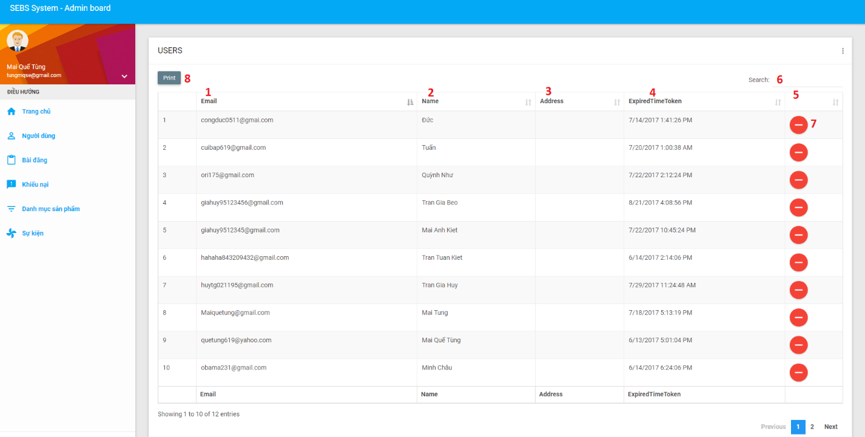

Figure : <Web> Admin Manage Users UI

**Fields**

|  |  |  |  |  |  |  |  |
| --- | --- | --- | --- | --- | --- | --- | --- |
| **No** | **Field Name** | **Description** | **Read Only** | **Mandatory** | **Control Type** | **Data Type** | **Length** |
| 1 | Email | Fill user email | Yes | Yes | Text | String | N/A |
| 2 | Name | Full name of user | Yes | Yes | Text | String | N/A |
| 3 | Address | Address of user | Yes | Yes | Text | String | N/A |
| 4 | Expired Time Token |  | Yes | Yes | Text | Datetime | N/A |
| 5 | Ban User | Ban User of system | No | No | Text | String | N/A |
| 6 | Search | Input searching keyword | No | No | Textbox | String | N/A |

**Button/ Hyperlinks**

|  |  |  |  |  |
| --- | --- | --- | --- | --- |
| **No** | **Function** | **Description** | **Validation** | **Outcome** |
| 7 | Ban user | Click “Ban” icon button to ban this user | N/A | Ban user |
| 8 | Print to pdf | Click “Print” button to print to pdf | N/A | Print to pdf |

* + - 1. <Web> Admin Manage Feedbacks

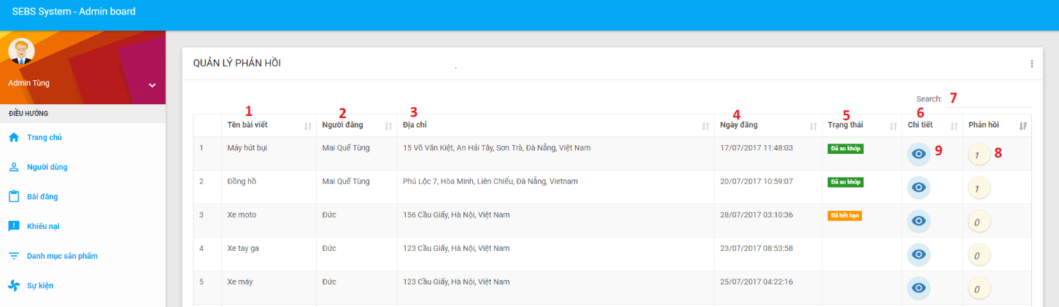

Figure : <Web> Admin Manage Feedbacks UI

**Fields**

|  |  |  |  |  |  |  |  |
| --- | --- | --- | --- | --- | --- | --- | --- |
| **No** | **Field Name** | **Description** | **Read Only** | **Mandatory** | **Control Type** | **Data Type** | **Length** |
| 1 | Name | Full name of the post | Yes | Yes | Text | String | N/A |
| 2 | Poster | Full name of poster | Yes | Yes | Text | String | N/A |
| 3 | Address | Address of the post | Yes | Yes | Text | String | N/A |
| 4 | Post date | The time that the post was posted | Yes | Yes | Text | Datetime | N/A |
| 5 | Status | Status of the post | Yes | Yes | Text | String | N/A |
| 6 | Post detail | Detail information of the post | Yes | Yes | Text | String | N/A |
| 7 | Search | Input searching keyword | No | No | Textbox | String | N/A |

**Button/ Hyperlinks**

|  |  |  |  |  |
| --- | --- | --- | --- | --- |
| **No** | **Function** | **Description** | **Validation** | **Outcome** |
| 8 | View feedback detail | Click “Phản hồi” icon button to view feedback detail | N/A | View feedback detail |
| 11 | View post detail | Click “Chi tiết” icon button to view post detail | N/A | View post detail |

* + - 1. <Mobile> Login

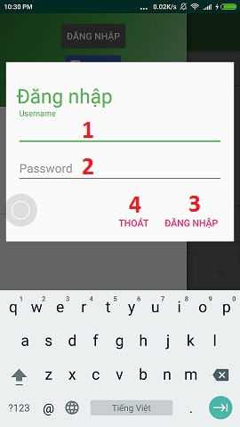

Figure : <Mobile> Login UI

**Fields**

|  |  |  |  |  |  |  |  |
| --- | --- | --- | --- | --- | --- | --- | --- |
| **No** | **Field Name** | **Description** | **Read Only** | **Mandatory** | **Control Type** | **Data Type** | **Length** |
| 1 | Username | Fill user email | No | Yes | Textbox | String | N/A |
| 2 | Password | Fill password | No | Yes | Password | String | N/A |

**Button/ Hyperlinks**

|  |  |  |  |  |
| --- | --- | --- | --- | --- |
| **No** | **Function** | **Description** | **Validation** | **Outcome** |
| 3 | Login | Click “Đăng nhập” button to login the system | N/A | Login |
| 4 | Cancel | Click “Thoát” button to cancel login page | N/A | Cancel |

* + - 1. <Mobile> Register as an User

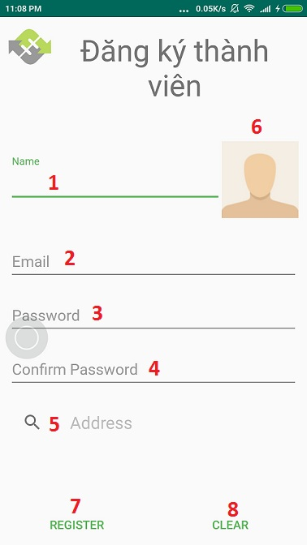

Figure : <Mobile> Register as an User UI

**Fields**

|  |  |  |  |  |  |  |  |
| --- | --- | --- | --- | --- | --- | --- | --- |
| **No** | **Field Name** | **Description** | **Read Only** | **Mandatory** | **Control Type** | **Data Type** | **Length** |
| 1 | Name | Full name of user | No | Yes | Textbox | String | N/A |
| 2 | Email | Fill user email | No | Yes | Textbox | String | N/A |
| 3 | Password | Fill password | No | Yes | Password | String | N/A |
| 4 | Confirm password | Fill confirm password | No | Yes | Password | String | N/A |
| 5 | Address | Address of user | No | Yes | Textbox | String | N/A |

**Button/ Hyperlinks**

|  |  |  |  |  |
| --- | --- | --- | --- | --- |
| **No** | **Function** | **Description** | **Validation** | **Outcome** |
| 6 | Update avatar | Click “Avatar” button to update avatar of user | N/A | Update avatar |
| 7 | Register | Click “Register” button to create a new user | N/A | Register |
| 8 | Clear | Click “Clear” button to remove content of the fill | N/A | Clear |

* + - 1. <Mobile> Find posted Products

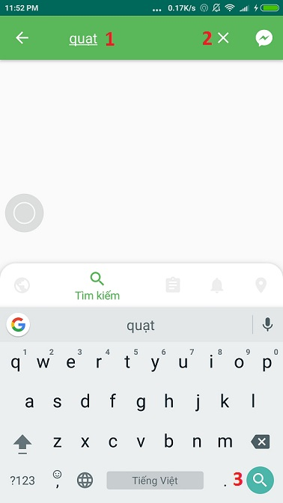

Figure : <Mobile> Find posted Products UI

**Fields**

|  |  |  |  |  |  |  |  |
| --- | --- | --- | --- | --- | --- | --- | --- |
| **No** | **Field Name** | **Description** | **Read Only** | **Mandatory** | **Control Type** | **Data Type** | **Length** |
| 1 | Search | Input searching keyword | No | Yes | Textbox | String | N/A |

**Button/ Hyperlinks**

|  |  |  |  |  |
| --- | --- | --- | --- | --- |
| **No** | **Function** | **Description** | **Validation** | **Outcome** |
| 2 | Close | Click “X” button to remove searching keyword | N/A | Close |
| 3 | Search | Click “Search” icon button to find products | N/A | Search |

* + - 1. <Mobile> View Post Detail

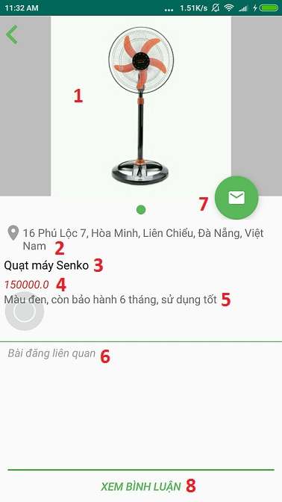

Figure : <Mobile> View Post Detail UI

**Fields**

|  |  |  |  |  |  |  |  |
| --- | --- | --- | --- | --- | --- | --- | --- |
| **No** | **Field Name** | **Description** | **Read Only** | **Mandatory** | **Control Type** | **Data Type** | **Length** |
| 1 | Product image | All image of product | Yes | Yes | Image | String | N/A |
| 2 | Address | Address of poster | Yes | Yes | Text | String | N/A |
| 3 | Product name | Name of product | Yes | Yes | Text | String | N/A |
| 4 | Price | Price of product | Yes | Yes | Text | String | N/A |
| 5 | Description | Description of product | Yes | Yes | Text | String | N/A |
| 6 | Related post | Posts related to this post | No | No | Text | String | N/A |

**Button/ Hyperlinks**

|  |  |  |  |  |
| --- | --- | --- | --- | --- |
| **No** | **Function** | **Description** | **Validation** | **Outcome** |
| 7 | Chat | Click “Chat” icon button to chat with poster | N/A | Chat |
| 8 | Comment | Click “XEM BÌNH LUẬN” button to comment post | N/A | Comment |

* + - 1. <Mobile> Comment Posts

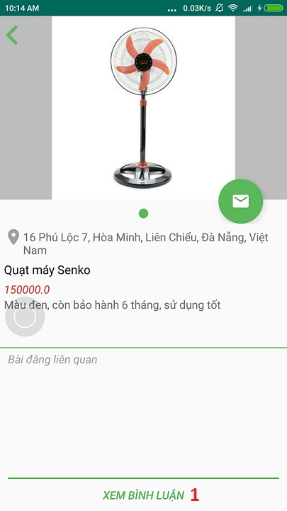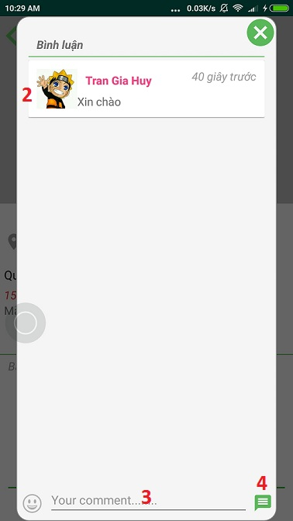

Figure : <Mobile> Comment Posts UI

**Fields**

|  |  |  |  |  |  |  |  |
| --- | --- | --- | --- | --- | --- | --- | --- |
| **No** | **Field Name** | **Description** | **Read Only** | **Mandatory** | **Control Type** | **Data Type** | **Length** |
| 2 | Name of commentator | Full name of commentator | Yes | Yes | Text | String | N/A |
| 3 | Comment | Box input comment content | No | Yes | Textbox | String | N/A |

**Button/ Hyperlinks**

|  |  |  |  |  |
| --- | --- | --- | --- | --- |
| **No** | **Function** | **Description** | **Validation** | **Outcome** |
| 1 | View comment | Click “XEM BÌNH LUẬN” to view all comments | N/A | View comment |
| 4 | Send comment | Click “send” icon button to send comment | N/A | Send comment |

* + - 1. <Mobile> Chat with other Users

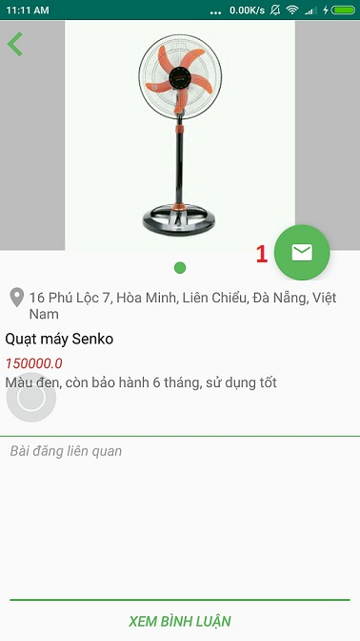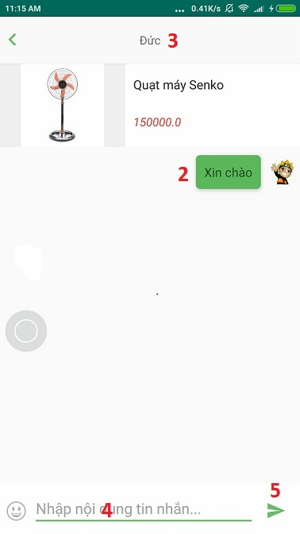

Figure : <Mobile> Chat with other Users

**Fields**

|  |  |  |  |  |  |  |  |
| --- | --- | --- | --- | --- | --- | --- | --- |
| **No** | **Field Name** | **Description** | **Read Only** | **Mandatory** | **Control Type** | **Data Type** | **Length** |
| 2 | Name of sender | Full name of sender | Yes | Yes | Text | String | N/A |
| 3 | Name of receiver | Full name of receiver | Yes | Yes | Text | String | N/A |
| 4 | Chatbox | Box input message content | No | Yes | Textbox | String | N/A |

**Button/ Hyperlinks**

|  |  |  |  |  |
| --- | --- | --- | --- | --- |
| **No** | **Function** | **Description** | **Validation** | **Outcome** |
| 1 | View chat | Click “Chat” icon button to view chat | N/A | View chat |
| 5 | Send message | Click ”send” button to send message | N/A | Send message |

* + - 1. Mobile loads owner menu

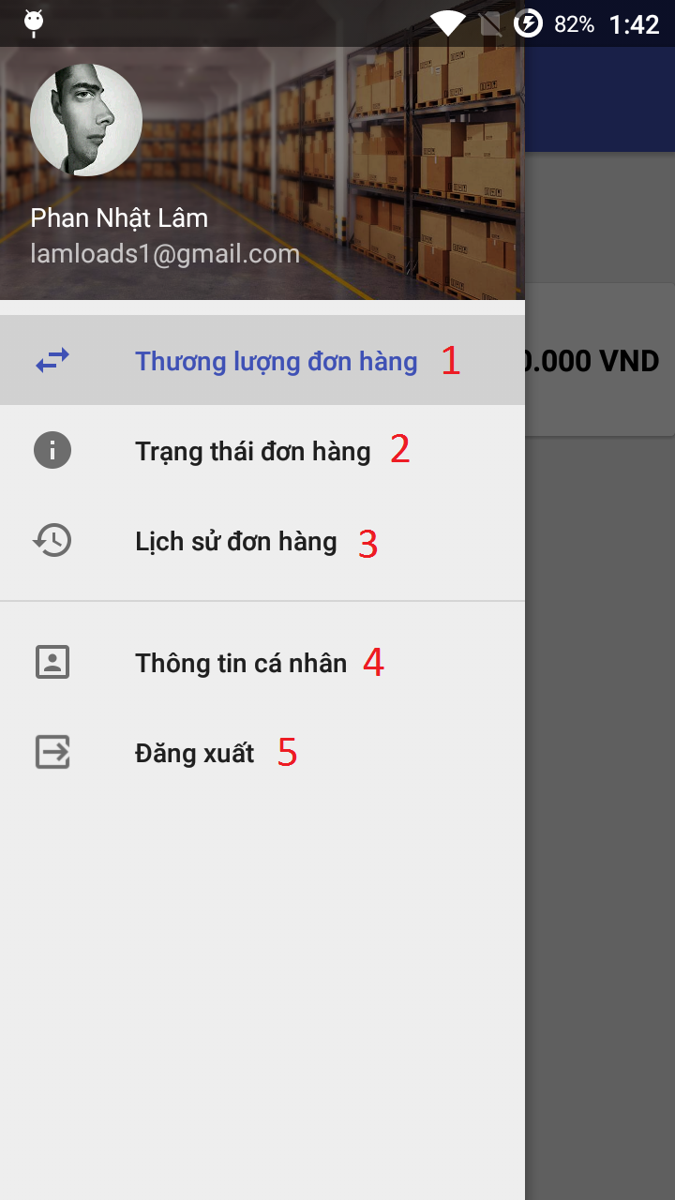

Figure : Loads Owner Menu UI

**Button/ Hyperlinks**

|  |  |  |  |  |
| --- | --- | --- | --- | --- |
| **No** | **Function** | **Description** | **Validation** | **Outcome** |
| 1 | Deal order | Deal this order | N/A | Deal order page is shown |
| 2 | Order status | View list of order status | N/A | Order status screen is shown |
| 3 | Order history | View all order of this loads owner | N/A | Order history screen is shown |
| 4 | Profile | Show loads owner’s profile | N/A | Profile screen is shown |
| 5 | Log out | Log out | N/A | Logging out of system |

* 1. Database design
     1. Entity relationship diagram

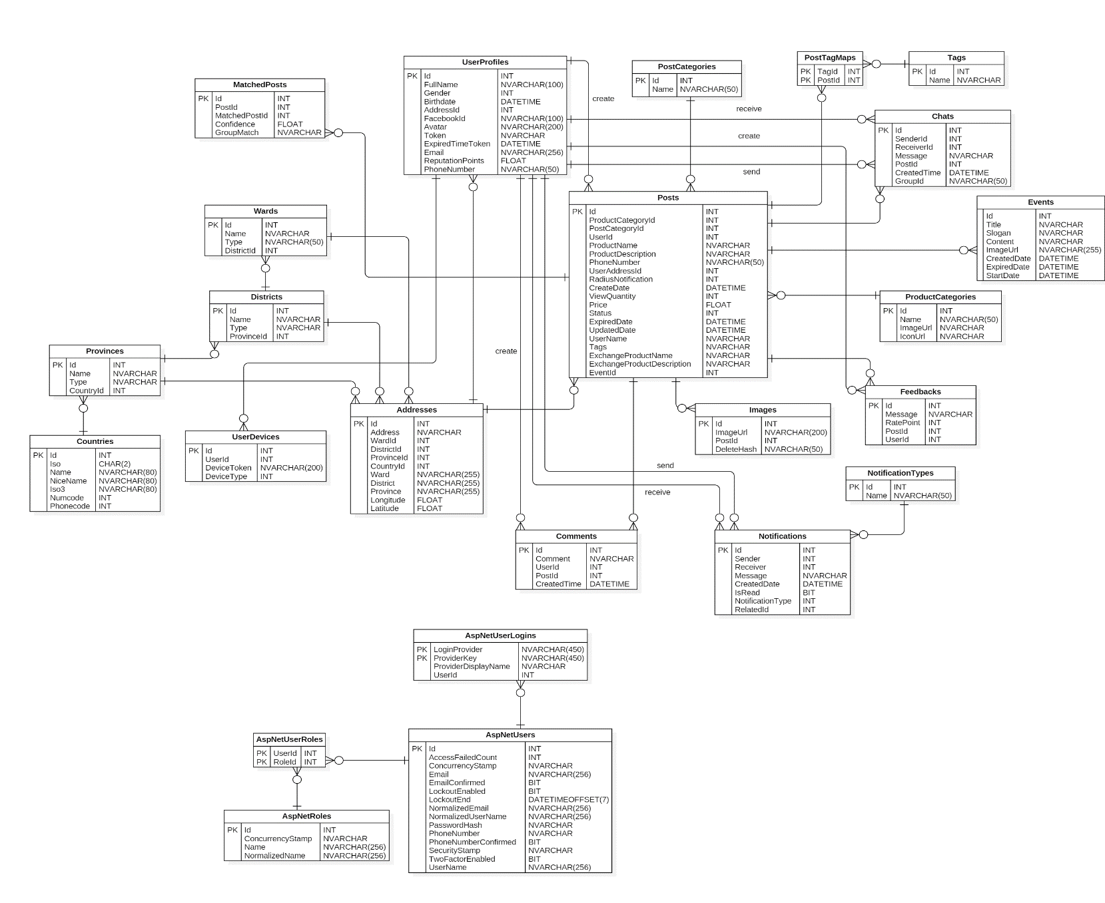

Figure : Entity Relationship Diagram

* + 1. Data dictionary

|  |  |
| --- | --- |
| **Entity Data Dictionary: describe contents of all entities** | |
| **Entity Name** | **Description** |
| UserProfiles | Contain information of user in the system |
| Wards | Contain information of ward |
| Districts | Contain information of district |
| Provinces | Contain information of province |
| Countries | Contain information of country |
| UserDevices | Contain information device of user that user receive notification |
| Addresses | Contain information about address of user |
| Comments | Contain comment information of user on post |
| Posts | Contain information of post in the system |
| Images | Contain all image of posts in the system |
| PostCategories | Contain information of post category in the system |
| Chats | Contain information of conversations between users |
| ProductCategories | Contain information of product category in the system |
| Feedbacks | Contain feedback information of user on posts |
| NotificationTypes | Contain information of notification type that user receive |
| Notifications | Contain information of notification that user receive |
| PostTagMaps | Contain information between tag and post |
| Tags | Contain information of tag in the system |
| MatchedPosts | Contain information that posts are matched |
| Events | Contain information of event in the system |
| AspNetUserLogins | Contain information of external user login by Facebook |
| AspNetUsers | Contain general information of user in the system |
| AspNetUserRoles | Contain information between user and role |
| AspNetRoles | Contain information of roles in the system |

Table : Entity Data Dictionary

* 1. Algorithms
     1. Match Posts
        1. Requirement

Match the post to others base on tags and location.

* + - 1. Solution

1. Get all posts on system.
2. Get tags in each post if post has tag. The unit of the matching is confidence. Its maximum value is 1.
3. If any posted matched won’t match again.
4. Matching will be recorded if both of matching item have at least one tag.
5. The confidence will be calculated by the formula: (number of tags * 0.1) + (0.3 – distance / 30), the unit of distance is km. If any tag match with others, the record for matching items will be saved.
   * + 1. Pseudo code

Dim tagList1 as List of tags

Dim tagList2 as List of tags

Dim intersectList as List of tags

Dim distance as Distance between 2 posts

If (tagList1.Length > 0 AndAlso tagList2.Length > 0) then

For i=0 to tagList1.Length-1 do

For j=0 to tagList2.Length-1 do

If tagList[i] = tagList[j] then

Add tagList[i] into the intersectList

End If

End For

End For

If intersectList.Length > 0 then

If (intersectList.Length > 7) then

Confidence = 0.7 + 0.3 – distance/30

Else

Confidence = 0.1 * intersectList.Length + 0.3 – (distance/30)

End If

End If

* + - 1. Example

Post A’s information:

* 1. Quạt máy senko
  2. Tags: quạt máy, quạt senko, quạt điện, điện tử, gia dụng
  3. Location: 16 Phú Lộc 7, phường Hòa Minh, quận Liên Chiểu, Thành phố Đà Nẵng

Post B’s information:

1. Quạt treo tường
2. Tags: treo tường, senko, quạt senko, gia dụng, điện tử
3. Location: 142 Phan Châu Trinh, phường Phước Ninh, quận Hải Châu, Thành phố Đà Nẵng

Confidence: (0.1 * 3) + (0.3 – 5.43/30) = 0.419

* + 1. Find nearby Products
       1. Requirement

Search the nearby post base on user’s location.

* + - 1. Solution

1. Get user location by their device.
2. Check their location and requested distance whether is valid.
3. The system will calculate the minimum and maximum of latitude and longitude.
4. Then check all post location. If the post’s location is within range of these maximum, the post is in requested range.
   * + 1. Pseudo code

Dim posts as List of posts

Dim latRange as Range of latitude

Dim lgnRange as Range of longitude

minLat = userLatitude – latRange

maxLat = userLongitude + latRange

minLgn = userLongitude – lgnRange

maxLgn = userLongitude + lgnRange

For i=1 to posts.Length do

If (posts[i].latitude >= minLat AndAlso

post[i].latitude <= maxLat AndAlso post[i].longitude >= minLgn AndAlso post[i].longitude <= maxLgn) then

Add post[i] into returned list

End If

End For

* + - 1. Example

User A’s location:

1. Latitude: 16.0585026
2. Longitude: 108.2199589
3. Radius: 30 km

* Latitude range: 30 * 0.00904404449669892375870489282807 = 0.2713213349009677127611467848421
* Longitude range: 30 * 0.00898311174991016888250089831117 = 0.2694933524973050664750269493351
* **Minimum Latitude**: 15.787181265099032287238853215158
* **Maximum Latitude**: 16.329823934900967712761146784842
* **Minimum longitude**: 107.95046554750269493352497305066
* **Maximum Longitude**: 108.48945225249730506647502694934

|  |  |  |
| --- | --- | --- |
|  | Latitude | Longitude |
| Post 1 | 16.065761 | 108.1935763 |
| Post 2 | 16.129086 | 108.5170203 |
| Post 3 | 16.016303 | 108.091684 |
| Post 4 | 16.024637 | 108.2067473 |
| Post 5 | 14.919989 | 108.7700163 |
| Post 6 | 19.999311 | 105.462573 |

* Post 1, Post 3 and Post 4 meet criteria.

1. System Implementation & Testing
   1. Introduction
      1. Overview

This section describes the approaches and methodologies used by our group to plan, organize and manage the testing process of SEBS system. It provides in detail all necessary information about system implementation information and testing procedure of SEBS, includes test plan, test cases and test results.

* + 1. Test approach
* Goal: test the features in the SEBS system based on the core flow.
* Method: Black-box testing.
* All of the team member must be involved in the testing process.

The testing process focus on assesing the realiability of SEBS system, includes finding errors that caused between the interactions of system components.

* 1. Database Relationship Diagram
     1. Physical diagram



Figure : Database relationship diagram

* + 1. Data dictionary

**Data Dictionary**

|  |  |  |
| --- | --- | --- |
| **Class Dictionary: Describe content of all table** | | |
| **Class name** | **Description** | **Mapping with class diagram** |
| UserProfiles | Contains the information of user in system | UserProfiles |
| Wards | Contains the information of ward in district | Wards |
| Districts | Contains the information of district in province | Districts |
| Provinces | Contains the information of province in country | Provinces |
| Countries | Contains the information of country | Countries |
| UserDevices | Contains the information device of user that user receive notification | UserDevices |
| Addresses | Contains the information about address of user | Addresses |
| Comments | Contains comment information of user on post | Comments |
| Posts | Contains the information of post in system | Posts |
| Images | Contains all image of posts in system | Images |
| PostCategories | Contains category of post in system | PostCategories |
| Chats | Contains information of conversations between users | Chats |
| ProductCategories | Contains category of product in system | ProductCategories |
| Feedbacks | Contains feedback information of user on posts | Feedbacks |
| NotificationTypes | Contains type of notification type that user receive | NotificationTypes |
| Notifications | Contains the information of notification that user receive | Notifications |
| PostTagMaps | Contains the information between tag and post | PostTagMaps |
| Tags | Contains the information of tag in system | Tags |
| MatchedPosts | Contains the information that posts are matched | MatchedPosts |
| Events | Contains the information of event in system | Events |
| AspNetUserLogins | Contain the information of external user login by Facebook | AspNetUserLogins |
| AspNetUsers | Contain general information of user | AspNetUsers |
| AspNetUserRoles | Contain the information between user and role | AspNetUserRoles |
| AspNetRoles | Contain the information of role | AspNetRoles |

Table : Class Data Dictionary

* 1. Test Plan

The purpose of this section is to verify and ensure that SEBS meets its design specification and other requirements from user. The following part will describe which features to be tested and which will not.

* + 1. Feature to be tested:

Web application:

* Guest: Register as an user.
* User: Find nearby products, find posted products, delete post, cancel post, finish post, post buying, post selling, post exchanging, post charity, feedback posts, comment posts, chat with other users.
* Admin: Ban user, examine post, extend post, create charity campaign.

Mobile application:

* Guest: Register as an user.
* User: Find nearby products, find posted products, delete post, cancel post, finish post, post buying, post selling, post exchanging, post charity, comment posts, chat with other users.
  + 1. Feature not to be tested:

Web application:

* Guest: Login, change language.
* User: Logout, change password, edit profile, receive notification, view post list, view post detail, edit post, match posts.
* Admin: View user list, view feedback list, view post list, edit charity campaign, delete charity campaign, create product category, edit product category, delete product category, view statistic report.

Mobile application:

* Guest: Login, change language.
* User: Logout, change password, edit profile, receive notification, view post list, view post detail, edit post, match posts.
  1. System Testing Test Cases
     1. Test case
        1. Web application test cases
           1. <Guest> Register as an User

|  |  |  |  |  |  |  |  |
| --- | --- | --- | --- | --- | --- | --- | --- |
| **ID** | **Test case description** | **Pre-condition** | **Test case procedure** | **Expected output** | **Inter-test case dependence** | **Result** | **Test Date** |
| RU01 | Register to this system as an user with valid information | N/A | 1 - Input email with no email existed  2 - Input password (uppercase, lowercase, special character and digit)  3 - Input confirm password (matching password)  4 - Input full name  5 - Input address  6 - Click on “ĐĂNG KÝ” | A new user with role user added into system database | N/A | Pass | 28 July 2017 |
| RU02 | Register to this system as an user with exist email | Database contain 1 email that same with guest input | 1 - Input email with existing email | System shows error message “Email đã tồn tại, vui lòng nhập email khác” | N/A | Pass | 28 July 2017 |
| RU03 | Register to this system as an user with some empty fields | N/A | 1 - Input the basic information and let empty full name field | System shows error message below invalid field(s) or empty: “Vui lòng điền vào trường này” | N/A | Pass | 28 July 2017 |
| RU04 | Register to this system as an user but password does not match | N/A | 1 - Input the basic information and input password (uppercase, lowercase, special character and not digit) | System shows error message: “Mật khẩu yêu cầu chữ hoa, thường, số và ký tự đặc biệt!” | N/A | Pass | 28 July 2017 |
| RU05 | Register to this system as an user but password and confirm password do not match | N/A | 1 - Input the basic information and let password, password confirm not match | System shows error message: “Mật khẩu xác nhận chưa chính xác!” | N/A | Pass | 28 July 2017 |

Table : <Guest> Register as an User TC

* + - * 1. <User> Find nearby Products

|  |  |  |  |  |  |  |  |
| --- | --- | --- | --- | --- | --- | --- | --- |
| **ID** | **Test case description** | **Pre-condition** | **Test case procedure** | **Expected output** | **Inter-test case dependence** | **Result** | **Test Date** |
| FN01 | Choose a distance shorter than the distance of existing posts | 1 - Login successful with role user | 1 - Input a distance shorter than all existing posts  2 - Click “Enter” on keyboard | System does not find any posts | N/A | Pass | 28 July 2017 |
| FN02 | Choose a distance equal to an existing post | 1- Login successful with role user | 1 - Input a distance equal to an existing post  2 - Click “Enter” on keyboard | System shows this post and posts with shorter distance | N/A | Pass | 28 July 2017 |
| FN03 | Choose a distance greater than the distance of existing posts | 1- Login successful with role user | 1 - Input a distance greater than all existing posts  2 - Click “Enter” on keyboard | System shows all existing posts | N/A | Pass | 28 July 2017 |
| FN04 | Choose character or string | 1- Login successful with role user | 1 - Input character or string  2 - Click “Enter” on keyboard | After step 1, System does not allow to input character or string | N/A | Pass | 28 July 2017 |

Table : <User> Find nearby Products TC

* + - * 1. <User> Find posted Products

|  |  |  |  |  |  |  |  |
| --- | --- | --- | --- | --- | --- | --- | --- |
| **ID** | **Test case description** | **Pre-condition** | **Test case procedure** | **Expected output** | **Inter-test case dependence** | **Result** | **Test Date** |
| FPP01 | Choose a keyword to find | 1 - Login successful with role user | 1 - Input a keyword  2 - Click “TÌM” button or “Enter” on keyboard | System shows all posts relate to the keyword | N/A | Pass | 28 July 2017 |
| FPP02 | Choose an empty keyword to find | 1 - Login successful with role user | 1 - Input an empty keyword  2 - Click “TÌM” button or “Enter” on keyboard | System shows all existing posts | N/A | Pass | 28 July 2017 |
| FPP03 | Choose a product category to find | 1 - Login successful with role user | 1 - Choose a product category  2 - Click “TÌM” button or “Enter” on keyboard | System shows all posts relate to this product category | N/A | Pass | 28 July 2017 |
| FPP04 | Choose a keyword and a product category to find | 1- Login successful with role user | 1 - Input a keyword  2 - Choose a product category  3 - Click “TÌM” button or “Enter” on keyboard | System shows all posts relate to this keyword and product category | N/A | Pass | 28 July 2017 |

Table : <User> Find posted Products TC

* + - * 1. <User> Delete Post

|  |  |  |  |  |  |  |  |
| --- | --- | --- | --- | --- | --- | --- | --- |
| **ID** | **Test case description** | **Pre-condition** | **Test case procedure** | **Expected output** | **Inter-test case dependence** | **Result** | **Test Date** |
| DP01 | Delete a examining post | 1 - Login successful with role user | 1 - Choose a examining post  2 - Click “Xóa bài viết” in menu drop down | System show message: “Sửa thành công!”. This post is removed from post manager | N/A | Pass | 28 July 2017 |
| DP02 | Delete a matching post | 1 - Login successful with role user | 1 - Choose a matching post  2 - Click “Xóa bài viết” in menu drop down | System show message: “Sửa thành công!”. This post is removed from post manager | N/A | Pass | 28 July 2017 |
| DP03 | Delete a matched post | 1 - Login successful with role user | 1 - Choose a matched post  2 - Click “Xóa bài viết” in menu drop down | System show message: “Sửa thành công!”. This post is removed from post manager | N/A | Pass | 28 July 2017 |
| DP04 | Delete a stopped post | 1 - Login successful with role user | 1 - Choose a stopped post  2 - Click “Xóa bài viết” in menu drop down | System show message: “Sửa thành công!”. This post is removed from post manager | N/A | Pass | 28 July 2017 |
| DP05 | Delete an expired post | 1 - Login successful with role user | 1 - Choose an expired post  2 - Click “Xóa bài viết” in menu drop down | System show message: “Sửa thành công!”. This post is removed from post manager | N/A | Pass | 28 July 2017 |
| DP06 | Delete a finished post | 1 - Login successful with role user | 1 - Choose a finished post  2 - Click “Xóa bài viết” in menu drop down | System show message: “Sửa thành công!”. This post is removed from post manager | N/A | Pass | 28 July 2017 |

Table : <User> Delete Post TC

* + - * 1. <User> Cancel Post

|  |  |  |  |  |  |  |  |
| --- | --- | --- | --- | --- | --- | --- | --- |
| **ID** | **Test case description** | **Pre-condition** | **Test case procedure** | **Expected output** | **Inter-test case dependence** | **Result** | **Test Date** |
| CP01 | Cancel a examining post | 1 - Login successful with role user | 1 - Choose a examining post  2 - Click “Tạm dừng” in menu drop down | System show message: “Sửa thành công!”. This post is stopped from post manager | N/A | Pass | 28 July 2017 |
| CP02 | Cancel a matching post | 1 - Login successful with role user | 1 - Choose a matching post  2 - Click “Tạm dừng” in menu drop down | System show message: “Sửa thành công!”. This post is stopped from post manager | N/A | Pass | 28 July 2017 |

Table : <User> Cancel Post TC

* + - * 1. <User> Finish Post

|  |  |  |  |  |  |  |  |
| --- | --- | --- | --- | --- | --- | --- | --- |
| **ID** | **Test case description** | **Pre-condition** | **Test case procedure** | **Expected output** | **Inter-test case dependence** | **Result** | **Test Date** |
| FP01 | Finish a matching post | 1 - Login successful with role user | 1 - Choose a matching post  2 - Click “Đã kết thúc” in menu drop down | System show message: “Sửa thành công!”. This post is finished from post manager | N/A | Pass | 28 July 2017 |

Table : <User> Finish Post TC

* + - * 1. <User> Post Buying

|  |  |  |  |  |  |  |  |
| --- | --- | --- | --- | --- | --- | --- | --- |
| **ID** | **Test case description** | **Pre-condition** | **Test case procedure** | **Expected output** | **Inter-test case dependence** | **Result** | **Test Date** |
| PB01 | Post buying with valid information | 1 - Login successful with role user | 1 - Choose a product category  2 - Input product name that you need  3 - Input product description  4 - Input product price  5 - Input telephone number  6 - Input your location  7 - Choose a radius to receive notification  8 - Update image of product  9 - Input tags  10 - Click “ĐĂNG TIN” button | System show message: “Đăng bài thành công!”. This post is examining status | N/A | Pass | 29 July 2017 |
| PB02 | Post buying with some required empty fields | 1 - Login successful with role user | 1 - Choose a product category  2 - Let empty name of product field  3 - Input product description  4 - Input product price  5 - Input telephone number  6 - Input your location  7 - Choose a radius to receive notification  8 - Update image of product  9 - Input tags  10 - Click “ĐĂNG TIN” button | System show error message: “Vui lòng nhập đầy đủ thông tin!” | N/A | Pass | 29 July 2017 |
| PB03 | Post buying with some not required empty fields | 1 - Login successful with role user | 1 - Choose a product category  2 - Input product name that you need  3 - Let empty description of product field  4 - Input product price  5 - Input telephone number  6 - Input your location  7 - Choose a radius to receive notification  8 - Update image of product  9 - Input tags  10 - Click “ĐĂNG TIN” button | System show message: “Đăng bài thành công!”. This post is examining status | N/A | Pass | 29 July 2017 |

Table : <User> Post Buying TC

* + - * 1. <User> Post Selling

|  |  |  |  |  |  |  |  |
| --- | --- | --- | --- | --- | --- | --- | --- |
| **ID** | **Test case description** | **Pre-condition** | **Test case procedure** | **Expected output** | **Inter-test case dependence** | **Result** | **Test Date** |
| PS01 | Post selling with valid information | 1 - Login successful with role user | 1 - Choose a product category  2 - Input product name that you have  3 - Input product description  4 - Input product price  5 - Input telephone number  6 - Input your location  7 - Choose a radius to receive notification  8 - Update image of product  9 - Input tags  10 - Click “ĐĂNG TIN” button | System show message: “Đăng bài thành công!”. This post is examining status | N/A | Pass | 29 July 2017 |
| PS02 | Post selling with some required empty fields | 1 - Login successful with role user | 1 - Choose a product category  2 - Let empty name of product field  3 - Input product description  4 - Input product price  5 - Input telephone number  6 - Input your location  7 - Choose a radius to receive notification  8 - Update image of product  9 - Input tags  10 - Click “ĐĂNG TIN” button | System show error message: “Vui lòng nhập đầy đủ thông tin!” | N/A | Pass | 29 July 2017 |
| PS03 | Post selling with some not required empty fields | 1 - Login successful with role user | 1 - Choose a product category  2 - Input product name that you need  3 - Let empty description of product field  4 - Input product price  5 - Input telephone number  6 - Input your location  7 - Choose a radius to receive notification  8 - Update image of product  9 - Input tags  10 - Click “ĐĂNG TIN” button | System show message: “Đăng bài thành công!”. This post is examining status | N/A | Pass | 29 July 2017 |

Table : <User> Post Selling TC

* + - * 1. <User> Post Exchanging

|  |  |  |  |  |  |  |  |
| --- | --- | --- | --- | --- | --- | --- | --- |
| **ID** | **Test case description** | **Pre-condition** | **Test case procedure** | **Expected output** | **Inter-test case dependence** | **Result** | **Test Date** |
| PE01 | Post exchanging with valid information | 1 - Login successful with role user | 1 - TÔI CẦN  2 - Choose a product category  3 - Input product name that you need  4 - Input product description that you need  5 - Input telephone number  6 - Input your location  7 - Choose a radius to receive notification  8 - Update image of product  9 - Input tags  10 - TÔI CÓ  11 - Input product name that you have  12 - Input product description that you have  13 - Click “ĐĂNG TIN” button | System show message: “Đăng bài thành công!”. This post is examining status | N/A | Pass | 29 July 2017 |
| PE02 | Post exchanging with some required empty fields | 1 - Login successful with role user | 1 - TÔI CẦN  2 - Choose a product category  3 - Let empty name of product field that you need  4 - Input product description that you need  5 - Input telephone number  6 - Input your location  7 - Choose a radius to receive notification  8 - Update image of product  9 - Input tags  10 - TÔI CÓ  11 - Input product name that you have  12 - Input product description that you have  13 - Click “ĐĂNG TIN” button | System show error message: “Vui lòng nhập đầy đủ thông tin!” | N/A | Pass | 29 July 2017 |
| PE03 | Post exchanging with some not required empty fields | 1 - Login successful with role user | 1 - TÔI CẦN  2 - Choose a product category  3 - Input product name that you need  4 - Let empty description of product field that you need  5 - Input telephone number  6 - Input your location  7 - Choose a radius to receive notification  8 - Update image of product  9 - Input tags  10 - TÔI CÓ  11 - Input product name that you have  12 - Input product description that you have  13 - Click “ĐĂNG TIN” button | System show message: “Đăng bài thành công!”. This post is examining status | N/A | Pass | 29 July 2017 |

Table : <User> Post Exchanging TC

* + - * 1. <User> Post Charity

|  |  |  |  |  |  |  |  |
| --- | --- | --- | --- | --- | --- | --- | --- |
| **ID** | **Test case description** | **Pre-condition** | **Test case procedure** | **Expected output** | **Inter-test case dependence** | **Result** | **Test Date** |
| PC01 | Post charity with valid information | 1 - Login successful with role user | 1 - Choose a product category  2 - Input product name that you have  3 - Input product description  4 - Input telephone number  5 - Input your location  6 - Update image of product  7 - Input tags  8 - Click “ĐĂNG TIN” button | System show message: “Đăng bài thành công!”. This post is donated status | N/A | Pass | 29 July 2017 |
| PC02 | Post charity with some required empty fields | 1 - Login successful with role user | 1 - Choose a product category  2 - Let empty name of product field  3 - Input product description  4 - Input telephone number  5 - Input your location  6 - Update image of product  7 - Input tags  8 - Click “ĐĂNG TIN” button | System show error message: “Vui lòng nhập đầy đủ thông tin!” | N/A | Pass | 29 July 2017 |
| PC03 | Post charity with some not required empty fields | 1 - Login successful with role user | 1 - Choose a product category  2 - Input product name that you have  3 - Let empty description of product field  4 - Input telephone number  5 - Input your location  6 - Update image of product  7 - Input tags  8 - Click “ĐĂNG TIN” button | System show message: “Đăng bài thành công!”. This post is donated status | N/A | Pass | 29 July 2017 |

Table : <User> Post Charity TC

* + - * 1. <User> Feedback Posts

|  |  |  |  |  |  |  |  |
| --- | --- | --- | --- | --- | --- | --- | --- |
| **ID** | **Test case description** | **Pre-condition** | **Test case procedure** | **Expected output** | **Inter-test case dependence** | **Result** | **Test Date** |
| FP01 | Feedback post | 1 - Login successful with role user | 1 - Click a post  2 - Click “Báo cáo lỗi” button  3 - Choose a problem  4 - Click “GỬI BÁO CÁO” button | Feedback has been sent to the admin | N/A | Pass | 29 July 2017 |

Table : <User> Feedback Posts TC

* + - * 1. <User> Comment Posts

|  |  |  |  |  |  |  |  |
| --- | --- | --- | --- | --- | --- | --- | --- |
| **ID** | **Test case description** | **Pre-condition** | **Test case procedure** | **Expected output** | **Inter-test case dependence** | **Result** | **Test Date** |
| CP01 | Comment a post | 1 - Login successful with role user | 1 - Choose a post  2 - Input comment content  3 - Click “Enter” on keyboard | The comment was posted | N/A | Pass | 29 July 2017 |

Table : <User> Comment Posts TC

* + - * 1. <User> Chat with other Users

|  |  |  |  |  |  |  |  |
| --- | --- | --- | --- | --- | --- | --- | --- |
| **ID** | **Test case description** | **Pre-condition** | **Test case procedure** | **Expected output** | **Inter-test case dependence** | **Result** | **Test Date** |
| COU01 | Chat with other User from a post | 1 - Login successful with role user | 1 - Click a post to view post detail  2 - Input message content  3 - Click “Enter” on keyboard | System shows chatbox. Message content has been sent | N/A | Pass | 29 July 2017 |
| COU02 | Chat with other User from chatbox | 1 - Login successful with role user | 1 - Click “TIN NHẮN” hyberlink on home page  2 - Click a message  3 - Input message content  4 - Click “Enter” on keyboard | Message content has been sent | N/A | Pass | 29 July 2017 |

Table : <User> Chat with other Users TC

* + - * 1. <Admin> Ban User

|  |  |  |  |  |  |  |  |
| --- | --- | --- | --- | --- | --- | --- | --- |
| **ID** | **Test case description** | **Pre-condition** | **Test case procedure** | **Expected output** | **Inter-test case dependence** | **Result** | **Test Date** |
| BU01 | Agree to ban user | 1 - Login successful with role admin | 1 - Click “Người dùng” on admin page  2 - Click “Cấm người dùng” icon button  3 - Click “Đồng ý” | After step 2, System pops up a message: “Bạn có đồng ý cấm người dùng này?”  After step 3, This user has been banned | N/A | Pass | 29 July 2017 |
| BU02 | Disagree to ban user | 1 - Login successful with role admin | 1 - Click “Người dùng” on admin page  2 - Click “Cấm người dùng” icon button  3 - Click “Hủy” | After step 2, System pops up a message: “Bạn có đồng ý cấm người dùng này?”  After step 3, This user is not banned | N/A | Pass | 29 July 2017 |

Table : <Admin> Ban User TC

* + - * 1. <Admin> Examine Post

|  |  |  |  |  |  |  |  |
| --- | --- | --- | --- | --- | --- | --- | --- |
| **ID** | **Test case description** | **Pre-condition** | **Test case procedure** | **Expected output** | **Inter-test case dependence** | **Result** | **Test Date** |
| EMP01 | Agree to examine post | 1 - Login successful with role admin | 1 - Click “Bài đăng” on admin page  2 - Click “Duyệt bài” icon button  3 - Click “Duyệt” | After step 2, System pops up a message: “Bạn sẽ duyệt bài đăng này?”  After step 3, This post has been examined | N/A | Pass | 29 July 2017 |
| EMP02 | Disagree to examine post | 1 - Login successful with role admin | 1 - Click “Bài đăng” on admin page  2 - Click “Duyệt bài” icon button  3 - Click “Hủy” | After step 2, System pops up a message: “Bạn sẽ duyệt bài đăng này?”  After step 3, This post is not examined | N/A | Pass | 29 July 2017 |

Table : <Admin> Examine Post TC

* + - * 1. <Admin> Extend Post

|  |  |  |  |  |  |  |  |
| --- | --- | --- | --- | --- | --- | --- | --- |
| **ID** | **Test case description** | **Pre-condition** | **Test case procedure** | **Expected output** | **Inter-test case dependence** | **Result** | **Test Date** |
| EP01 | Agree to extend post | 1 - Login successful with role admin | 1 - Click “Bài đăng” on admin page  2 - Click “Gia hạn” icon button  3 - Click “Đồng ý” | After step 2, System pops up a message: “Bạn sẽ gia hạn bài đăng này?”  After step 3, This post has been extended | N/A | Pass | 29 July 2017 |
| EP02 | Disagree to extend post | 1 - Login successful with role admin | 1 - Click “Bài đăng” on admin page  2 - Click “Gia hạn” icon button  3 - Click “Hủy” | After step 2, System pops up a message: “Bạn sẽ gia hạn bài đăng này?”  After step 3, This post is not extended | N/A | Pass | 29 July 2017 |

Table : <Admin> Extend Post TC

* + - * 1. <Admin> Create Charity Campaign

|  |  |  |  |  |  |  |  |
| --- | --- | --- | --- | --- | --- | --- | --- |
| **ID** | **Test case description** | **Pre-condition** | **Test case procedure** | **Expected output** | **Inter-test case dependence** | **Result** | **Test Date** |
| CCC01 | Create charity campaign with valid information | 1 - Login successful with role admin | 1 - Click “Sự kiện” on admin page  2 - Click “Thêm sự kiện”  3 - Input title  4 - Input slogan  5 - Input start date  6 - Input end date  7 - Update avatar  8 - Input content of campaign  9 - Click “Thêm” button | A new charity campaign has been created | N/A | Pass | 29 July 2017 |
| CCC02 | Create charity campaign with some required empty fields | 1 - Login successful with role admin | 1 - Click “Sự kiện” on admin page  2 - Click “Thêm sự kiện”  3 - Let empty title of campaign field  4 - Input slogan  5 - Input start date  6 - Input end date  7 - Update avatar  8 - Input content of campaign  9 - Click “Thêm” button | System show error message: “Vui lòng điền vào trường này” | N/A | Pass | 29 July 2017 |
| CCC03 | Create charity campaign with some not required empty fields | 1 - Login successful with role admin | 1 - Click “Sự kiện” on admin page  2 - Click “Thêm sự kiện”  3 - Input title  4 - Input slogan  5 - Input start date  6 - Input end date  7 - Let empty avatar of campaign field  8 - Input content of campaign  9 - Click “Thêm” button | A new charity campaign has been created | N/A | Pass | 29 July 2017 |

Table : <Admin> Create Charity Campaign TC

* + - 1. Mobile application test cases
         1. <Guest> Register as an User

|  |  |  |  |  |  |  |  |
| --- | --- | --- | --- | --- | --- | --- | --- |
| **ID** | **Test case description** | **Pre-condition** | **Test case procedure** | **Expected output** | **Inter-test case dependence** | **Result** | **Test Date** |
| MRU01 | Register to this system as an user with valid information | N/A | 1 - Input full name  2 - Input email with no email existed  3 - Input password (uppercase, lowercase, special character and digit)  4 - Input confirm password (matching password)  5 - Input address  6 - Click “REGISTER” button | A new user with role user added into system database | N/A | Pass | 04 August 2017 |
| MRU02 | Register to this system as an user with exist email | Database contain 1 email that same with guest input | 1 - Input email with existing email | System does not allow to register | N/A | Pass | 04 August 2017 |
| MRU03 | Register to this system as an user with some empty fields | N/A | 1 - Input the basic information and let empty full name field | System shows error message: “Xin hãy nhập tên” | N/A | Pass | 04 August 2017 |
| MRU04 | Register to this system as an user but password and confirm password do not match | N/A | 1 - Input the basic information and let password, password confirm not match | System shows error message: “Mật khẩu nhập lại không trùng khớp” | N/A | Pass | 04 August 2017 |

Table : (Mobile) Register as an User TC

* + - * 1. Accept Deal (Driver)

|  |  |  |  |  |  |  |  |
| --- | --- | --- | --- | --- | --- | --- | --- |
| **ID** | **Test case description** | **Pre-condition** | **Test case procedure** | **Expected output** | **Inter-test case dependence** | **Result** | **Test Date** |
| DA01 | Accept deal | - Login successful with role driver  - Deal order view loaded successful | 1 - Click on order want to accept deal  2 – Click on “Chấp nhận” | After step 1, Application pops up a view of order detail  After step 2, This order status updated into system database, send notification to loads owner | N/A | Pass | 19 April 2017 |

* + - * 1. <User> Find posted Products

|  |  |  |  |  |  |  |  |
| --- | --- | --- | --- | --- | --- | --- | --- |
| **ID** | **Test case description** | **Pre-condition** | **Test case procedure** | **Expected output** | **Inter-test case dependence** | **Result** | **Test Date** |
| MFP01 | Choose a keyword to find | 1- Login successful with role user | 1 - Input a keyword  2 - Click “Search” icon button on mobile keyboard | System shows all posts relate to the keyword | N/A | Pass | 04 August 2017 |
| MFP02 | Choose an empty keyword to find | 1- Login successful with role user | 1 - Input an empty keyword  2 - Click “Search” icon button on mobile keyboard | System shows empty result | N/A | Pass | 04 August 2017 |

Table : (Mobile) Find posted Products TC

* + - * 1. Deal (Driver)

|  |  |  |  |  |  |  |  |
| --- | --- | --- | --- | --- | --- | --- | --- |
| **ID** | **Test case description** | **Pre-condition** | **Test case procedure** | **Expected output** | **Inter-test case dependence** | **Result** | **Test Date** |
| MD01 | Deal this order with new price > 0 | - Login successful with role driver  - Deal order view loaded successful | 1 - Click on order want to deal  2 - Input a new offer price “912321444” an click on “Done”  3 - Click on “Thoả thuận” | After step 1, Application pops up a view of order detail  After step 2, New offer price changed into “912321444”, this order actual price updated into system database, send notification to transporter | N/A | Pass | 19 April 2017 |
| MD02 | Deal this order with new price < current price | - Login successful with role driver  - Manage deal page loaded successful | 1 - Click on deal button of this deal  2 - Input a new offer price > current price  3 - Click on “Thoả thuận” | After step 1, Application pops up a view of order detail  After step 2, Application pops up a message “Giá đề nghị phải lớn hơn giá hiện tại” | N/A | Pass | 19 April 2017 |

* + - * 1. Rate loads owner

|  |  |  |  |  |  |  |  |
| --- | --- | --- | --- | --- | --- | --- | --- |
| **ID** | **Test case description** | **Pre-condition** | **Test case procedure** | **Expected output** | **Inter-test case dependence** | **Result** | **Test Date** |
| RL01 | Rate 0 star for loads owner | - Login successful with role driver  - Order history view loaded successful | 1 - Click on order to loads owner  2 - Click on rating symbol to rate  3 - Click on “Đánh giá” | After step 1, Application pops up a view of order detail  After step 2, Application pops up a view of rating  After step 3, Application pops up a message “Bạn phải đánh giá sao cho chủ hàng” | N/A | Pass | 19 April 2017 |
| RL02 | Rate 3 star for loads owner | - Login successful with role driver  - Order history view loaded successful | 1 - Click on order to rate driver  2 - Click on rating symbol to rate  3 - Click on third star and input “nice”  4 - Click on “Đánh giá” | After step 1, Application pops up a view of order detail  After step 2, Application pops up a view of rating  After step 4, This rate added into system database | N/A | Pass | 19 April 2017 |

* + - * 1. Accept Deal (Mobile Loads Owner)

|  |  |  |  |  |  |  |  |
| --- | --- | --- | --- | --- | --- | --- | --- |
| **ID** | **Test case description** | **Pre-condition** | **Test case procedure** | **Expected output** | **Inter-test case dependence** | **Result** | **Test Date** |
| MLA01 | Accept deal | - Login successful with role loads owner  - Deal order view loaded successful | 1 - Click on order want to accept deal  2 – Click on “Chấp nhận” | After step 1, Application pops up a view of order detail  After step 2, This order status updated into system database | N/A | Pass | 19 April 2017 |

* + - * 1. Reject Deal (Mobile Loads Owner)

|  |  |  |  |  |  |  |  |
| --- | --- | --- | --- | --- | --- | --- | --- |
| **ID** | **Test case description** | **Pre-condition** | **Test case procedure** | **Expected output** | **Inter-test case dependence** | **Result** | **Test Date** |
| MLR01 | Reject deal | - Login successful with role loads owner  - Deal order view loaded successful | 1 - Click on order want to accept deal  2 – Click on “Từ chối” | After step 1, Application pops up a view of order detail  After step 2, This order status updated into system database | N/A | Pass | 19 April 2017 |

* + - * 1. <User> Comment Posts

|  |  |  |  |  |  |  |  |
| --- | --- | --- | --- | --- | --- | --- | --- |
| **ID** | **Test case description** | **Pre-condition** | **Test case procedure** | **Expected output** | **Inter-test case dependence** | **Result** | **Test Date** |
| MCP01 | Comment a post | 1 - Login successful with role user | 1 - Choose a post  2 - Input comment content  3 - Click “Send” icon button | The comment was posted | N/A | Pass | 04 August 2017 |

Table : (Mobile) Comment Posts TC

* + - * 1. <User> Chat with other Users

|  |  |  |  |  |  |  |  |
| --- | --- | --- | --- | --- | --- | --- | --- |
| **ID** | **Test case description** | **Pre-condition** | **Test case procedure** | **Expected output** | **Inter-test case dependence** | **Result** | **Test Date** |
| MCU01 | Chat with other User from a post | 1 - Login successful with role user | 1 - Click a post to view post detail  2 - Input message content  3 - Click “Send” icon button | System shows chatbox. Message content has been sent | N/A | Pass | 04 August 2017 |
| MCU02 | Chat with other User from chatbox | 1 - Login successful with role user | 1 - Click “Bạn bè” icon button on “Trang chủ” bottom tab bar  2 - Click a message  3 - Input message content  4 - Click “Send” icon button | Message content has been sent | N/A | Pass | 04 August 2017 |

Table : (Mobile) Chat with other Users

1. Software User’s Manual
   1. Installation Guide
      1. Setting up environment at server side

The following software must be installed into the server machine:

* + - 1. Hardware requirements
* CPU: Intel core i3 2.5Ghz or above
* RAM: 4GB (Best with 8GB)
* Hard disk: 30GB or above
* Internet connection: 4 Mbps or above
  + - 1. Software requirements
* Web Server: Internet Information System – IIS 7.
* Operating system: Windows 7 Pro or above
* SQL Server 2012 Express, or above: used to create and manage database of web application.
  + 1. Deployment at server side
       1. Prepare deployment package
* Extract the deployment package to a folder on the server.
* For example: D:\ETSProject

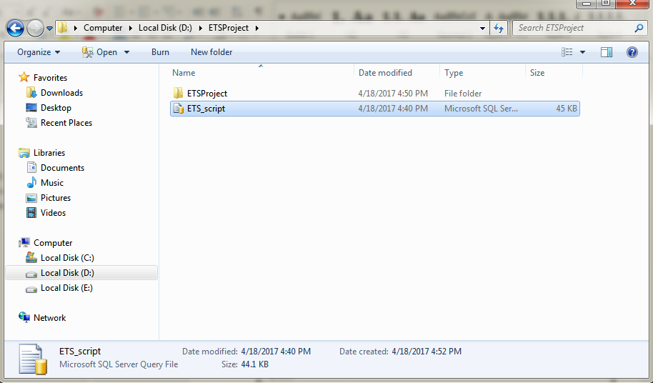

Figure : Extract Deployment package

* + - 1. Database deployment
* Open Microsoft SQL Server Management Studio 2014 and login with administration account.

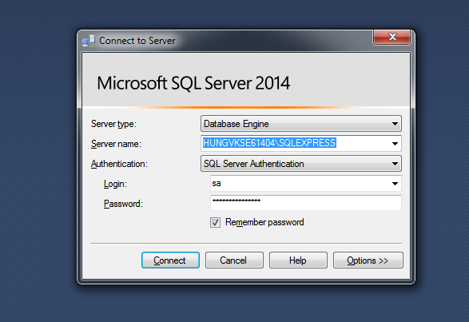

Figure : Connect to server

* Open “ETS_script.sql” in Microsoft SQL Server Management
* Change FILENAME in line 7 and 9 to the directory of SQL Server Instance in your server

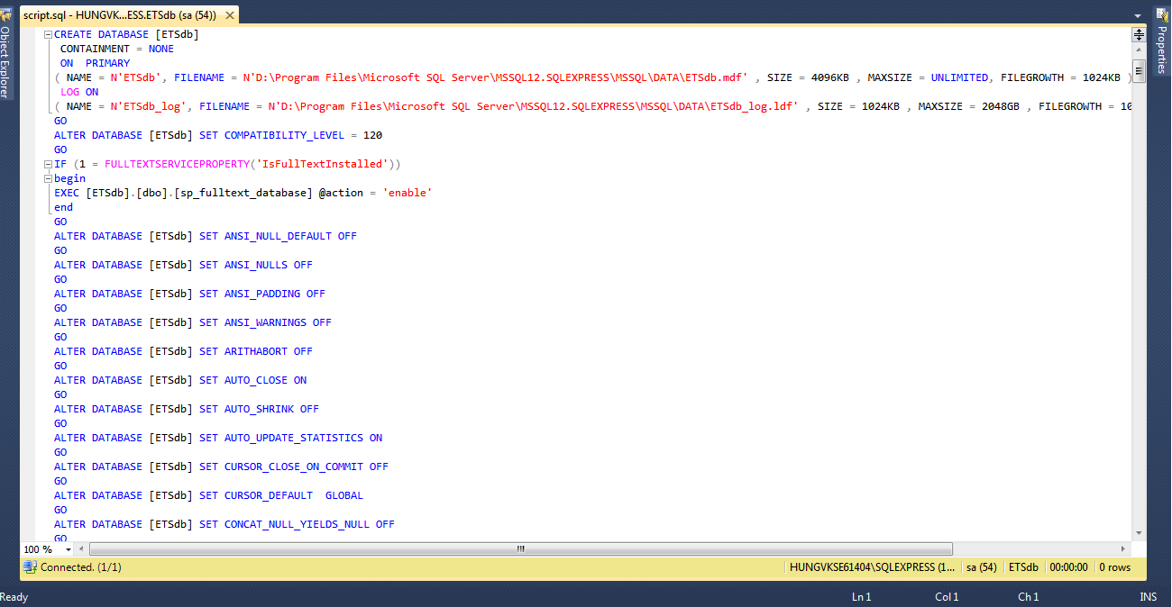

Figure : Open database script

* Execute the script
* Create a new Query and use this script:

alter database [ETSdb] set enable_broker with rollback immediate;

* + - 1. Server configuration

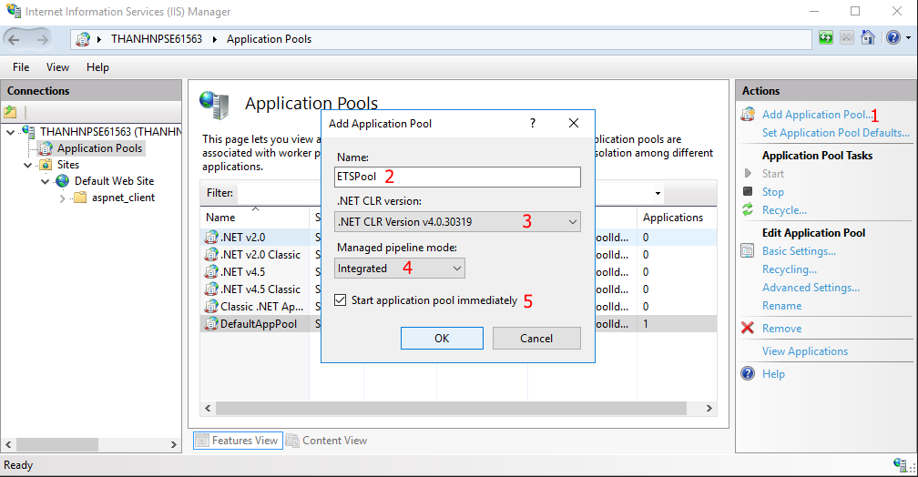

Figure : Create New Application Pool

Create a new Application Pool with the following:

* Name: ETSPool (can be changed to suit your needs)
* .NET CLR version: v4.0
* Pipeline mode: Intergrated

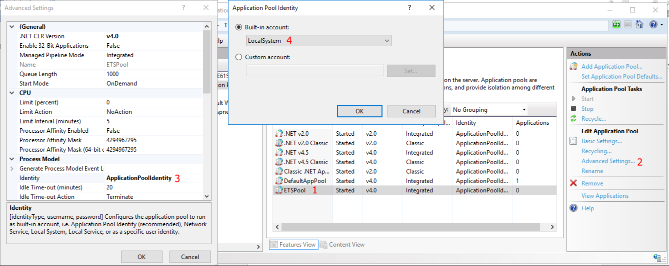

Figure : Configure Application Pool

Change ETSPool setting as following:

* Process Model > Identity: LocalSystem
  + - 1. Deploy
* Change the data source parts of connection string in Web.config (in ETS.Web folder) with your data
* Change the data source parts of connection string in App.config (in ETS.Model folder) with your data

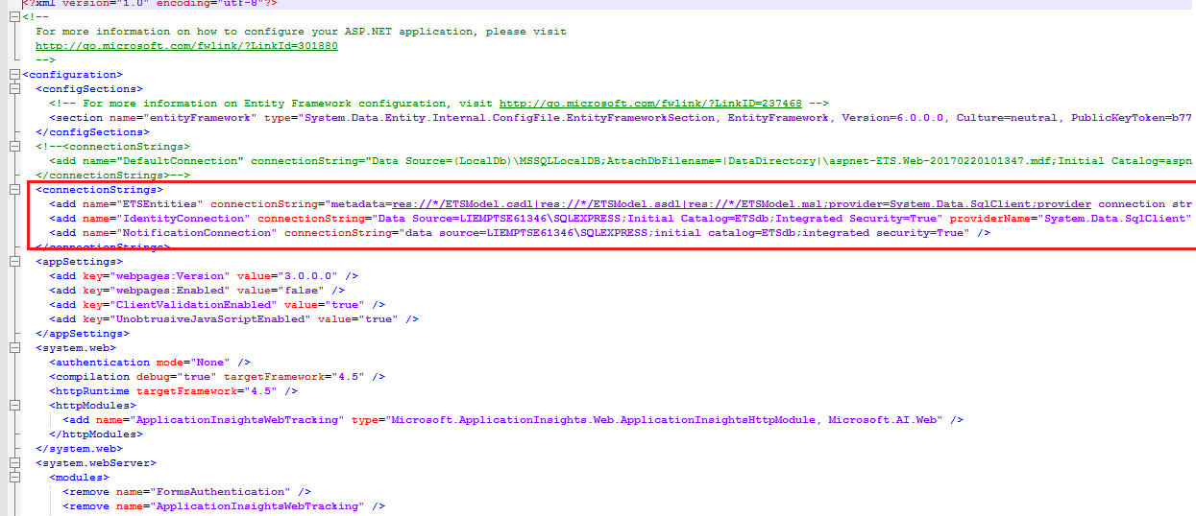

Figure : Change Web.config connection string

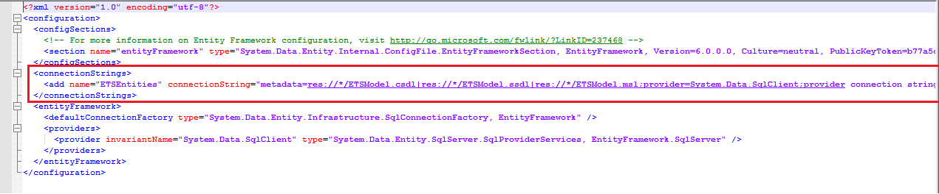

Figure : Change App.config connection string

* On IIS Manager, right click as Sites. Choose “Add Web Site”.

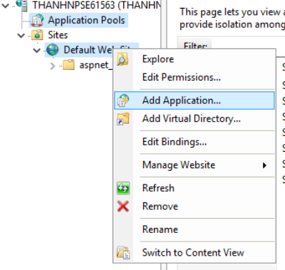

Figure : Deploy web application on server

* Enter site name (ex. ETS). Choose ETS as Application Pool
* Select the path to the “ETS.Web” folder in step 1. 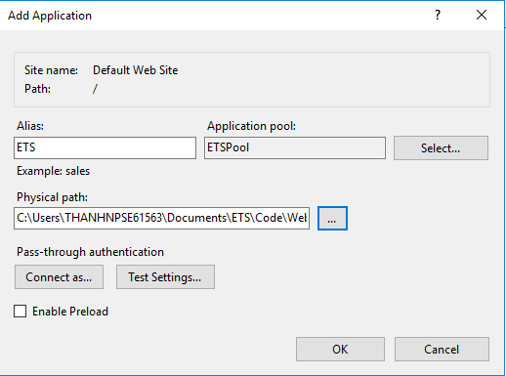

Figure : Deploy web application on server

* Press ok to finish the process
* Choose “Authentication”

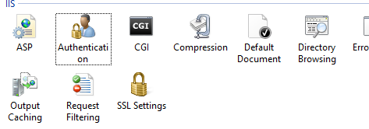

Figure : Authentication Setting

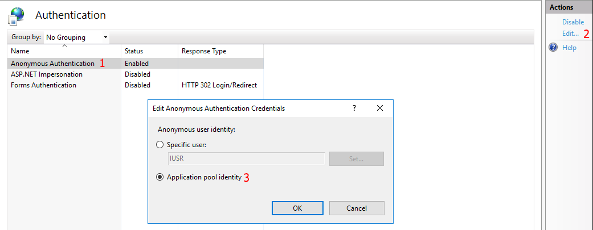

* Choose “Anonymouse Authentication”
* Click “Edit”
* Change Anonymous user identity to “Application pool identity”
  + 1. Client side environment setting

Client side should have one of these following browsers:

* Google Chrome
* Firefox
  1. User Guide
     1. Web Application
        1. <Guest> Login

|  |  |
| --- | --- |
| **Step** | **Description** |
| 1 | Fill in fields:   * Email: Email of guest * Password: Password of guest |
| 2 | Click “ĐĂNG NHẬP” button |

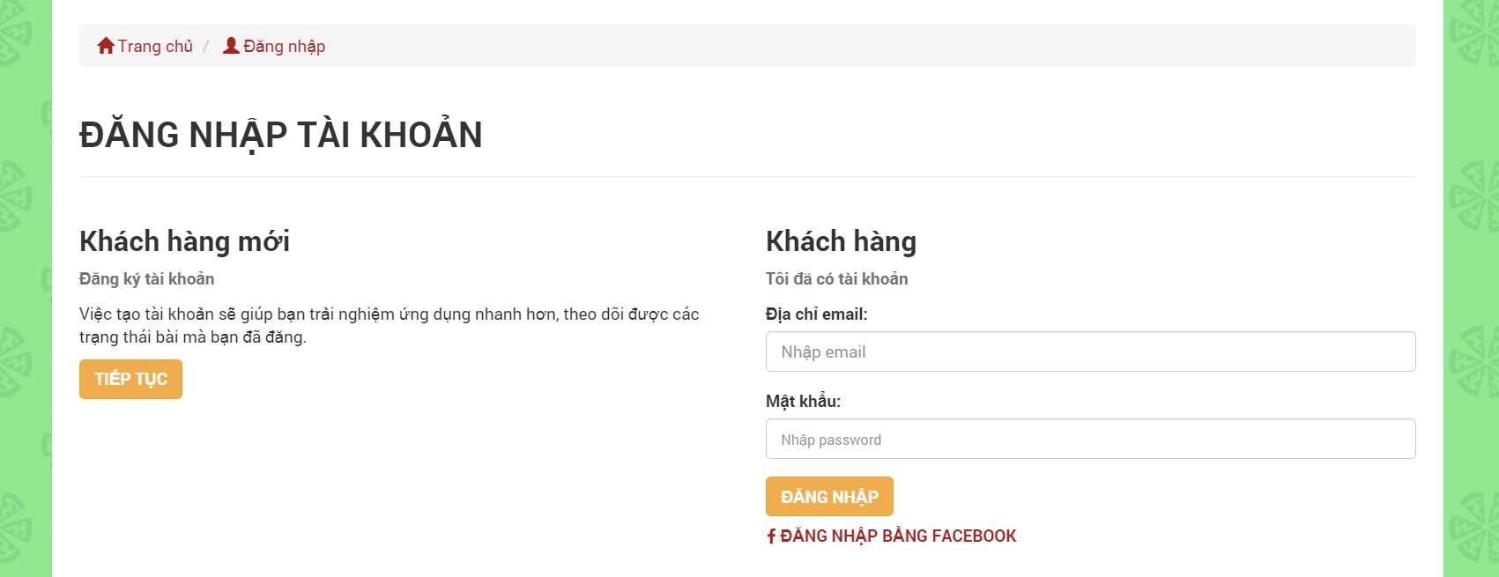

Figure : <Guest> Login UI

* + - 1. <Guest> Register as an User

|  |  |
| --- | --- |
| **Step** | **Description** |
| 1 | Fill in fields:   * Email: Email of guest * Password: Password of guest * Confirm Password: Confirm Password of guest * Full name: Full name of guest * Address: Address of guest |
| 2 | Click “ĐĂNG KÝ” button |

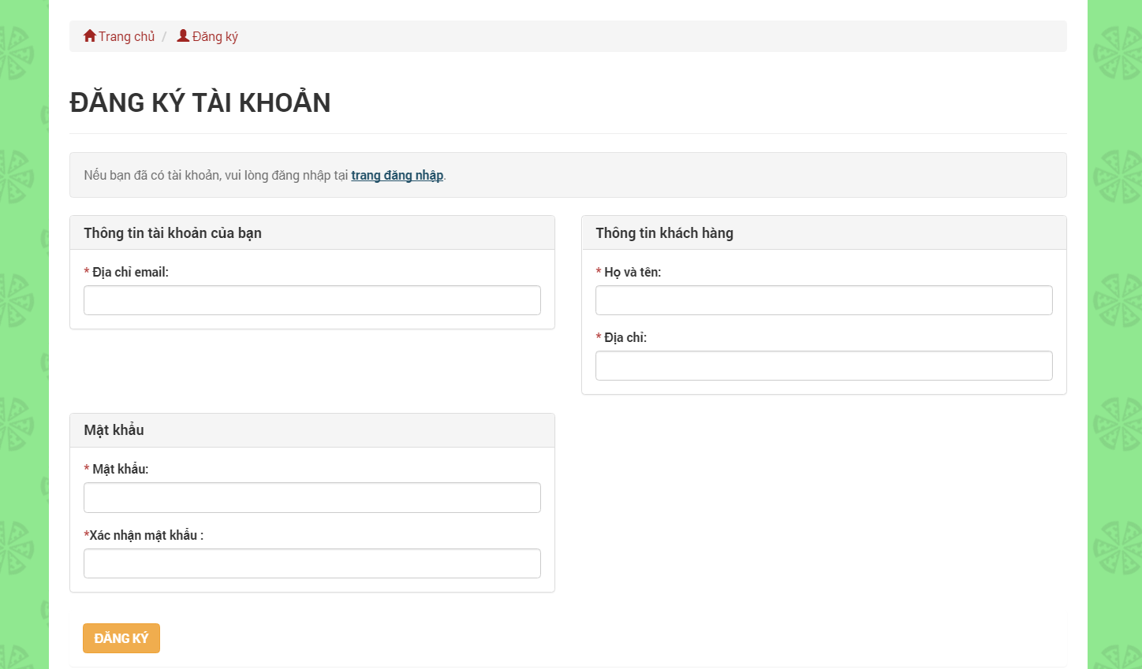

Figure : <Guest> Register as an User UI

* + - 1. <Guest> Find nearby Products

|  |  |
| --- | --- |
| **Step** | **Description** |
| 1 | Click ”QUANH ĐÂY” tab |
| 2 | Click “PHẠM VI” drop down |
| 3 | Fill in field:   * Range: Searching range |
| 4 | Click “Enter” on keyboard |

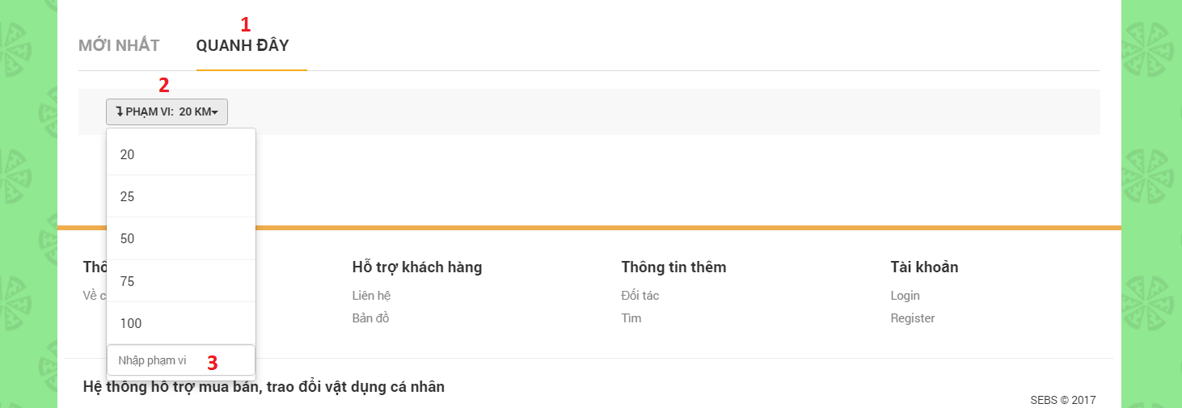

Figure : <Guest> Find nearby Products UI

* + - 1. <Guest> Find posted Products

|  |  |
| --- | --- |
| **Step** | **Description** |
| 1 | Fill in field:   * Search: Searching keyword |
| 2 | Click “TÌM” button |

|  |  |
| --- | --- |
| **Step** | **Description** |
| 1 | Choose a product category |
| 2 | Click “TÌM” button |

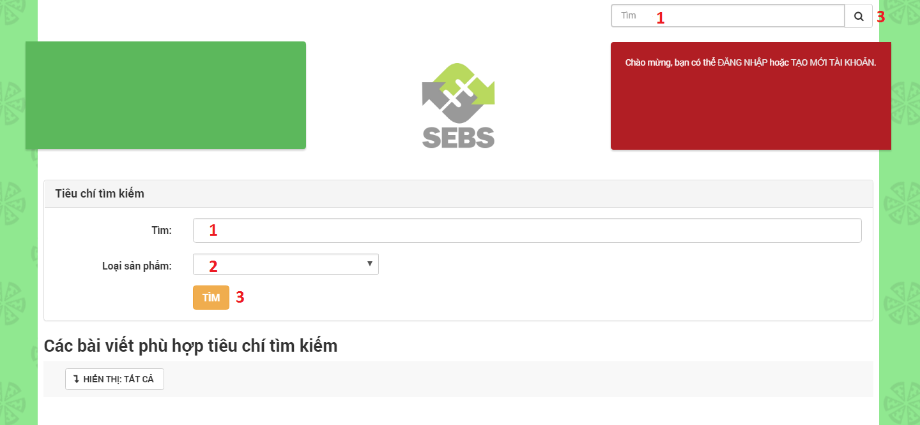

Figure : <Guest> Find posted Products UI

* + - 1. <User> Post Buying

|  |  |
| --- | --- |
| **Step** | **Description** |
| 1 | Fill in fields:   * Product category: Name of product category * Product name: Name of product * Product description: Description detail of product * Price: Price of product * Telephone number: Telephone number of user * Location: Location of user * Receive notification: Radius receiving notifications * Image: Image of product * Tag: Tags are matching posts |
| 2 | Click “ĐĂNG TIN” button |

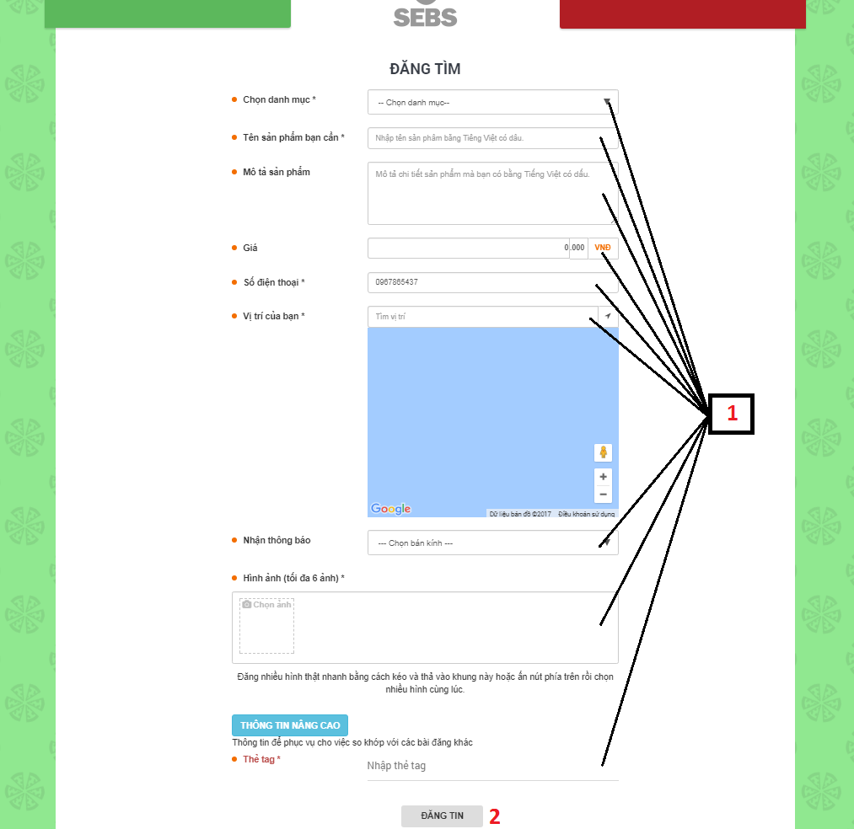

Figure : <User> Post Buying UI

* + - 1. <User> Post Selling

|  |  |
| --- | --- |
| **Step** | **Description** |
| 1 | Fill in fields:   * Product category: Name of product category * Product name: Name of product * Product description: Description detail of product * Price: Price of product * Telephone number: Telephone number of user * Location: Location of user * Receive notification: Radius receiving notifications * Image: Image of product * Tag: Tags are matching posts |
| 2 | Click “ĐĂNG TIN” button |

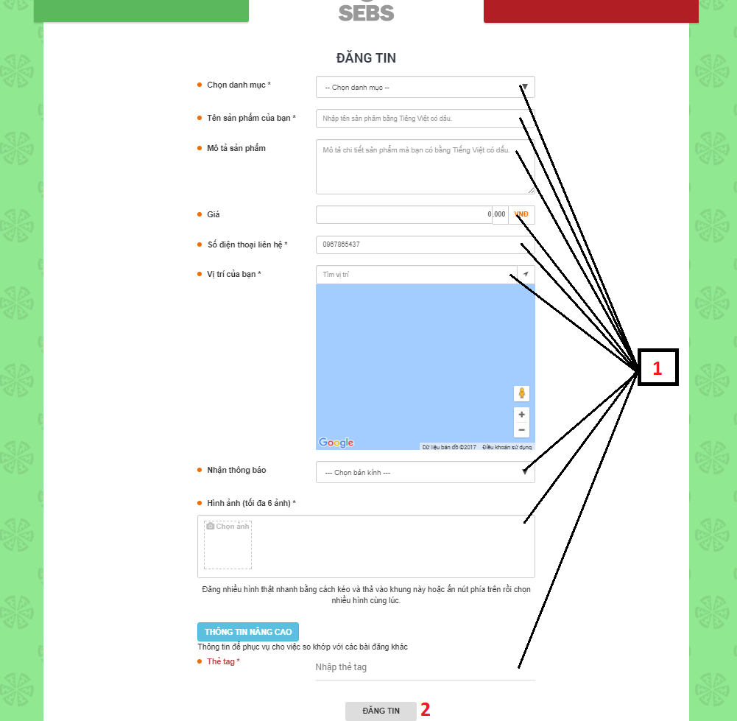

Figure : <User> Post Selling UI

* + - 1. <User> Post Exchanging

|  |  |
| --- | --- |
| **Step** | **Description** |
| 1 | Click ”TÔI CẦN” tab |
| 2 | Fill in fields:   * Product category: Name of product category * Product name: Name of product that you need * Product description: Description detail of product * Telephone number: Telephone number of user * Location: Location of user * Receive notification: Radius receiving notifications * Image: Image of product * Tag: Tags are matching posts |
| 3 | Click “TÔI CÓ” tab |
| 4 | Fill in fields:   * Product name: Name of product that you have * Product description: Description detail of product * Telephone number: Telephone number of user * Location: Location of user * Receive notification: Radius receiving notifications * Image: Image of product * Tag: Tags are matching posts |
| 5 | Click “ĐĂNG TIN” button |

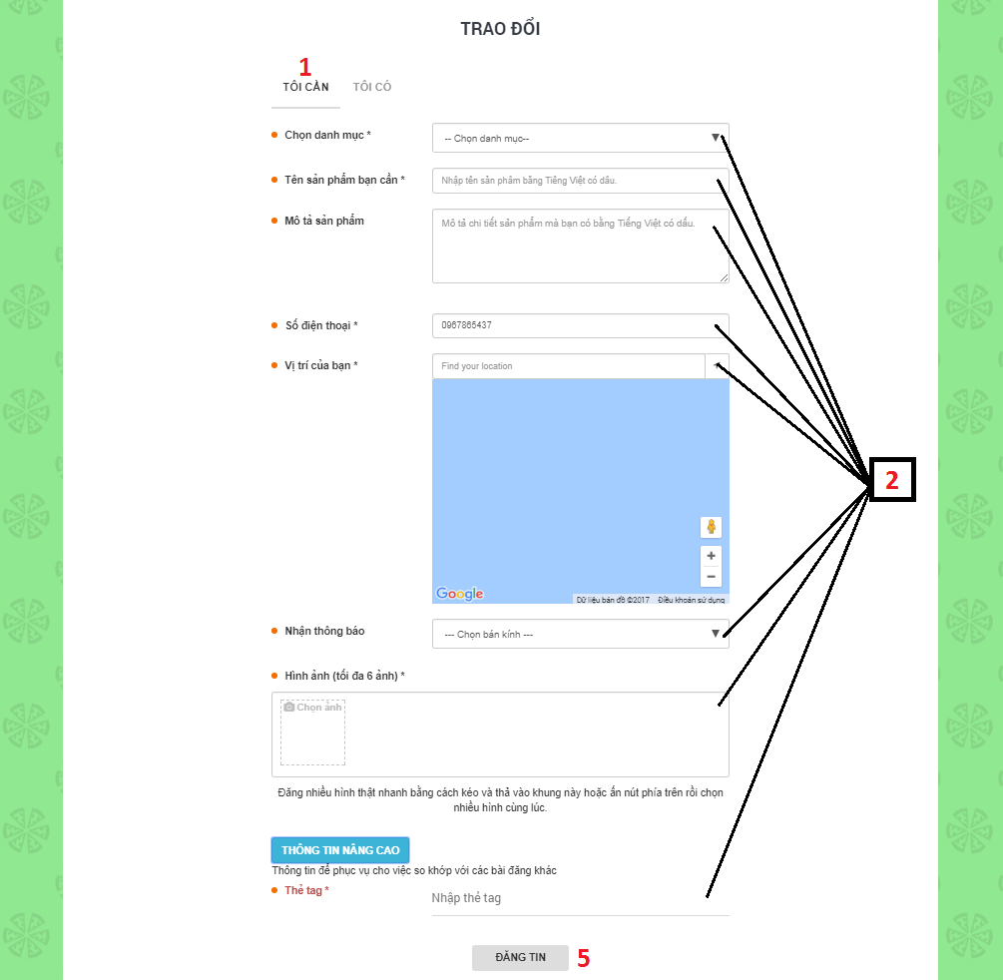

Figure : <User> Post Exchanging (1) UI

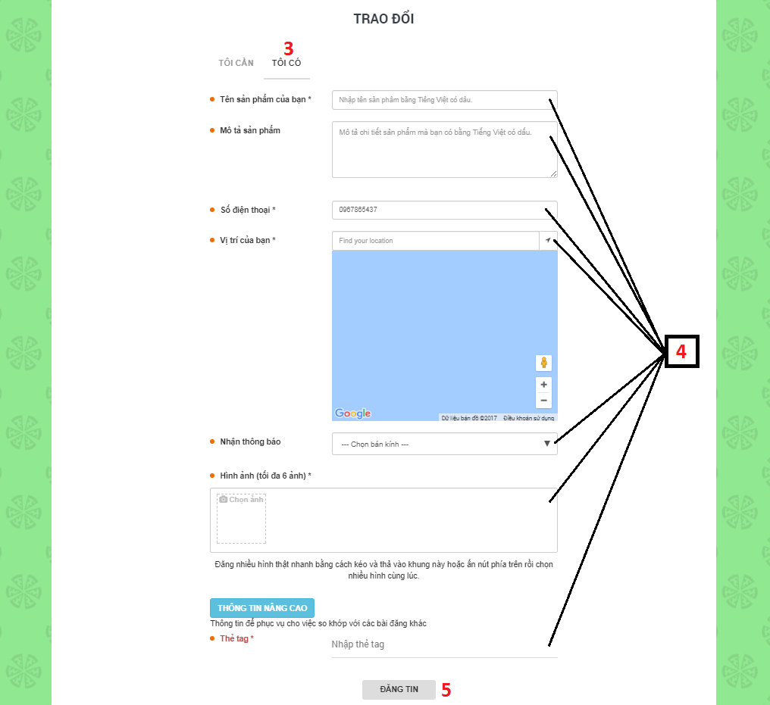

Figure : <User> Post Exchanging (2) UI

* + - 1. <User> Post Charity

|  |  |
| --- | --- |
| **Step** | **Description** |
| 1 | Fill in fields:   * Product category: Name of product category * Product name: Name of product * Product description: Description detail of product * Telephone number: Telephone number of user * Location: Location of user * Image: Image of product * Tag: Tags are matching posts |
| 2 | Click “ĐĂNG TIN” button |

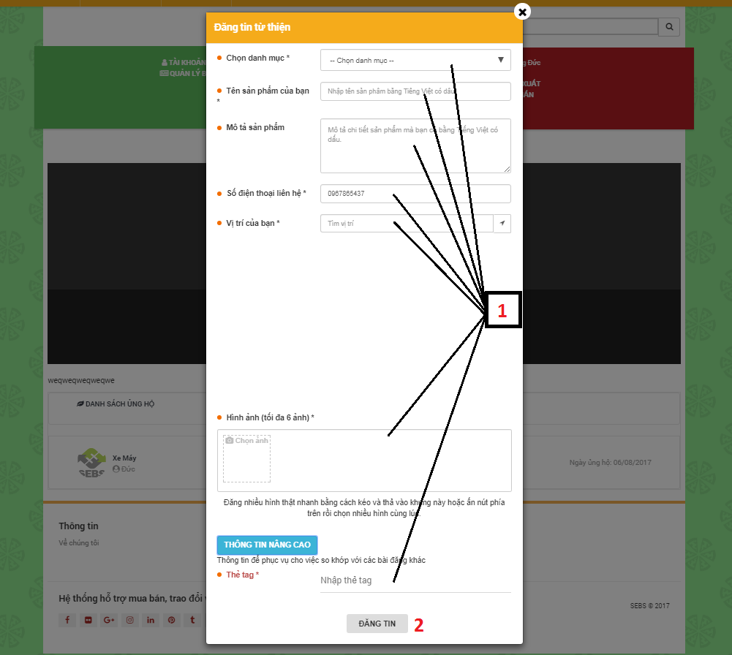

Figure : <User> Post Charity UI

* + - 1. <User> Manage Profile

|  |  |
| --- | --- |
| **Step** | **Description** |
| 1 | Click “TÀI KHOẢN CỦA TÔI” hyberlink |

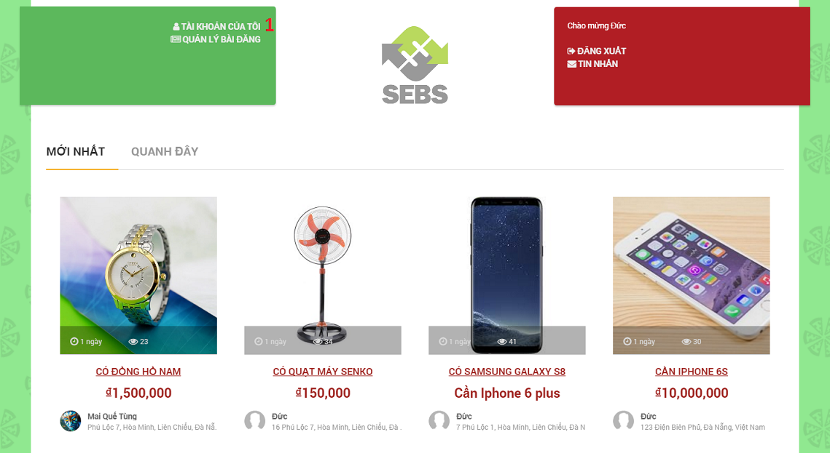

Figure : <User> Manage Profile UI

* + - 1. <User> Edit Profile

|  |  |
| --- | --- |
| **Step** | **Description** |
| 1 | Edit profile:   * Full name: Full name of user * Phone number: Phone number of user * Address: Address of user * Birthday: Birthday of user * Gender: Gender of user |
| 2 | Click “LƯU THAY ĐỔI” button |

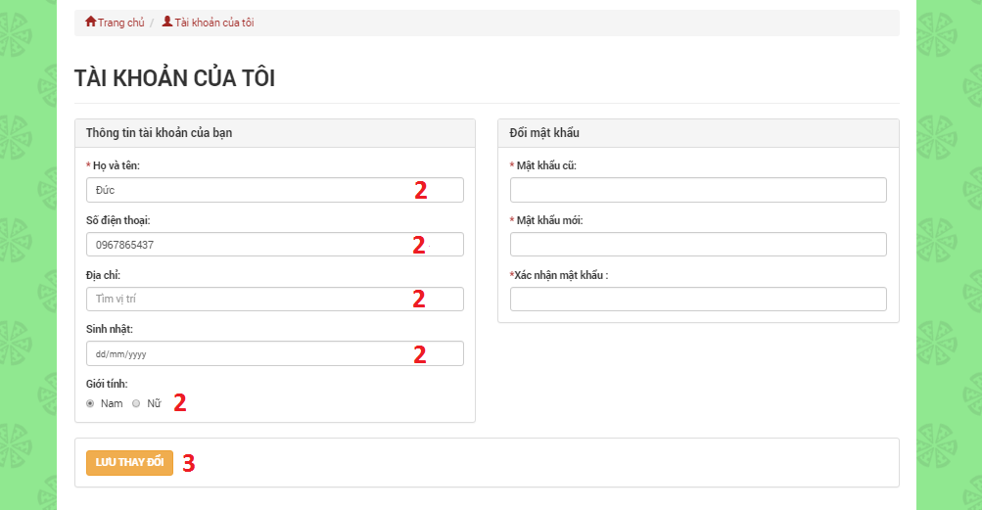

Figure : Edit Profile UI

* + - 1. <User> Change Password

|  |  |
| --- | --- |
| **Step** | **Description** |
| 1 | Change Password:   * Old password: Current password of user * New password: New password of user * Confirm password: Confirm password of user |
| 2 | Click “LƯU THAY ĐỔI” button |

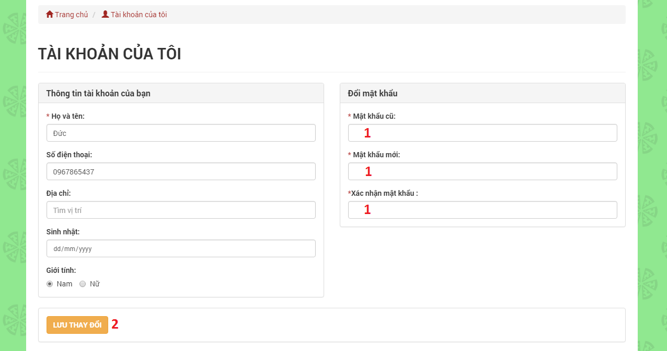

Figure : <User> Change Password UI

* + - 1. <User> Manage Posts

|  |  |
| --- | --- |
| **Step** | **Description** |
| 1 | Click “QUẢN LÝ BÀI ĐĂNG” hyberlink |

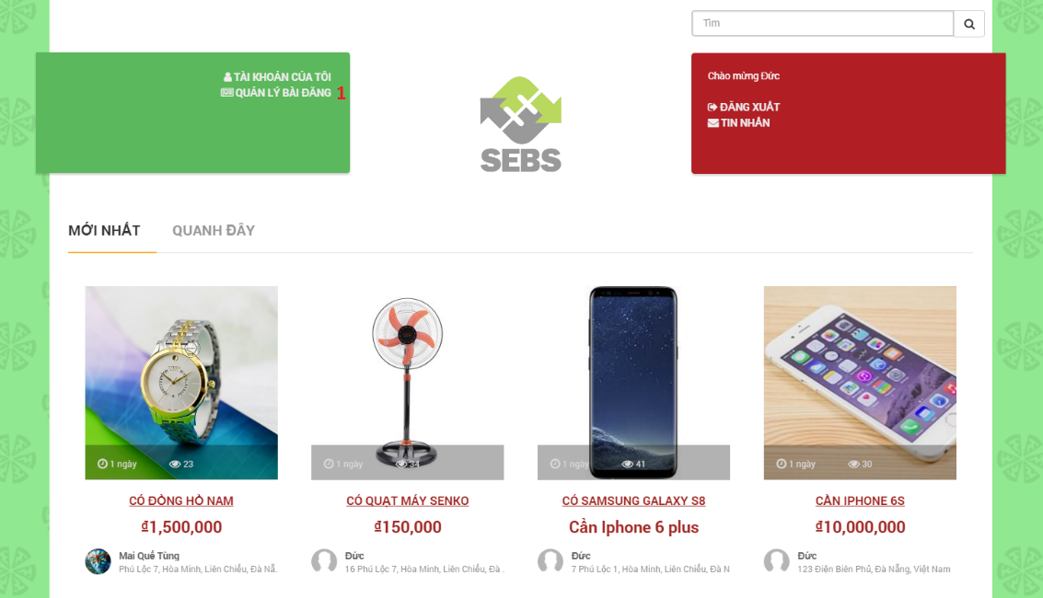

Figure : <User> Manage Posts UI

* + - 1. <User> Edit Post

|  |  |
| --- | --- |
| **Step** | **Description** |
| 1 | Click “Chỉnh sửa” on menu drop down |
| 2 | Edit post:   * Product category: Name of product category * Product name: Name of product * Product description: Description detail of product * Price: Price of product * Telephone number: Telephone number of user * Location: Location of user * Receive notification: Radius receiving notifications * Image: Image of product * Tag: Tags are matching posts |
| 3 | Click “CHỈNH SỬA” button |

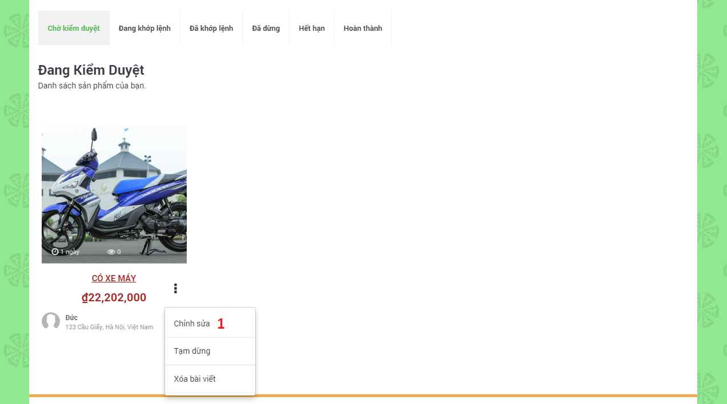

Figure : <User> Edit Post (1) UI

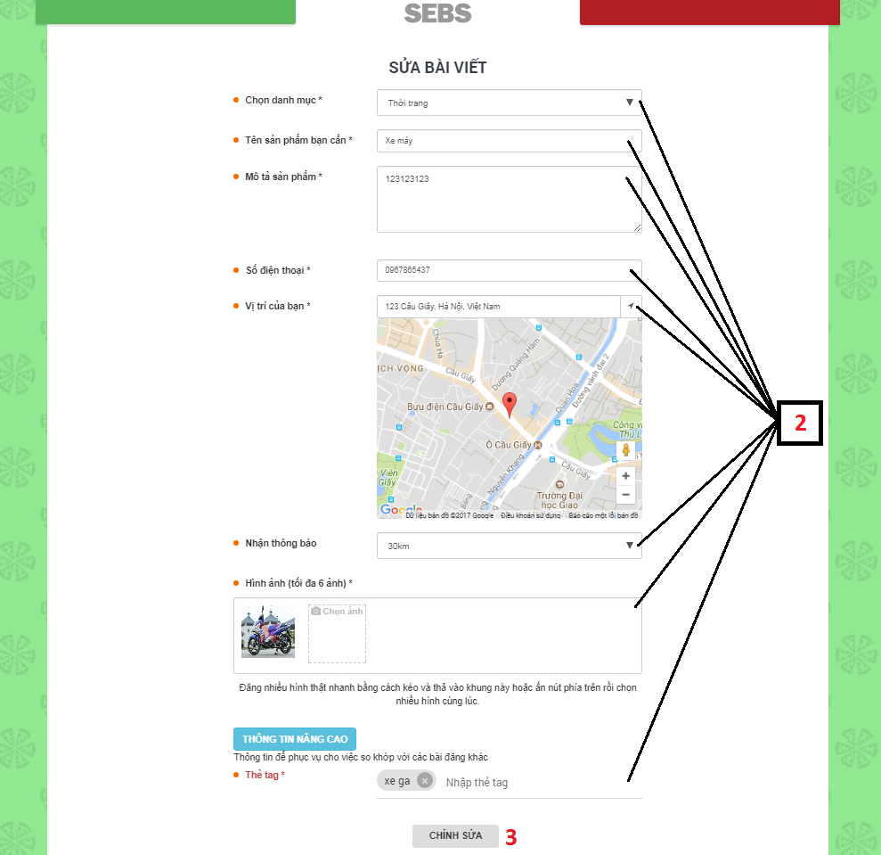

Figure : <User> Edit Post (2) UI

* + - 1. <User> Delete Post

|  |  |
| --- | --- |
| **Step** | **Description** |
| 1 | Click “Xóa bài viết” on menu drop down |

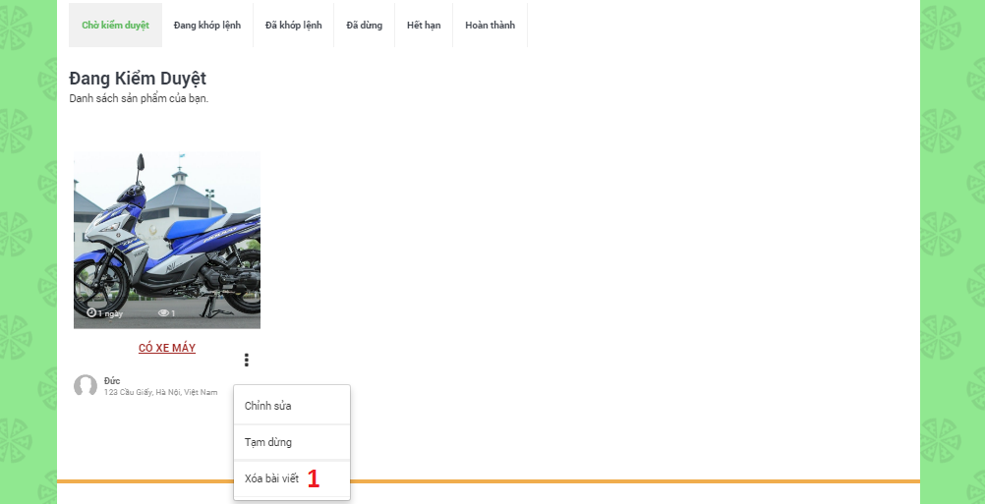

Figure : <User> Delete Post UI

* + - 1. <User> Cancel Post

|  |  |
| --- | --- |
| **Step** | **Description** |
| 1 | Click “Tạm dừng” on menu drop down |

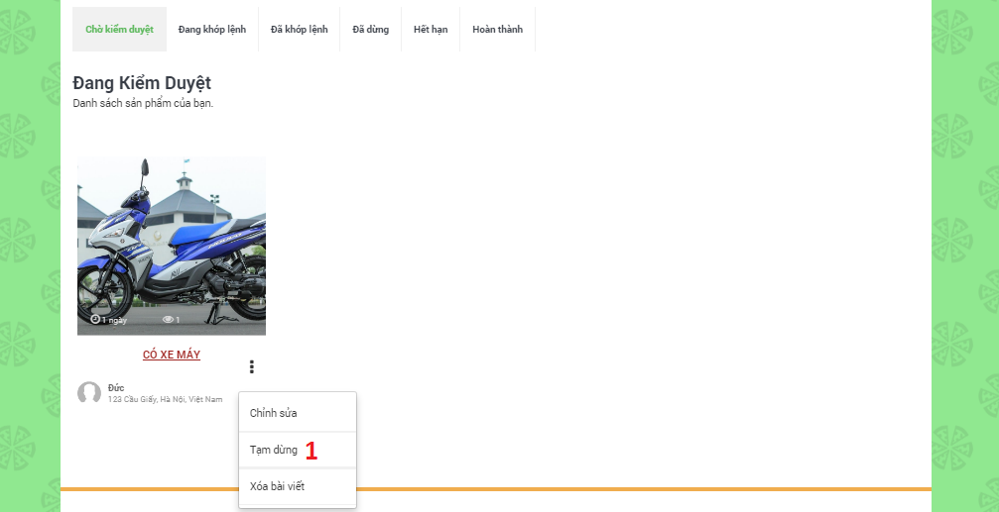

Figure : <User> Cancel Post UI

* + - 1. <User> Finish Post

|  |  |
| --- | --- |
| **Step** | **Description** |
| 1 | Click “Đã kết thúc” on menu drop down |

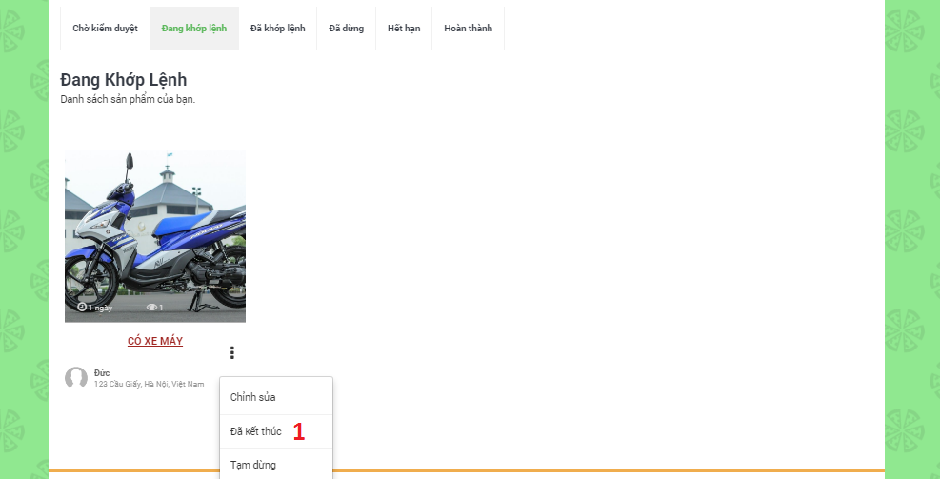

Figure : <User> Finish Post UI

* + - 1. <User> Feedback Posts

|  |  |
| --- | --- |
| **Step** | **Description** |
| 1 | Click “Báo cáo bài viết” button |
| 2 | Choose a problem |
| 3 | Click “GỬI BÁO CÁO” button |



Figure : <User> Feedback Posts UI

* + - 1. <User> Comment Posts

|  |  |
| --- | --- |
| **Step** | **Description** |
| 1 | Fill in field:   * Comment: Content of comment |
| 2 | Click  "Enter" on keyboard |

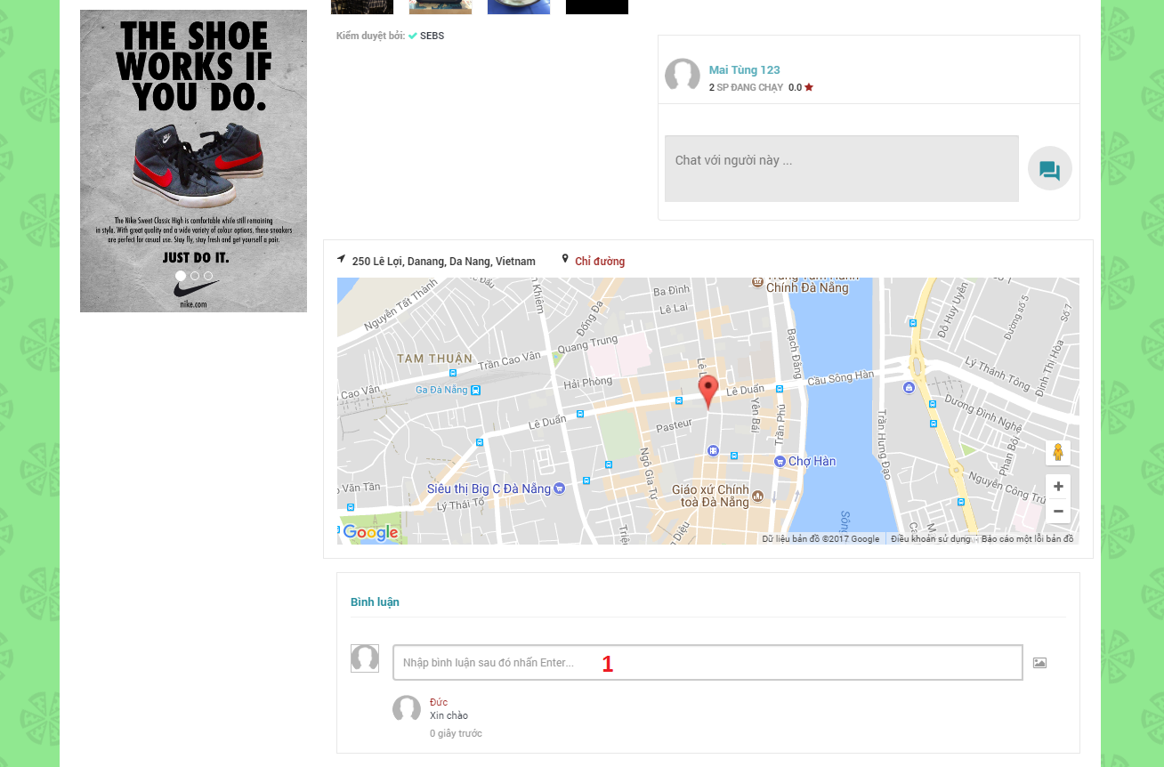

Figure : <User> Comment Posts UI

* + - 1. <User> Chat with other Users

|  |  |
| --- | --- |
| **Step** | **Description** |
| 1 | Click “TIN NHẮN” hyberlink |
| 2 | Fill in field:   * Chat: Content of message |
| 3 | Click  "Enter" on keyboard |

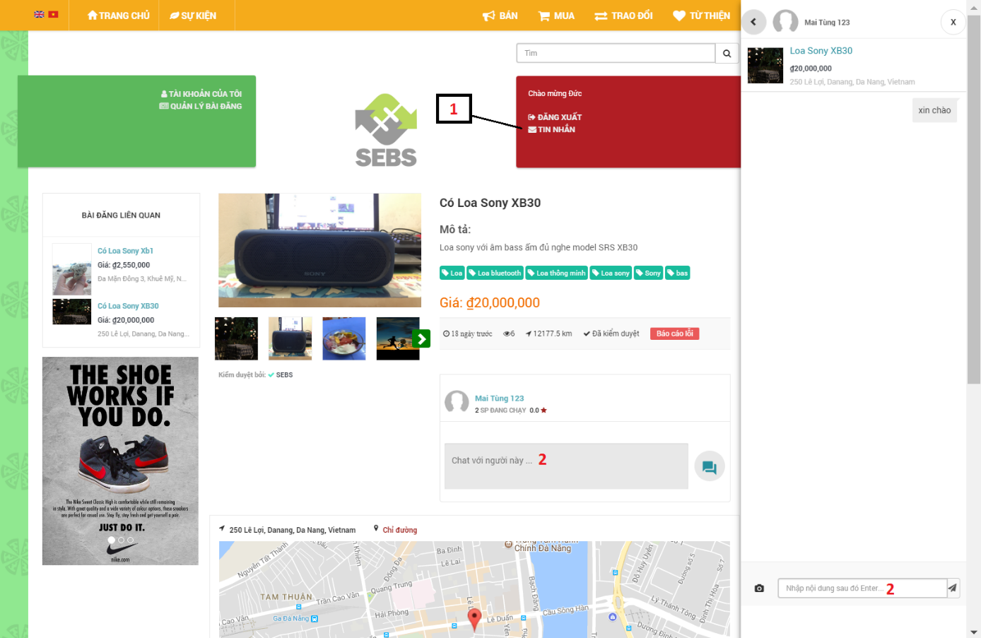

Figure : <User> Chat with other Users UI

* + - 1. <Admin> Manage Charity Campaigns

|  |  |
| --- | --- |
| **Step** | **Description** |
| 1 | Click “Sự kiện” |

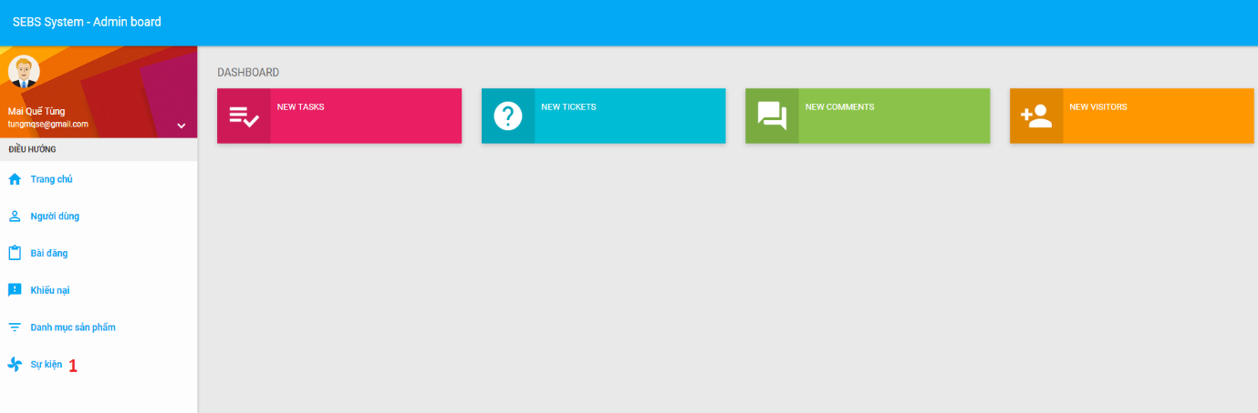

Figure : <Admin> Manage Charity Campaigns UI

* + - 1. <Admin> Create Charity Campaign

|  |  |
| --- | --- |
| **Step** | **Description** |
| 1 | Click “Thêm sự kiện” |
| 2 | Fill in fields:   * Title: Title of campaign * Slogan: Slogan of campaign * Start date: Start date of campaign * End date: End date of campaign * Image: Avatar of campaign * Content: Detail content of campaign |
| 3 | Click “Thêm” button |

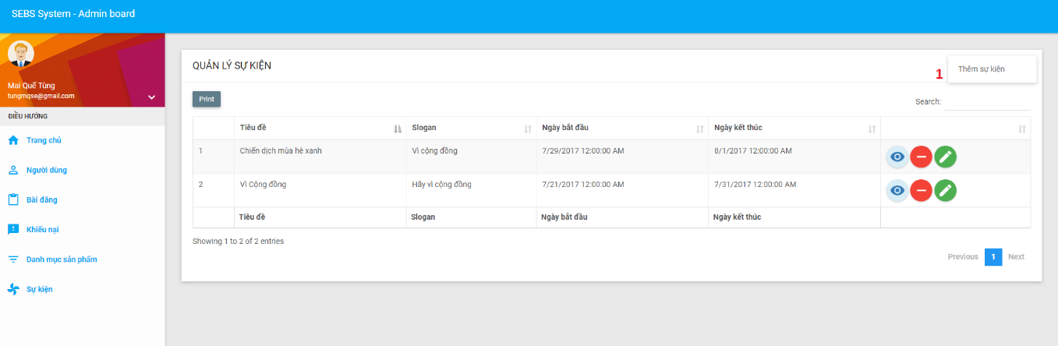

Figure : <Admin> Create Charity Campaign (1) UI

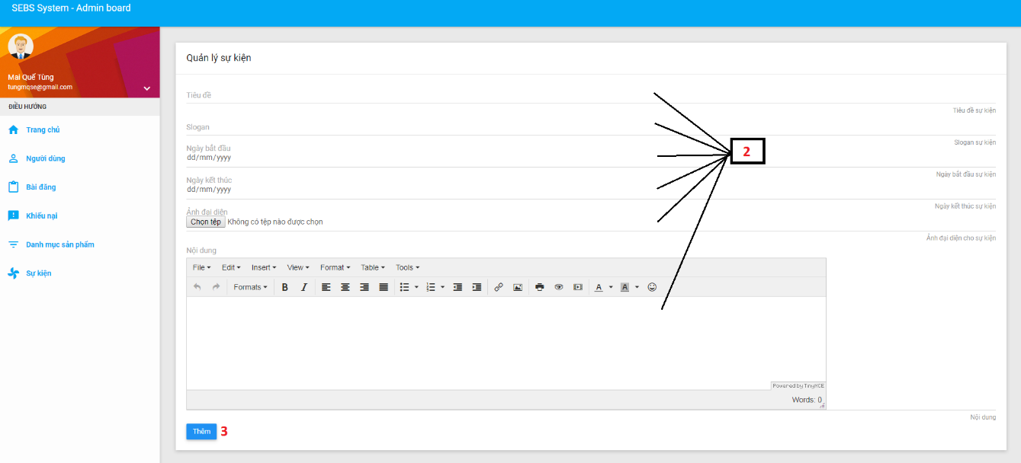

Figure : <Admin> Create Charity Campaign (2) UI

* + - 1. <Admin> Delete Charity Campaign

|  |  |
| --- | --- |
| **Step** | **Description** |
| 1 | Click “Delete” icon button |

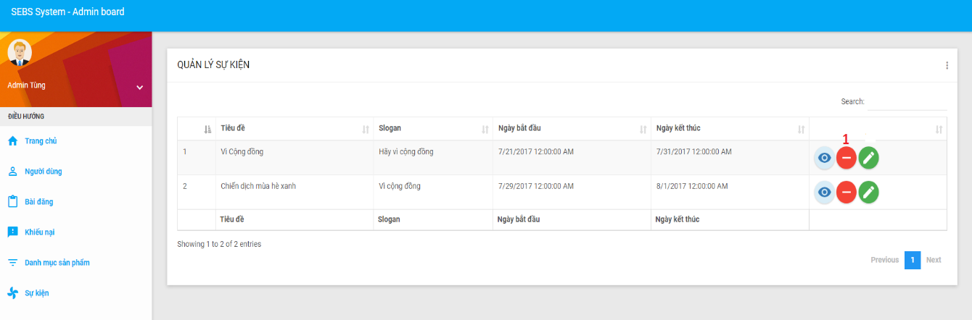

Figure : <Admin> Delete Charity Campaign UI

* + - 1. <Admin> Edit Charity Campaign

|  |  |
| --- | --- |
| **Step** | **Description** |
| 1 | Click “Edit” icon button |
| 2 | Edit information:   * Title: Title of campaign * Slogan: Slogan of campaign * Start date: Start date of campaign * End date: End date of campaign * Image: Avatar of campaign * Content: Detail content of campaign |
| 3 | Click “Sửa” button |

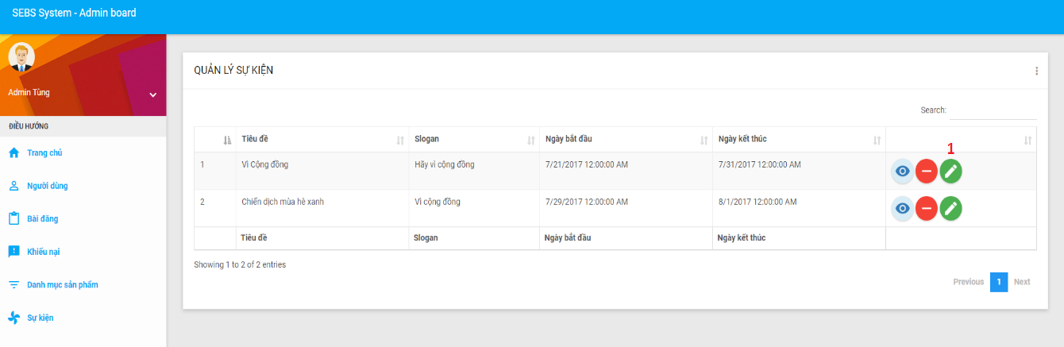

Figure : <Admin> Edit Charity Campaign (1) UI

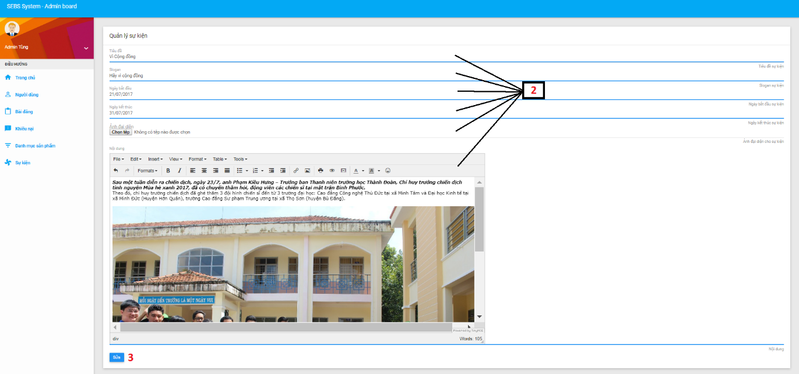

Figure : <Admin> Edit Charity Campaign (2) UI

* + - 1. <Admin> Manage Product Categories

|  |  |
| --- | --- |
| **Step** | **Description** |
| 1 | Click “Danh mục sản phẩm” |

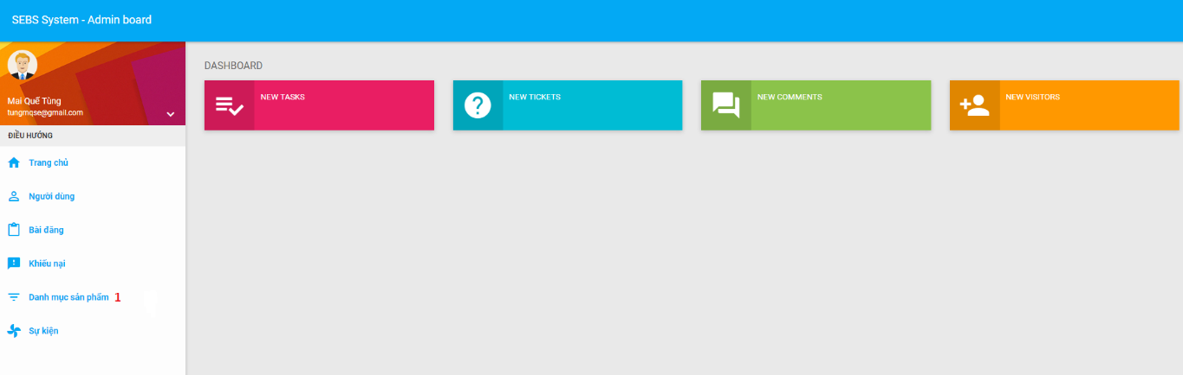

Figure : <Admin> Manage Product Categories UI

* + - 1. <Admin> Create Product Category

|  |  |
| --- | --- |
| **Step** | **Description** |
| 1 | Click "Thêm danh mục sản phẩm" |
| 2 | Fill in fields:   * Name: Name of product category * Image: Avatar of product category |
| 3 | Click “Thêm” button |

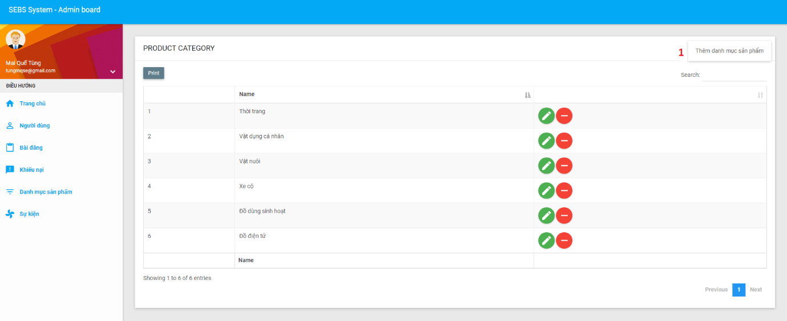

Figure : <Admin> Create Product Category (1) UI

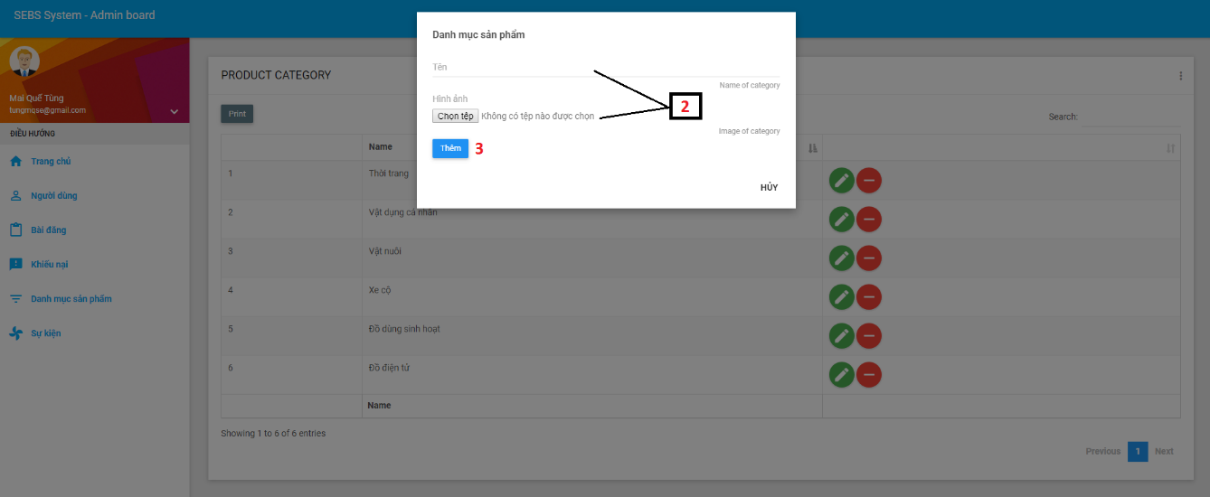

Figure : <Admin> Create Product Category (2) UI

* + - 1. <Admin> Delete Product Category

|  |  |
| --- | --- |
| **Step** | **Description** |
| 1 | Click "Delete" icon button |

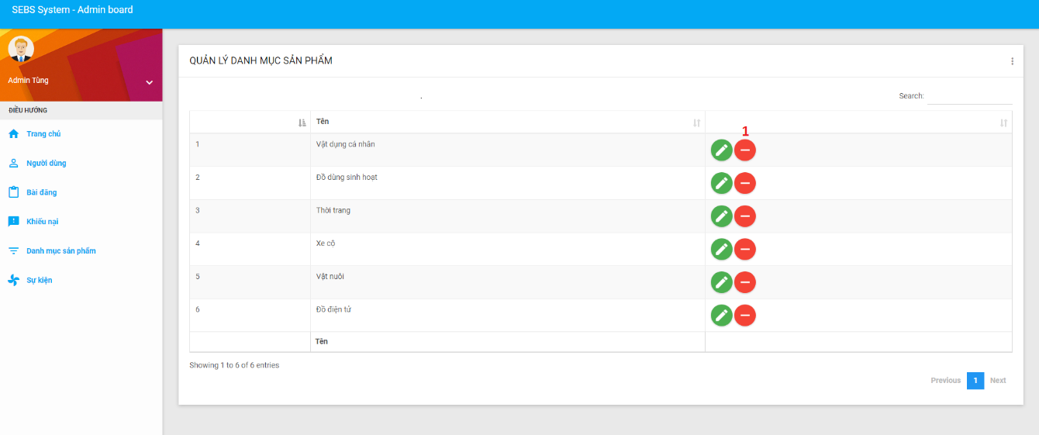

Figure : <Admin> Delete Product Category UI

* + - 1. <Admin> Edit Product Category

|  |  |
| --- | --- |
| **Step** | **Description** |
| 1 | Click "Edit" icon button |
| 2 | Edit information:   * Name: Name of product category * Image: Avatar of product category |
| 3 | Click “Sửa” button |

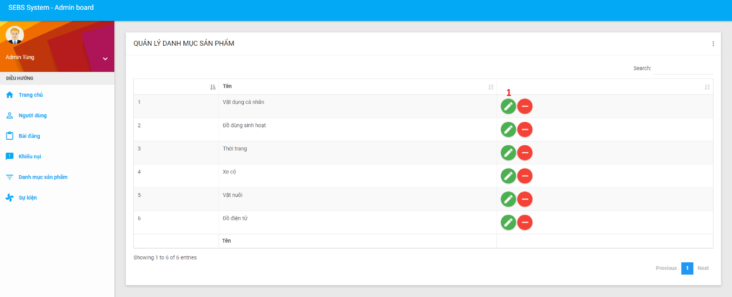

Figure : <Admin> Edit Product Category (1) UI

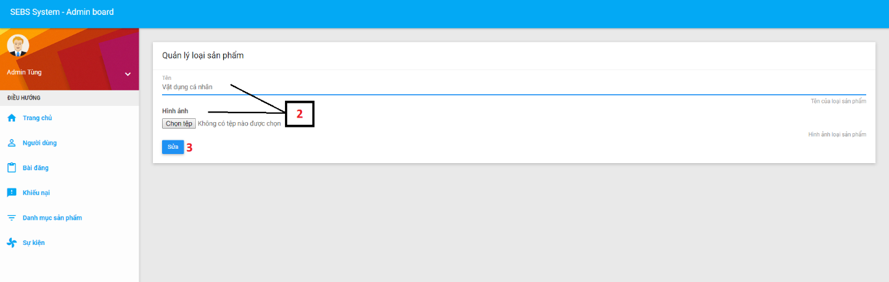

Figure : <Admin> Edit Product Category (2) UI

* + - 1. <Admin> Manage Feedbacks

|  |  |
| --- | --- |
| **Step** | **Description** |
| 1 | Click “Khiếu nại” |

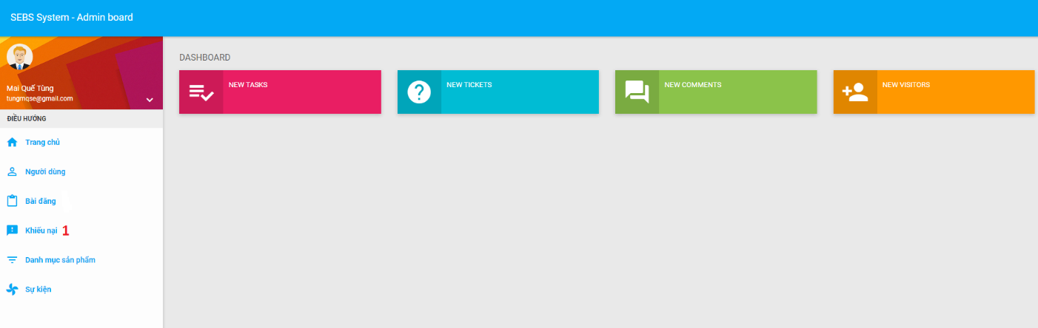

Figure : <Admin> Manage Feedbacks UI

* + - 1. <Admin> View Feedback List

|  |  |
| --- | --- |
| **Step** | **Description** |
| 1 | Click “Phản hồi” icon button |

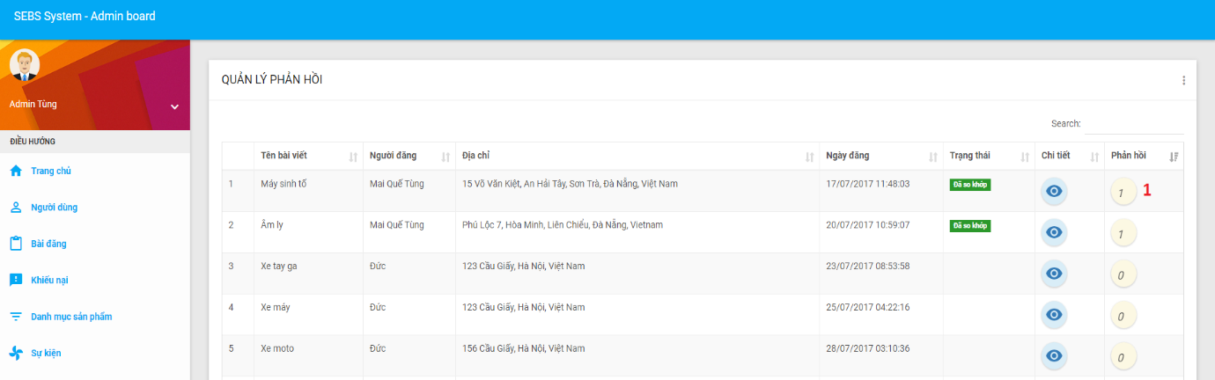

Figure : <Admin> View Feedback List UI

* + - 1. <Admin> Manage Posts

|  |  |
| --- | --- |
| **Step** | **Description** |
| 1 | Click “Bài đăng” |

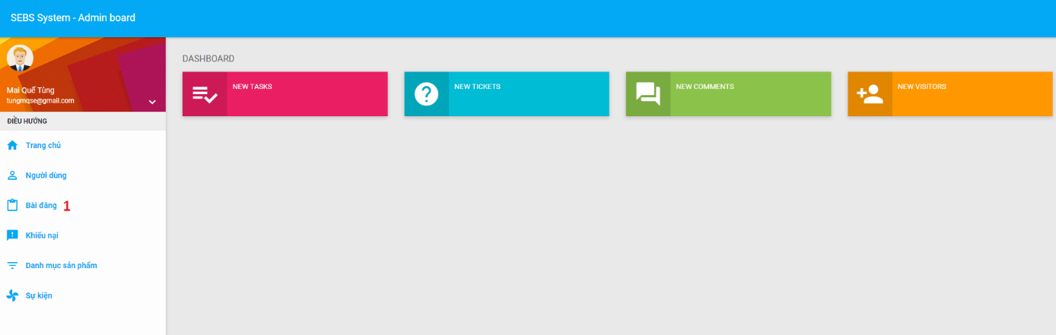

Figure : <Admin> Manage Posts UI

* + - 1. <Admin> Examine Post

|  |  |
| --- | --- |
| **Step** | **Description** |
| 1 | Click “Duyệt bài” icon button |

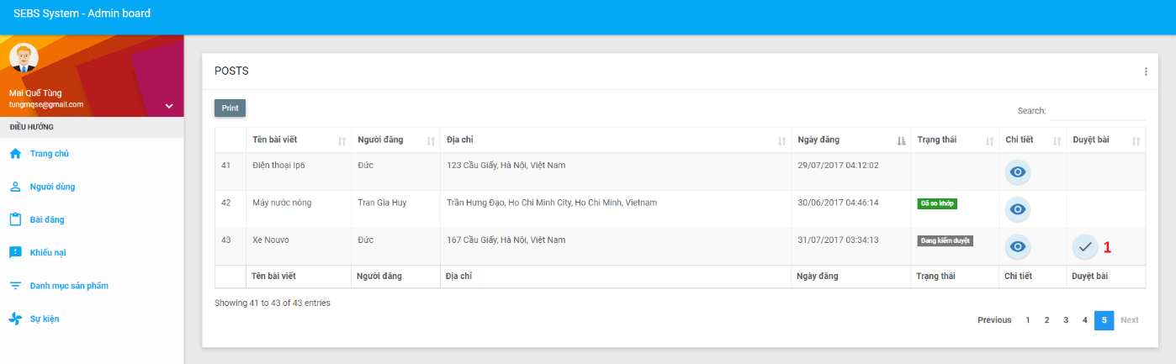

Figure : <Admin> Examine Post UI

* + - 1. <Admin> Extend Post

|  |  |
| --- | --- |
| **Step** | **Description** |
| 1 | Click “Gia hạn” icon button |

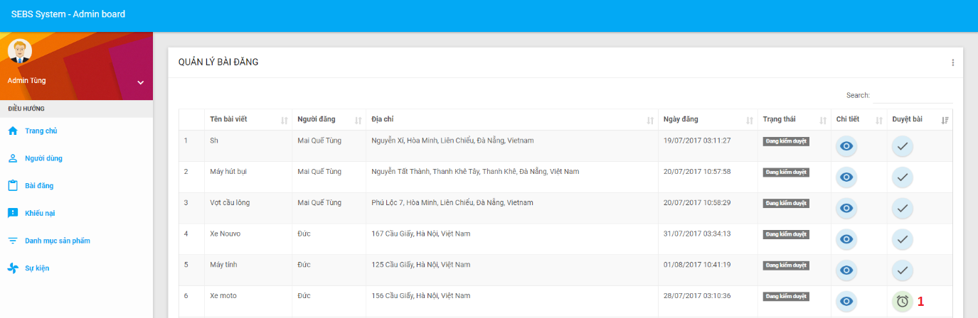

Figure : <Admin> Extend Post UI

* + - 1. <Admin> Manage Users

|  |  |
| --- | --- |
| **Step** | **Description** |
| 1 | Click “Người dùng” |

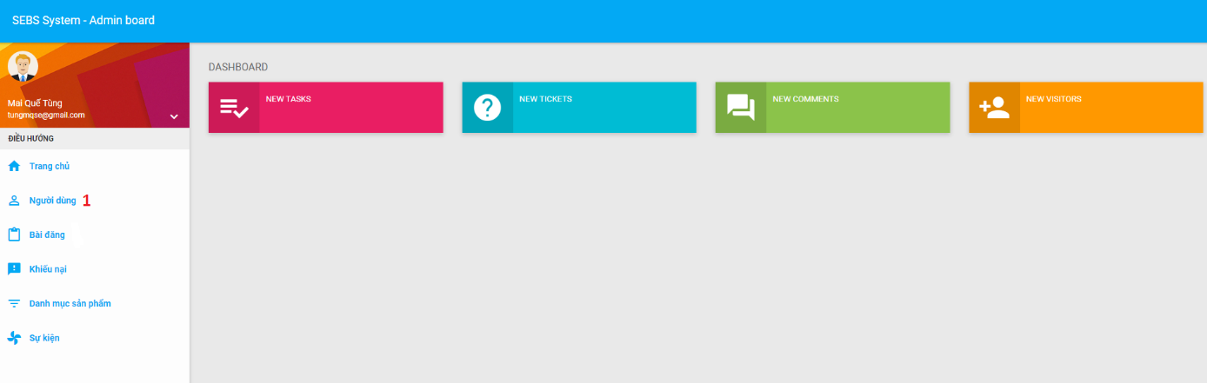

Figure : <Admin> Manage Users UI

* + - 1. <Admin> Ban User

|  |  |
| --- | --- |
| **Step** | **Description** |
| 1 | Click “Cấm” icon button |

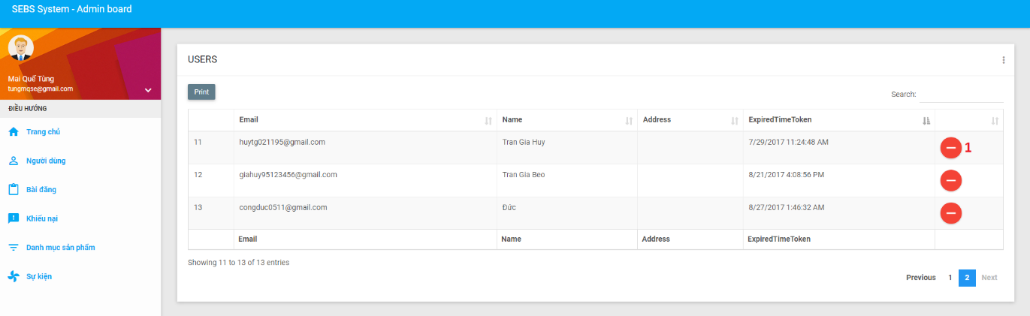

Figure : <Admin> Ban User UI

* + 1. Mobile application
       1. <Guest> Login

|  |  |
| --- | --- |
| **Step** | **Description** |
| 1 | Fill in fields :   * Username: Email of user * Password: Password of user |
| 2 | Click “ĐĂNG NHẬP” button |

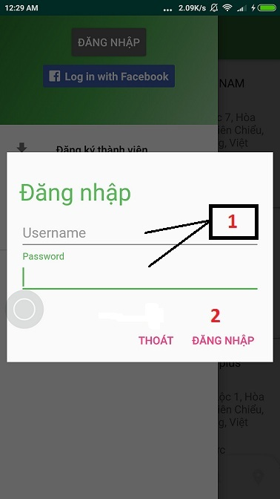

Figure : (Mobile) Login UI

* + - 1. <Guest> Register as an User

|  |  |
| --- | --- |
| **Step** | **Description** |
| 1 | Fill in fields :   * Name: Full name of guest * Email: Email of guest * Password: Password of guest * Confirm password: Confirm password of guest * Address: Address of guest * Avatar: Avatar image of guest |
| 2 | Click “REGISTER” button |

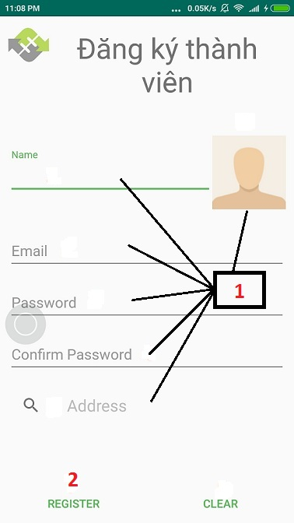

Figure : (Mobile) Register as an User UI

* + - 1. <Guest, User> Find posted Products

|  |  |
| --- | --- |
| **Step** | **Description** |
| 1 | Click “Tìm kiếm” button bottom tab bar |
| 2 | Fill in field:   * Search: Keyword to find |
| 3 | Click “Search” icon button on keyboard |

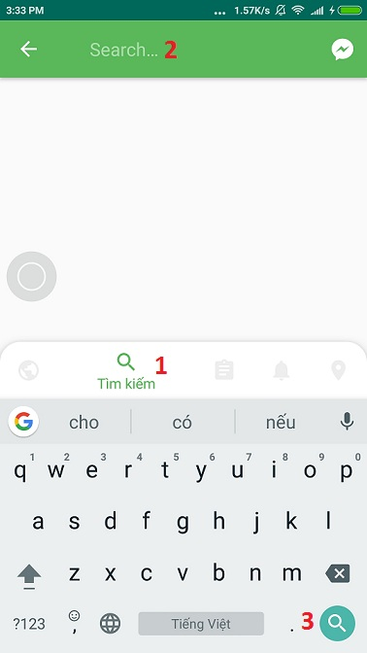

Figure : (Mobile) Find posted Products UI

* + - 1. <Loads owner, Driver> Deal order

|  |  |
| --- | --- |
| **Step** | **Description** |
| 1 | Click at the item you want to deal |
| 2 | Input price |
| 3 | Click button “Thương lượng” |

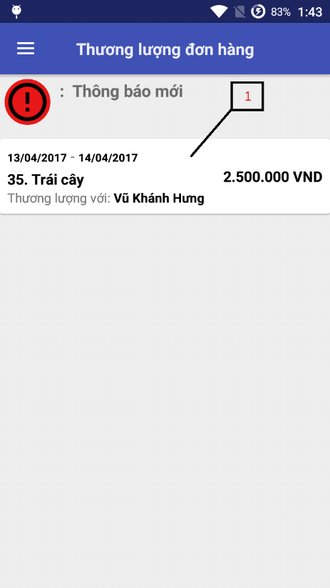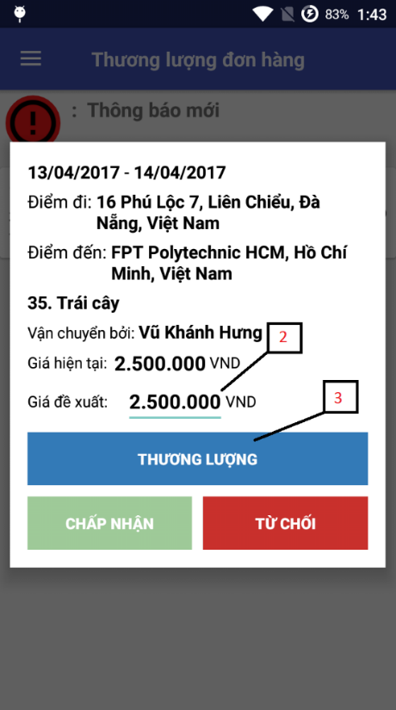

Figure : (Mobile) Deal order UI

* + - 1. <User> Manage Profile

|  |  |
| --- | --- |
| **Step** | **Description** |
| 1 | Click “Thông tin cá nhân” |

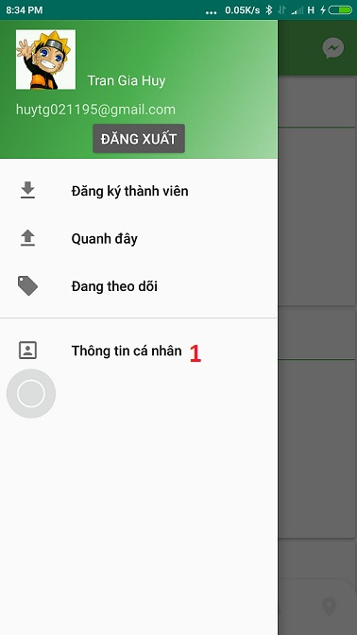

Figure : (Mobile) Manage Profile UI

* + - 1. <Loads owner, Driver> Reject order

|  |  |
| --- | --- |
| **Step** | **Description** |
| 1 | Click at the item you want to deal |
| 2 | Click button “Từ chối” |

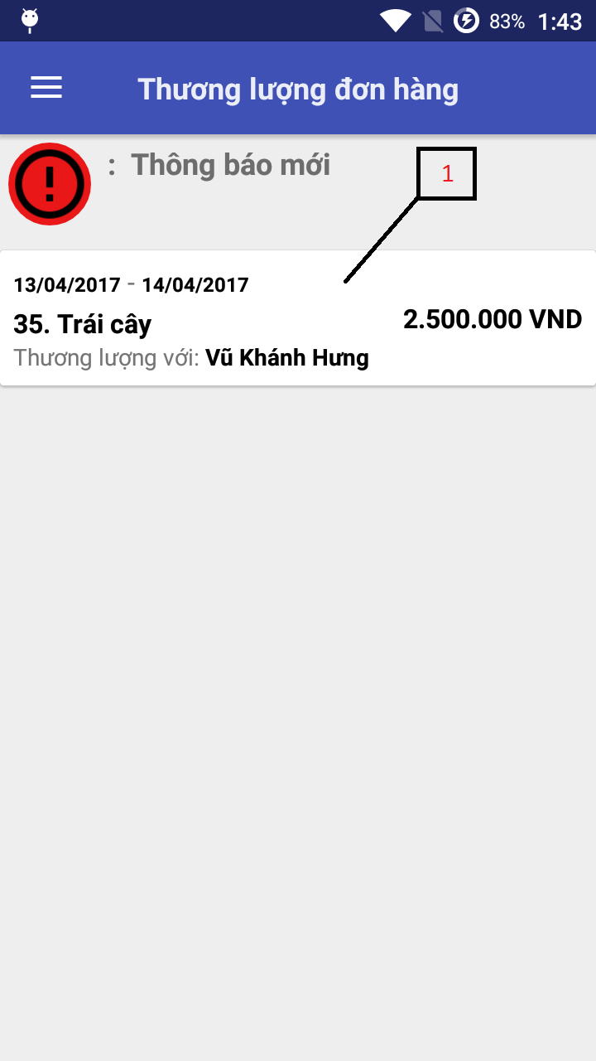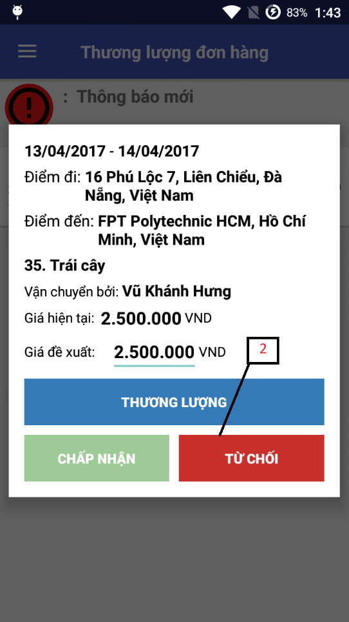

Figure : (Mobile) Reject order UI

* + - 1. <User> Comment Posts

|  |  |
| --- | --- |
| **Step** | **Description** |
| 1 | Click “XEM BÌNH LUẬN” button |
| 2 | Fill in field:   * Comment: Content of comment |
| 3 | Click “Send” icon button |

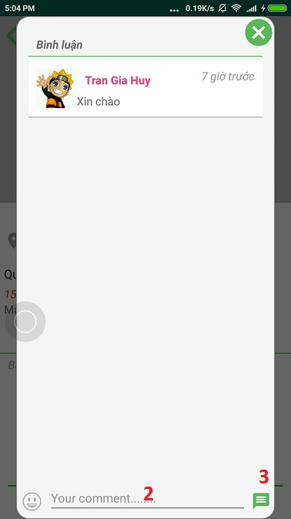

Figure : (Mobile) Comment Posts UI

* + - 1. <User> Chat with other Users

|  |  |
| --- | --- |
| **Step** | **Description** |
| 1 | Click "Chat" icon button |
| 2 | Fill in field:   * Chat: Content of message |
| 3 | Click "Send" icon button |

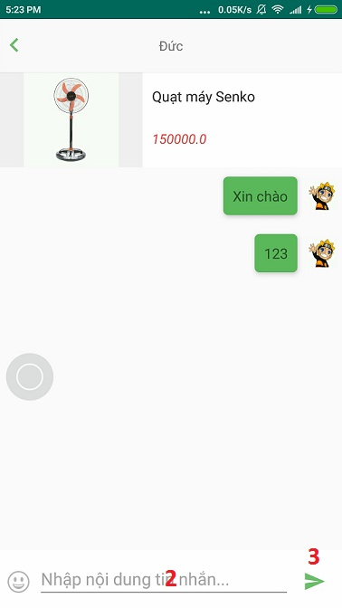

Figure : (Mobile) Chat with other Users UI

* + - 1. <User> Logout

|  |  |
| --- | --- |
| **Step** | **Description** |
| 1 | Click “ĐĂNG XUẤT” button |

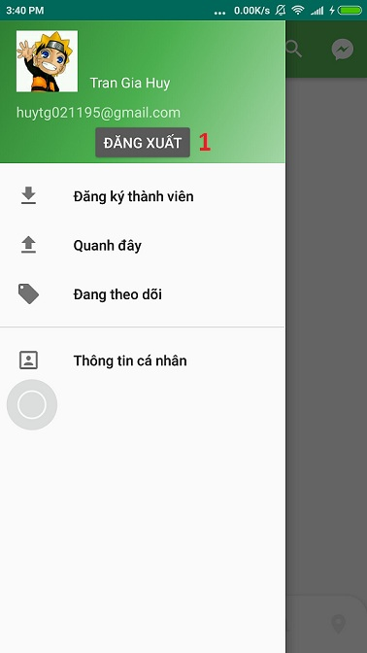

Figure : (Mobile) Logout UI

1. Conclusion
   1. Lesson learned

After completing the capstone project, we have learned a lot.

On the technical side, we learned design a system from the ground up. In the process, we learned how to create services using ASP.NET MVC 5, how to send and consume json data on the client using Ajax, how to create a responsive UI and approach many other technologies such as Google Map API, Retrofit, Recycle View as well as theories such as material design, UI/UX …

On the process side, we learned how to organize a team and work together to archive the same goal. At the same time, we also learned how to solve conflicts between team members and how to encourage each other to keep going when time gets rough.

* 1. Difficulties

“There is no royal road to learning”. Even though we learned a lot in the process of making Efficient Transport System, we also faced a lot problems and difficulties.

The first thing we faced was team conflict. It was the first time we worked together as a team so everyone had their own opinion on the same idea. This created a conflict between team members, which led to a delay in our schedule.

The second thing we found difficult was the time constraint. In the duration of four months, we had to do many things without prior experience. We found it very hard to stick to the schedule at first but eventually we got used to it.

The last thing we had problems with is the algorithm. We tried many methods then narrow it down to one method, which was using Google Map Direction API. After that, we spent a lot of time implementing, testing and optimizing the algorithm but it is still not good enough for our expectation.

With that said, we would like to thank Mr. Nguyễn Ngọc Anh for guiding us to the right path so that we can complete our capstone project with the best result possible. We also want to thank other teachers and friends who supported us in the making of Efficient Transport Solution. We cannot do it without the help of such people.

Thank you so much.

1. Reference

"Scrum Guides". Scrumguides.org. N.p., 2017. Web. June. 2016.

"The Repository Pattern". Msdn.microsoft.com. N.p., 2017. Web. 19 Apr. 2017.

"Bài 71: Xây Dựng Web Service Dùng API Restful Service (Phần 4)". Advanced programming. N.p., 2017. Web. 11 Nov. 2015.